|  |  |  |  |  |  |  |
| --- | --- | --- | --- | --- | --- | --- |
| **DRAFT REPORT FOR**  **PURPOSE DRIVEN STUDY UNDER HP-II**  **On**  **Integrated approach for snowmelt runoff studies and effect of anthropogenic activities in Beas basin**  **PANDOH DAM**  **Principal Investigator**  **Dr Sanjay K. Jain,**  **Scientist F, NIH**  Email: [sjain@nih.ernet.in](mailto:sjain@nih.ernet.in)  **NIH_Logo 003**  **NATIONAL INSTITUTE OF HYDROLOGY**  **JAL VIGYAN BHAVAN**  **ROORKEE - 247 667 (INDIA)**  **MARCH 2014**  **THE STUDY GROUP**  **Dr. Sanjay K. Jain, Scientist ‘F’**  **Dr. S P Rai, Scientist ‘D’**  **Dr. C K Jain, Scientist ‘F’**  **Mr. L N Thakural, Scientist ‘B’**  **Mr. Tanvear Ahmad, Scientist ‘B’**  **Mr. P K Agarwal, Scientist ‘B’**  **Mrs. Anju Chaudhary, PRA**  **Mr. Rajeev Ahluwalia, Project Officer**  **Ms. Neha Jain, Resource Person**  **CONTENTS** | | | | | | |
|  |  | | | | | Page No. |
|  | List of Figures | | | | | i |
|  | List of Tables | | | | | iii |
|  | Executive Summary | | | | | iv |
| **1.0** | **INTRODUCTION** | | | | | 3 |
|  | 1.1 | GENERAL | | | | 3 |
|  | 1.2 | SNOW AND GLACIER MELT RUNOFF | | | | 4 |
|  | 1.3 | ISOTOPIC TECHNIQUES | | | | 6 |
|  | 1.4 | IMPACT OF CLIMATE CHANGE | | | | 11 |
|  | 1.5 | OBJECTIVES | | | | 15 |
|  |  |  | | | |  |
| **2.0** | **REVIEW OF LITERTURE** | | | | | 17 |
|  |  | TREND ANALYSIS | | | | 17 |
|  |  | APPLICATION OF SNOWMELT RUNOFF MODELLING | | | | 19 |
|  |  | ISOTOPE STUDIES | | | | 24 |
|  |  | CLIMATE CHANGE STUDIES | | | | 24 |
|  |  |  | | | |  |
| **3.0** | THE STUDY AREA, DATA USED AND FIELD INVESTIGATIONS | | | | | 26 |
|  | 3.1 | THE STUDY AREA | | | | 26 |
|  | 3.2 | DATA USED | | | | 26 |
| 3.2.1 Meteorological data | | | | 26 |
| 3.2.2 Satellite data | | | | 27 |
| 3.2.3 Digital Elevation Model(DEM) | | | | 28 |
|  | 3.3 | FIELD INVESTIGATIONS | | | | 29 |
|  |  |  | | | |  |
| **4.0** | TREND ANALYSIS | | | | | 32 |
|  | 4.1 | INTRODUCTION | | | | 32 |
|  | 4.2 | DATA USED | | | | 33 |
|  | 4.3 | DATA PREPARATION | | | | 33 |
|  | 4.4 | METHODOLOGY | | | | 34 |
|  | 4.5 | RESULTS AND DISCUSSIONS | | | | 37 |
|  | 4.6 | TRENDS IN RAINFALL | | | | 42 |
|  |  |  | | | |  |
| **5.0** | **SNOWMELT RUNOFF MODELLING** | | | | | 46 |
|  | 5.1 | SNOWMELT RUNOFF MODELLING | | | | 46 |
|  | 5.2 | INPUT DATA | | | | 47 |
|  | 5.3 | MODEL VARIABLES AND PARAMETERS | | | | 47 |
|  |  | 5.3.1 | Division of catchment into elevation bands | | | 47 |
|  |  | 5.3.2 | Precipitation data and distribution | | | 48 |
|  |  | 5.3.3 | Temperature data- Space and time distribution and Lapse Rate | | | 49 |
|  |  | 5.3.4 | Degree days | | | 50 |
|  |  | 5.3.5 | Degree Day Factor | | | 51 |
|  |  | 5.3.6 | Rain on snow | | | 52 |
|  | 5.4 | COMPUTATION OF DIFFERENT RUNOFF COMPONENTS | | | | 53 |
|  |  | 5.4.1 | Surface runoff from snow covered area | | | 53 |
|  |  | 5.4.2 | Surface runoff from snow free area | | | 54 |
|  |  | 5.4.3 | Estimation of subsurface runoff | | | 55 |
|  |  | 5.4.4 | Total runoff | | | 55 |
|  | 5.5 | EFFICIENCY CRITERIA OF THE MODEL | | | | 57 |
|  | 5.6 CREATION OF DATABASE FOR MODELLING | | | | | 58 |
|  |  | 5.6.1 | DIGIAL ELEVATION DATA | | | 57 |
|  |  | 5.6.2 | PRECIPITATION AND TEMPERATURE DATA | | | 58 |
|  |  | 5.6.3 | SNOW COVERED AREA (SCA) | | | 60 |
|  |  |  | 5.6.3.1 | | SCA using satellite data | 60 |
|  |  |  | 5.6.3.2 | | SCA using Temperature data | 62 |
|  |  |  | 5.6.3.3 | | Interpolation and simulation of SCA | 64 |
|  |  |  | 5.6.3.4 | | Generation of SCA maps for climate change studies | 64 |
|  | 5.7 | CALIBRATION OF MODEL | | | | 70 |
|  | 5.8 SIMULATION OF STREAM FLOW | | | | | 70 |
|  |  | 5.8.1 | MODELING OF STREAMFLOW OF BEAS RIVER AT MANALI | | | 70 |
|  |  | 5.8.2 | MODELING OF STREAMFLOW OF PARVATI RIVER AT BHUNTER | | | 71 |
|  |  | 5.8.3 | MODELING OF STREAMFLOW OF BEAS RIVER AT PANDOH | | | 73 |
|  | 5.9 | ESTIMATION OF SNOWMELT RUNOFF AND RAINFALL RUNOFF | | | | 74 |
|  |  |  | | | |  |
| **6.0** | **MAJOR ION CHEMISTRY OF BEAS RIVER** | | | | | 76 |
|  | 6.1 | INTRODUCTION | | | | 76 |
|  | 6.2 | THE RIVER BEAS | | | | 77 |
|  | 6.3 | ANALYTICAL METHODOLOGY | | | | 77 |
|  |  | 6.3.1 | SAMPLING AND PRESERVATION | | | 77 |
|  |  | 6.3.2 | CHEMICALS AND REAGENTS | | | 79 |
|  |  | 6.3.3 | PHYSICO-CHEMICAL ANALYSIS | | | 79 |
|  | 6.4 | RESULTS AND DISCUSSION | | | | 80 |
|  |  |  | | | |  |
| **7.0** | **SNOW AND GLACIER MELT SEPERATION USING ISOTOPE** | | | | | 92 |
|  | 7.1 | INTRODUCTION | | | | 92 |
|  |  | METHODOLOGY | | | | 93 |
|  |  | 7.1.1 | | Derivation of Isotopic Model for Hydrograph Separation | | 94 |
|  | 7.2 | DEVELOPMENT OF ISOTOPIC INDICES FOR VARIOUS COMPONENT OF RIVER DISCHARGE | | | | 96 |
|  |  | 7.2.1 | | Isotopic Signature of Snow/Ice | | 96 |
| 7.2.2 | | Isotopic Characteristics of Rain | | 97 |
| 7.2.3 | | Isotopic Characteristics of Groundwater | | 98 |
| 7.2.4 | | Isotopic Characteristics of River | | 98 |
|  | 7.3 | HYDROGRAPH SEPARATION OF BEAS AND PARVATI RIVER | | | | 99 |
|  |  | 7.3.1 | | Hydrograph Separation of Beas River at Manali | | 100 |
|  |  | 7.3.2 | | Hydrograph Separation of Parvati River at Bhunter | | 102 |
|  |  | 7.3.3 | | Hydrograph Separation of Beas River at Bhunter | | 104 |
|  |  |  | | | |  |
| **8.0** | **CLIMATE CHANGE MODELLING** | | | | | 107 |
|  | 8.1 | GENERATION OF FUTURE SCANRIOS | | | | 107 |
|  | 8.2 | OVERVIEW OF DOWNSCALING STRATEGIES | | | | 108 |
|  | 8.3 | SCENARIOS | | | | 109 |
|  |  | 8.3.1 | Methodology | | | 109 |
|  |  | 8.3.2 | k-Nearest Neighbor temporal disaggregation methodology | | | 111 |
|  | 8.4 | RESULTS AND DISCUSSION | | | | 113 |
|  |  |  | | | |  |
| **9.0** | **STREAM FLOW/SNOWMELT RUNOFF UNDER CHANGED CLIMATE SCENARIOS** | | | | | 145 |
|  | 9.1 | IMPACT OF CLIMATE CHANGE ON STREAM FLOW | | | | 145 |
|  | 9.2 | IMPACT OF TEMPERATURE CHANGE ON STREAM FLOW | | | | 147 |
|  |  |  | | | |  |
| **10.0** | **CONCLUSIONS** | | | | | 149 |
|  | **REFERENCES** | | | | | 152 |

|  |  |  |
| --- | --- | --- |
|  | LIST OF FIGURES |  |
| **Figure No.** | Title | **Page No.** |
|  |  |  |
| Figure 3.1 | Location of the study area | 27 |
| Figure 4.1 | Anomalies in annual rainfall (% of mean) and trends at selected stations in Beas basin | 43 |
| Figure 5.1 | Digital Elevation model of the area | 58 |
| Figure 5.2 | Area elevation curve for the study area | 59 |
| Figure 5.3 | Snow cover area maps for the year 2001 | 61 |
| Figure 5.4 | Snow cover depletion curves for the period (March to October) | 62 |
| Figure 5.5 | Snow cover depletion curves (SDC) for the years 1996- | 66 |
| Figure 5.6 | Observed and simulated snow cover area for Band 4 and Band 5 for the year 2001-2002 | 67 |
| Figure 5.7 | Snow cover depletion curves (SDC) for increase of 10C | 68 |
| Figure 5.8 | Snow cover depletion curves (SDC) for increase of 2°C | 69 |
| Figure 5.9 | Stream flow hydrograph | 74 |
| Figure 6.1 | Variation of pH at Different Sites of River Beas | 82 |
| Figure 6.2 | Variation of Conductivity at Different Sites of River Beas | 83 |
| Figure 6.3 | Variation of TDS at Different Sites of River Beas | 83 |
| Figure 6.4 | Variation of Alkalinity at Different Sites of River Beas | 84 |
| Figure 6.5 | Variation of Hardness at Different Sites of River Beas | 84 |
| Figure 6.6 | Variation of Sodium at Different Sites of River Beas | 85 |
| Figure 6.7 | Variation of Potassium at Different Sites of River Beas | 85 |
| Figure 6.8 | Variation of Calcium at Different Sites of River Beas | 86 |
| Figure 6.9 | Variation of Magnesium at Different Sites of River Beas | 86 |
| Figure 6.10 | Variation of Bicarbonate at Different Sites of River Beas | 87 |
| Figure 6.11 | Variation of Chloride at Different Sites of River Beas | 87 |
| Figure 6.12 | Variation of Sulphate at Different Sites of River Beas | 88 |
| Figure 6.13 | Variation of Nitrate at Different Sites of River Beas | 88 |
| Figure 6.14 | Piper Trilinear Diagram Showing Chemical Character of Water  (February 2011) | 89 |
| Figure 6.15 | Piper Trilinear Diagram Showing Chemical Character of Water  (May 2011) | 90 |
| Figure 6.16 | Piper Trilinear Diagram Showing Chemical Character of Water  (July 2011) | 90 |
| Figure 7.1 | Study area up to Manali | 93 |
| Figure 7.2 | Satellite imagery showing the ablation and accumulation period of Beas basin up to Manali. | 94 |
| Figure 7.3 | Isotopic characteristics of snow/ice of Beas basin, Himachal Pradesh | 97 |
| Figure 7.4 | Isotopic signature of rainfall in Beas basin upto Bhunter | 98 |
| Figure 7.5 | Isotopic Characteristic of Beas River | 99 |
| Figure 7.6 | Variation of stream discharge and its δ18O composition with rainfall during the year (2010-2011) | 100 |
| Figure 7.7 | Rainfall-runoff, baseflow (groundwater) and Snow and glacier melt components separated out using isotopic techniques during the year 2010-2011at site Manali | 102 |
| Figure 7.8 | Surface runoff, groundwater and Snow/glacier melt components of Parvati river separated out using isotopic technique during the year 2010-2011 at Bhunter site | 103 |
| Figure 7.9 | Variation of stream discharge and its δ18O composition with rainfall during the year (2010-2011) at Bhunter | 104 |
| Figure 7.10 | Surface runoff, groundwater and Snow and glacier melt components of Beas River separated out using isotopic techniques during the year 2010-2011 at site Bhunter | 105 |
| Figure 8.1 | Typical correlation plots that have been scrutinized to identify predictors for downscaling maximum temperature | 115 |
| Figure 8.2 | Results pertaining to calibration and validation of SVM downscaling model developed to downscale NCEP data (on large scale predictor variables) to monthly maximum temperature at Bhuntar station | 121 |
| Figure 8.3 | Results pertaining to calibration and validation of SVM downscaling model developed to downscale NCEP data (on large scale predictor variables) to monthly minimum temperature at Bhuntar station | 122 |
| Figure 8.4 | Results pertaining to calibration and validation of SVM downscaling model developed to downscale NCEP data (on large scale predictor variables) to monthly rainfall at Bhuntar station | 123 |
| Figure 8.5 | Future projections of annual average maximum temperature for Bhuntar station | 124 |
| Figure 8.6 | Future projections of annual average maximum temperature for Larji station | 125 |
| Figure 8.7 | Future projections of annual average maximum temperature for Manali station | 126 |
| Figure 8.8 | Future projections of annual average maximum temperature for Pandoh station | 127 |
| Figure 8.9 | Future projections of annual average minimum temperature for Bhuntar | 128 |
| Figure 8.10 | Future projections of annual average minimum temperature for Larji | 129 |
| Figure 8.11 | Future projections of annual average minimum temperature for Manali | 130 |
| Figure 8.12 | Future projections of annual average minimum temperature for Pandoh | 131 |
| Figure 8.13 | Future projections of annual rainfall for Bhuntar station | 132 |
| Figure 8.14 | Future projections of annual rainfall for Banjar station | 133 |
| Figure 8.15 | Future projections of annual rainfall for Larji station | 134 |
| Figure 8.16 | Future projections of annual rainfall for Manali station | 135 |
| Figure 8.17 | Future projections of annual rainfall for Pandoh station | 136 |
| Figure 8.18 | Future projections of annual rainfall for Sainj station | 137 |
| Figure 8.19 | Projected daily max. temperature for different time period for Manali station | 143 |
| Figure 8.20 | Projected daily max. temperature for different time period for Largi station | 143 |
| Figure 8.21 | Projected daily max. temperature for different time period for Bhunter station | 144 |
| Figure 8.22 | Projected daily max. temperature for different time period for Pandoh station | 144 |

|  |  |  |
| --- | --- | --- |
|  | LIST OF TABLES |  |
|  |  |  |
| **Table No.** | Title | **Page No.** |
|  |  |  |
| Table 4.1 | Details of the meteorological stations located in the study area | 33 |
| Table 4.2 | Mean Temperature Seasonal and annual linear trends in temperature for stations in Beas basin | 37 |
| Table 4.3 | Mean Max Temperature Seasonal and annual linear trends in temperature for stations in Beas basin | 38 |
| Table 4.4 | Mean Minimum Temperature Seasonal and annual linear trends in temperature for stations in Beas basin | 38 |
| Table 4.5 | H max Temperature Seasonal and annual linear trends in temperature for stations in Beas basin | 39 |
| Table 4.6 | L min Temperature Seasonal and annual linear trends in temperature for stations in Beas basin | 40 |
| Table 4.7 | Range Temperature Seasonal and annual linear trends in temperature for stations in Beas basin | 40 |
| Table 4.8 | Seasonal distribution of rainfall at different stations in Beas basin | 42 |
| Table 4.9 | Rainfall Seasonal and annual linear trends in temperature for stations in Beas basin | 44 |
| Table 4.10 | Discharge seasonal and annual linear trends in temperature for stations in Beas basin | 45 |
| Table 5.3 | Parameter values used in calibration of model | 52 |
| Table 5.1 | Beas basin area covered in different elevation band | 58 |
| Table 5.2 | Raingauge and temperature stations used for different bands | 59 |
| Table 5.4 | Coefficients and R2 values for the ablation period | 64 |
| Table 5.5 | Difference in volume, model efficiency and contributions of rain, snow and base flow computed by the model for Beas at Manali | 73 |
| Table 5.6 | Contribution of snowmelt and rainfall to the ablation and annual flows | 75 |
| Table 6.1 | Details of Sampling Locations | 78 |
| Table 6.2 | Analytical Methods and Equipment Used in the Analysis | 79 |
| Table 6.3 | Chemical Composition of Beas River and its Tributaries (February 2011) | 80 |
| Table 6.4 | Chemical Composition of Beas River and its Tributaries (May 2011) | 81 |
| Table 6.5 | Chemical Composition of Beas River and its Tributaries (July 2011) | 81 |
| Table 6.6 | Summarized Results of Piper Trilinear Classification | 91 |
| Table 7.1 | Isotope indices for entire Beas basin upto Bhunter | 99 |
| Table 7.2 | Percentage contribution of various components of Beas River discharge at Manali site | 102 |
| Table 7.3 | Percentage contribution of various components of Parvati River discharge at Bhunter site | 103 |
| Table 7.4 | Percentage contribution of various components of Beas River discharge at Bhunter site | 105 |
| Table 8.1 | Site-to-site cross-correlation for maximum temperature at monthly time scale | 110 |
| Table 8.2 | Site-to-site cross-correlation for minimum temperature at monthly time scale | 110 |
| Table 8.3 | List of predictors that have been chosen for downscaling the predictands | 115 |
| Table 8.4 | Information pertaining to downscaling models developed for Bhuntar site | 117 |
| Table 8.5 | Correlation between the observed and the downscaled monthly values of maximum temperature (based on NCEP data) for sites in Bias basin | 118 |
| Table 8.6 | Correlation between the observed and the downscaled monthly values of minimum temperature (based on NCEP data) for sites in Beas basin | 118 |
| Table 8.7 | Correlation between the observed and the downscaled monthly values of rainfall (based on NCEP data) for sites in Beas basin | 118 |
| Table 8.8 | Projected maximum temperature for different time period for Manali station | 139 |
| Table 8.9 | Projected maximum temperature for different time period for Largi station | 140 |
| Table 8.10 | Projected maximum temperature for different time period for Bhunter station | 141 |
| Table 8.11 | Projected maximum temperature for different time period for Pandoh station | 142 |
| Table 9.1 | Simulation of streamflow | 147 |
| Table 9.2 | Mean (annual) runoff for different scenarios for Beas basin | 148 |

**ABSTRACT**

Effects of climate variability and human activities on runoff Runoff is a result of basin processes and is affected by many factors. Changes in any of the factors such as climate and human activities may result in changes in runoff. The study area chosen for this study viz. Beas basin up to Pandoh dam falls in western Himalayan region. In this report a model for estimation of snowmelt contribution is presented which is based on the meteorological observation and snow covered area. This model employs direct input of remotely sensed snow cover extent data for calibration and simulation of the model. Snow covered area in the basin was determined from MODerate resolution Imaging Spectro-radiometer (MODIS) in the form of eight day snow cover data. Beside this daily precipitation and temperature data as well as elevation information derived from ASTER DEM have been taken as input for the model. Snow cover maps have been prepared for the period 2000 to 2005 using MODIS data. Using these snow cover maps and cumulative temperature, a relationship has been developed for preparation of snow cover maps when satellite data is not available.

In snowmelt runoff modelling, catchment is divided into number of elevation zones and snow cover area is required for each zone. Therefore a relationship between snow cover area and cumulative mean temperature has been developed for each zone separately. The snow cover depletion curves thus obtained have been found suitable to have snow cover area for the years when satellite data were not available. The model has been calibrated using the dataset for a period of three years (2002- 2005) for Beas basin and model parameters for streamflow routing are optimised. Using the optimised parameters, streamflow simulations have been made for the years 1990- 2002, containing 3 years period. The accuracy of the streamflow verification has been determined using different criteria such as shape of the outflow hydrograph, efficiency, difference in volume. In all the five cases for Beas basin (one for calibration and four for simulation), model successfully simulated the observed flow and efficiency of the model varied

between 75-85%. For all the years, snowmelt runoff and rainfall runoff have been computed separately. It was found that on an average snowmelt runoff contribution is 31% while runoff generated from rainfall is 32%.

Trend analysis

In the present study, a stable environmental isotope approach (two and three component based) is used to carry out the analysis of water samples collected from river, snowfall, rainfall, runoff (total discharge), springs (subsurface flows). Recorded total discharge hydrographs were separated to their components using isotopes δD and δ18O. Analysis of the samples reveals that the contribution of ground water in the basin play important role to maintain the river flow.

The isotopic analyses (δ2H, δ18O) of about 90% of the water samples were carried out at the Nuclear Hydrology Laboratory of the National Institute of Hydrology (NIH), Roorkee, using Dual Inlet Isotope Ratio Mass spectrometer (DIIRMS), mostly for δ2H measurements, and Continuous Flow Isotope Ratio Mass Spectrometer (CFIRMS), mostly for δ18O measurements.

Further, a climate change impact study has been carried out for the basin. In order to study the climate change impact on water resources in snow covered basins, snow cover depletion curves have been modified with change in temperature (T) and precipitation (P). The change in computed stream flow due to change in climate scenarios provided an indication of the influence of climate change. The climate modelling has been carried out

**CHAPTER 1.0 INTRODUTION**

**1.1 GENERAL**

Mountains have been described as the water towers of the world; they are the source of the water which flows down the rivers. A large amount of freshwater is available in the form of snow and glaciers in basins located in high mountainous areas. Many rivers, streams, springs and lakes are fed by the release of water from these frozen snow and ice reservoirs. It is now well established that planet Earth is already experiencing a global warming trend because of the increase in greenhouse emissions as a result of rapid industrialization and other anthropogenic activities. Ice and snow important components of the Earth’s climate system are particularly sensitive to global warming.

Himalayan snow and glaciers are apex natural water resource reservoirs and release large quantity of freshwater year round. From west to east the Himalayan glaciers can be divided into three segments according to their latitudes and topographic features: those on the Western Himalayas, the Central Himalayas and the Eastern Himalayas.Broadly rivers originating from the Himalayan region can be grouped in three main river systems; the Indus, the Ganges and the Brahmaputra. In India, 35% of the geographical area is mountainous and out of which 58% is covered under Himalaya. This area covers about 16% of India’s total geographical area. The water flowing in the Himalayan Rivers is the combined drainage from rainfall, snowmelt and glacier-melt runoff. In Himalayan region, several water resources projects are under operation and many more are coming up to harness these resources. These projects are of considerable national and local importance in terms of hydropower generation, irrigation, flood control and subsequent socio-economic development of the region. Proper planning and management of these projects depends on correct assessment of stream flow generated from snow and glacier melt.

The Himalayan region, including the Tibetan Plateau, has shown consistent trends in overall warming during the past 100 years (Yao et al. 2007). Various studies suggest that warming in the Himalayas has been much greater than the global average of 0.74°C over the last 100 years (IPCC, 2007). Long-term trends in the maximum, minimum and mean temperatures over the north western Himalaya during the 20th century (Bhutiyani and others, 2007) suggest a significant rise in air temperature in the north western Himalaya, with winter warming occurring at a faster rate. Global warming has remitted in large-scale retreat of glaciers throughout the world. This has led to most glaciers in the mountainous regions such as the Himalayas to recede substantially during the last century and influence stream run-off of Himalayan Rivers. The widespread glacial retreat in the Himalayas has resulted in the formation of many glacial lakes. Glacier retreat and shrinking could form dangerous moraine lakes, which can produce sudden glacier lake outburst floods (GLOFs) damaging life and property downstream over a long distance. For water resources planning and management, it is therefore essential to study and monitor the Himalayan glaciers and glacial lakes including GLOF.

**1.2 SNOW AND GLACIER MELT RUNOFF**

A major source of runoff and groundwater recharge in middle and higher latitudes are contributed through snowmelt from seasonal snow covered areas of the Earth’s mountain region. The Himalayan mountain system is the source of one of the world’s largest suppliers of freshwater. All the major south Asian rivers originate in the Himalayas and their upper catchments are covered with snow and glaciers. The Indus, Gangaand Brahmaputra river systems, originating from the Himalayan region, receive substantial amounts of snowmelt water and are considered as the lifeline of the Indian sub-continent. Few scientific evaluation is available for Himalayan water resources, firstly, due to an insufficient network of observations for both precipitation and stream discharge measurements and secondly, Himalayan terrain being most rugged and inaccessible. Nevertheless, the available estimates show that the water yield from high Himalayan basins is roughly double that of an equivalent one located in Peninsular India. This is mainly due to inputs from snow and ice melt contributions. The perennial nature of Himalayan Rivers and the suitable topographic setting of the region provide a substantial exploitable hydropower potential in this region. Therefore, near real time estimation of snow cover is of utmost importance for effective management of water resources and can serve as a guideline for reservoir operations. Moreover, planning of new hydroelectric projects on the Himalayan Rivers emphasizes the need for reliable estimation of snow and glacier runoff.

Snow and glacier runoff play a vital role in making all these rivers perennial, whereas the rainfall contribution during the monsoon period is critical for storages in various reservoirs. Estimation of the snow and glacier contribution in the annual runoff of various Himalayan rivers is necessary for the development and efficient management of water resources, which include flood forecasting, reservoir operation, design of hydraulic structures, etc. The planning of new multi-purpose projects on the Himalayan Rivers further emphasizes the need for reliable estimates of snow and glacier runoff. Despite their well-recognized importance and potential, not many attempts have been made to assess the snow and glacier contributions in these rivers, although a few hydrological studies have been carried out for glacierized river basins in the western Himalayan region (Singh *et al*., 1994, 2005; Singh & Kumar, 1997; Singh & Jain, 2002). Singh *et al.* (1994) estimated about 28% as the average contribution of snow- and glacier-melt in the annual flow of the Ganga River at Devprayag. Singh *et al.* (1997) estimated about 49% as the snow and glacier contribution for the Chenab River at Akhnoor. In a similar study of the Satluj River at Bhakra Dam site, the snow- and glacier-melt contribution was estimated to be 60% (Singh & Jain, 2002) and 39% for Beas basin up to Pandoh dam (Jain et al., 2010).

The Himalayan water system is highly dependent on snow storage and hence susceptible to suffer from the effects of global warming. This region having a large fraction of runoff driven by snowmelt would be especially susceptible to changes in temperature, because temperature determines the fraction of precipitation that falls as snow and is the most important factor determining the timing of snowmelt. Increased snow melt could cause extreme floods in the beginning followed by reduced flow during dry season. For assessment of snow and glacier melt runoff a model (SNOWMOD) has been developed (Jain, 2001, Singh & Jain 2003). The snowmelt model is designed to simulate daily streamflow in mountainous basin where snowmelt is major runoff component. The process of generation of streamflow from snow covered areas involves primarily the determination of the amount of basin input derived from snowmelt along with some contribution from glacier melt and rain. Most of the Himalayan basins experience runoff from the snowmelt as well as rain. The contribution of rain comes from the lower part of the basin having elevation less than 2000m, the middle part between 2000m to 4000m contributes runoff from the combination of rain and snowmelt while in the high altitude region having elevation more than 4000m, runoff computation comes from the glacier melt. The contribution from snow and glacier is controlled by the climatic conditions and therefore, varies from year to year. For the Himalayan basins, most important factor influencing the development of model and the approach to be adopted is the limited availability of data. There is very sparse network of measurement stations in the high altitude region of the Himalayas. Data collected at most of the measurement stations consist of mostly temperature and precipitation data. Most of the meteorological data required for the application of energy balance approach is hardly available. Therefore, development of a conceptual model with an index approach for calculating the snow and glacier melt runoff is the suitable choice for snowmelt runoff in the Himalayan basins. Keeping in view the limited data availability, the structure of the present model has been kept simple so that all suitable/available data is properly utilised.

**1.3 ISOTOPE TECHNIQUES**

The use of isotopes in hydrology was introduced in early 1950s when the radiocarbon dating technique was employed for determining the age of groundwater. After that a number of applications of isotopes were successfully tried and used to find the effective solutions of various hydrological problems in the developed countries. Later on the International Atomic Energy Agency (IAEA), Vienna, Austria, an independent intergovernmental organisation with in the United Nations System, took a leading role in the development and use of isotope techniques in hydrology. Now a days, isotope techniques are used frequently in the developed countries while their use in the developing counties is increasing slowly.

Atom consists of a positively charged nucleus surrounded by a cloud of negatively charged particles called electron which revolve around it. The diameters of atoms are of the order of 10-8 cm while nuclei of atoms are about 10-12cm (1000 times less). In nucleus, most of the atom's mass is concentrated. The nucleus contains different types of particles that interact with each other but proton and neutron are considered to be the main constituents. The proton is a positively charged particle while neutron is a neutral particle. The combination and distribution of positive and negative charge of an atom makes it neutral in normal conditions.

**Isotopes:**

There are three important terms i.e., isotopes, isobars and isotones that are used to differentiate and distinguish the atoms of a same element and atoms of different elements showing similarities in physical and chemical properties. Isotopes are the atoms of an element having same atomic number (Z) but different atomic weight (A). In other words, the atoms of an element having different number of neutrons (N) but same number of protons or electrons are called isotopes. For example, hydrogen has three isotopes having the same atomic number of 1 but different atomic masses or weights of 1, 2 and 3 respectively i.e.,  only one proton in nucleus and one electron revolving around the nucleus in an orbit,  - one neutron added to the nucleus of atom,  one more neutron added to the nucleus of .

Similarly oxygen has eleven isotopes, 12O,13O, 14O, 15O, 16O, 17O, 18O, 19O, 20O, 21O and 22O, but except 16O, 17O, and 18O all other isotopes are radioactive and their existence in nature is very small ( half life vary from 150 seconds to few femo seconds - of the order 10-15 seconds ) therefore, we normally talk about only three isotopes of oxygen i.e., 16O, 17O, and 18O. The carbon also has three isotopes 12C, 13C and 14C.

Isobars are the atoms of different elements having same atomic weight (A) but different atomic number (A). For example,  and  are isobars. On the other hand atoms having same number of neutrons but different atomic number (Z) and atomic weight (A) are called isotones. For examples,  and  are the isotones.

**Classification of Isotopes**

Isotopes can be classified in two important categories, (i) stable isotopes and (ii) unstable isotopes

Stable isotopes are the atoms of an element, which are satisfied with the present arrangement of proton, neutron and electron. On the other hand, unstable isotopes are the atoms of an element which do not satisfy with the present arrangement of atomic particles and disintegrate by giving out alpha ( α ), beta ( β ) particles and/or gamma (γ) radiation etc. and transform into an another type of atom. This process continued till the stable nuclide (element) is formed. Because of disintegration or the property of giving out radiation, the unstable isotopes are also called radioactive isotopes. For example, 1H and 2H are stable isotopes while 3H is unstable. Similarly 12C and 13C are stable isotopes while 14C is unstable. On the other hand, isotopes of oxygen (16O, 17O and 18O) are stable.

Isotopes can also be classified as natural and artificial isotopes, i.e., the isotopes that occur naturally are called natural isotopes while those produced in a reactor or laboratory under controlled conditions are known as artificial isotopes. Normally the artificially produced isotopes are radioactive while stable and radioactive, both types of isotopes occur naturally.

Another category of isotopes has been devised that is called environmental isotopes. These isotopes have different types of categories i.e. naturally occurring stable and radioactive isotopes and radioisotopes introduced into the atmosphere due to anthropogenic activities etc. The environmental radioisotopes whether naturally occurring due to cosmic ray interaction with various gaseous molecules or anthropogenically produced and become the part of hydrological cycle are safe in normal conditions and do not pose any threat to human health.

**Stable Isotopes**

As described earlier, the atoms of an element which do not decay with time or take infinite time to decay are called stable isotopes of that element. Over 2000 isotopes of 92 naturally occurring elements have been identified out of which several hundred are stable isotopes. But for hydrological investigations, we talk much about hydrogen and oxygen stable isotopes. As we know water molecule is made up of two hydrogen atoms and one oxygen atom therefore, many combinations (18) are possible out of which 1H1H16O, 1H1H16O, 1HD16O, 'HD18O, 1H1H17O and 1HD17O are important. The natural occurrence of few very important types of water molecules is given below:

H216O ~ 999680 ppm (99.9680 %)

HD16O ~ 320 ppm (0.032 %)

H218O ~ 2040 ppm (0.204 %)

There are few other stable isotopes (3He, 6Li, 11B, 13C, 15N, 34S, 37Cl, 81Br and 87Sr) which have been found useful in many hydrological studies. These stable isotopes are popularly called environmental stable isotopes as they are available in the environment and introduced in the hydrological cycle naturally. Thus the investigator does not require them to either purchase or inject into the system for carrying out hydrological studies.

Measurements of stable isotopes are done in terms of abundance ratios i.e. atomic mass of heavy atom to the atomic mass of light atom. For example heavy water 2H216O(D216O ) has a mass of 20 compared to normal water 1H216O which has a mass of 18. Similarly heavier stable molecule of water D218O has a mass 22. This is because of the variation in the number of neutrons.

The absolute abundance ratio of isotopes is not usually measured in natural waters and in other components. Only the relative difference in the ratio of the heavy isotopes to the more abundant light isotope of the sample with respect to a reference is determined. The difference is designated by a Greek letter δ and is defined as follows:

δ = (Rsample - Rreference ) / Rreference (1.1) Where R's are the ratios of the 18O/ 16O and D/H isotopes in case of water.

The difference between samples and references are usually quite small, δ values are therefore, expressed in per mille differences (‰) i.e. per thousand, δ (‰) = δ x 1000.

δ (‰ ) = [(Rs - Rr ) / Rr ] x 10 3 = [ (Rs / Rr) - 1 ] x 10 3 (1.2)

If the δ value is positive, it refers to the enrichment of the sample in the heavy-isotope species with respect to the reference and negative value corresponds to the sample depleted in the heavy-isotope species.

The reference standards normally considered are SMOW (Standard Mean Oceanic Water) and VSMOW (Vienna Standard Mean Ocean Water)

(18O/ 16O)SMOW = 1.008 (18O/ 16O) NBS-1  (1.3)

(D/H) SMOW = 1.050 (D/H)NBS-1  (1.4)

Craig evaluated the isotopic ratios of SMOW as;

18O/ 16O = (1993.4 ± 2.5) x 10-6 and D/H = (158 ± 2) x 10-6 (1.5)

VSMOW has the same 18O content as defined in SMOW but its D-content is 0.2 ‰ lower.

**Global Meteoric Water Line:**

The relation between δD and δ18O can be written in a standard form (equation for straight line) i.e.;

δD‰ = A δ18O + d (1.6)

Where A is the slope and d is the intercept of δD - δ18O line of fresh global meteoric waters.

One can develop regional and local meteoric water lines on the pattern of standard relationship between δD and δ18O valid on regional or local levels.

For northern hemisphere: δD= 8δ18O + 10 (1.7)

For southern hemisphere: δD= 8 δ18O + 22 (1.8)

New relationship, Rozonski (1993): δD= 8.13 δ18O+10.8 (1.9)

δD and δ18O in water vapours at low altitudes in the atmosphere differs considerably than the isotopic composition in clouds or precipitation

**Isotope Effects**

Variation of isotopic composition in atmosphere is also governed by various factors like, latitude, altitude, distance from sea, amount of rain, etc. These are called as isotope effects and described below.

**(i) Latitude Effect:**

Relations established by Daansgard in 1964 and later by Yurtsever and Gat (1981) using annual average and monthly average temperatures:

δ18O = 0.695 Tannual - 13.6 SMOW ; δD = 5.6 Tannual -100 SMOW (1.10)

δ18O = (0.338 ±0.028) Tmonthly - 11.99 VSMOW (1.11)

On average there is a 1 decrease in average δ18O corresponding to the average annual temperature. As latitude increases, the temperature decreases, therefore isotopic composition depleted in precipitation. Polar Regions are located at the highest latitudes and also at the end of Rayleigh rainout process, thus precipitation has maximum depleted values in heavier isotopic composition

Thus , water vapours or precipitation depletes in heavier isotopes with the increase in latitude. In low latitudes water vapours depletes very less in heavier isotope species of water molecule. δ18O varies on the order of -0.6 ‰ per degree of latitude for continental stations of the North America, Europe and about -2 ‰ per degree latitude for the colder Antarctica stations.

**(ii) Continental Effect:**

Precipitation depletes in heavier isotopes of water molecules as clouds move away from the coastal parts.

On average, δ18O depletes about -2 ‰ per 1000km from seacoast.

Global T-δ18O relationship - δ18O = 0.695Tannual -13.6 ‰ SMOW changes significantly due to continental effect.

**(iii) Altitude or Elevation effect:**

Precipitation progressively depletes in δ-values with increase in altitude.

Mainly due to two reasons:

1. Decrease in temperature with increase in altitude
2. Rainout process increases with increase in altitude due to orographic effect.

In general, δ18O varies between -0.15 to 0.5 ‰ per 100m rise in altitude δD depleted between -1 to -4 ‰ per 100m increase in altitude. This effect is used in the identification of location/altitude and source of springs. Source of precipitation can also be identified by knowing the altitude and continental effects.

**(iv) Seasonal Effects:**

Variation of δD and δ18O due to change in season is called seasonal effects. Mainly two factors are responsible for the seasonal effects

1. Variation in temperature with respect to seasons and
2. Change in amount of precipitation.

**1.4 IMPACT OF CLIMATE CHANGE**

It is well known fact that climate change has significant implications for the environment, ecosystems, water resources and virtually every aspect of human life. There are a number of natural causes of climate variability namely, variations in the amount of energy emitted by the Sun, changes in the distance between the Earth and the Sun, and the presence of volcanic pollution in the upper atmosphere, presence of green house gases etc. (Brasseur and Roeckenr, 2005, Scafetta and West, 2005). Natural and human influences called "forcings" in the climate-science community alter the flow of radiant energy in the atmosphere, cooling and warming Earth by perturbing its energy balance. One of these forcings is greenhouse gases, which alter the planet's energy balance by absorbing infrared radiation that would otherwise escape to space. The major greenhouse gases include CO2, methane, nitrous oxide, tropospheric ozone, chlorofluorocarbons (CFCs), and water vapor. With the exception of water vapor, the concentrations of all the greenhouse gases are controlled more or less directly by human activities. (Water vapor levels depend on Earth's temperature and the availability of liquid water, and thus are indirectly affected by humans). Other forcings include reflective aerosols (mostly sulfate particles from burning of fossil fuel), black carbon particles (soot), land-cover changes, variations in solar output, and cloud-cover changes resulting from global temperature variations and aerosols (IPCC 2007). The Intergovernmental Panel on Climate Change (IPCC) scientists, through their report released on February 2, 2007 have estimated that temperatures are likely to increase by 1.8-4°C (3.2-7.2°F) by the end of the century. Global temperatures have been on the increase since 1750, following the industrial revolution of the developed world, fuelling the suspicion that the earth warming is not unrelated to human activities. Eleven of the last twelve years (1995 -2006) rank among the 12 warmest years ever recorded since global surface temperatures are measured (1850). Over the last 100 years (1906–2005), there has been an increase in surface temperature of 0.74°C, which is larger than the 0.6°C increase given in the Third Assessment Report (TAR) for the 1901-2000 period. The warming trend over the last 50 years (0.13°C per decade) is nearly twice that for the last 100 years.

Potential climate change impacts on hydrology pose a threat to water resources systems throughout the world. One of the most important and immediate effects of global warming would be the changes in local and regional water availability, since the climate system is interactive with the hydrologic cycle. This global warming is likely to have significant impacts on the hydrologic cycle, affecting water resources systems (Arnell, 1999; IPCC, 2001, 2007). Such effects may include the magnitude and timing of runoff, the frequency and intensity of floods and droughts, rainfall patterns, extreme weather events, and the quality and quantity of water availability; these changes, in turn, influence the water supply system, power generation, sediment transport and deposition, and ecosystem conservation. Some of these effects may not necessarily be negative, but they need to be evaluated as early as possible because of the great socio-economic importance of water and other natural resources.

Ice and snow are important components of the Earth’s climate system and are particularly sensitive to global warming. Over the last few decades the amount of ice and snow, especially in the Northern Hemisphere, has decreased substantially, mainly due to human-made global warming. Changes in the volumes and extents of ice and snow have both global and local impacts on climate, ecosystems and human well-being. Air temperatures are projected to continue increasing in many mountainous regions, which will raise snow lines and cause other changes in mountain snow cover. Hundreds of millions of people are affected by the ice and snow that accumulate in mountain regions. The slow melt from glaciers provides water to rivers supporting agriculture, domestic water supplies, hydroelectric power stations, and industry. If the glaciers disappear, people distant from these mountains, in the lowlands and big cities of Asia and South America, will suffer from the loss of this dry-season water flow.

Regions that have a large fraction of runoff driven by snowmelt would be especially susceptible to changes in temperature, because temperature determines the fraction of precipitation that falls as snow and is the most important factor determining the timing of snowmelt. The Himalayan water system is highly dependent on snow storage and hence has great potential to suffer from the effects of global warming. This potential risk has fueled a vast number of research activities in the last 20 years in the field of climate change and its resulting impacts on water resources. The methodologies used to address climate change impacts on hydrology and water resources systems have been addressed by Gleick (1989) and Wood et al. (1997). There are two major steps involved in this process: 1) Determining changes in temperature, precipitation and other climatologic variables such as evapotranspiration and; 2) Using these changes to determine the resulting changes in stream flow.

The extent of snow cover area (SCA) largely depends on the climate i.e. precipitation, temperature and solar radiation. During the past four decades, satellite remote sensing has provided valuable information on hemispheric-scale snow extent. SCA has decreased in most regions, especially in spring and summer. Northern Hemisphere (NH) SCA observed by satellite over the 1966 to 2005 period decreased in every month except November and December, with a stepwise drop of 5% in the annual mean in the late 1980s. Where snow cover or snowpack decreased, temperature often dominated; where snow increased, precipitation almost always dominated (IPCC, 2007). Since the early 1920s, and especially since the late 1970s, SCA has declined in spring and summer, but not substantially in winter despite winter warming. Recent declines in SCA in the months of February through August have resulted in (1) a shift in the month of maximum SCA from February to January; (2) a statistically significant decline in annual mean SCA; and (3) a shift towards earlier spring melt by almost two weeks in the 1972 to 2000 period (Dye, 2002).

In a recent study, Bhutiyani et al. (2010) observe a statistically significant downward trend (at 5% significance level) in monsoon and average annual rainfall in the northwest Indian Himalaya (as represented by three stations) during 1866-2006. A similar trend is noted for 1960-2006 over the western Indian Himalaya region (Sontakke et al. 2009) but without any mention of statistical significance. The literature shows intra-regional differences in winter rainfall trends over Western Indian Himalaya. Dimri and Dash (2011) note significantly decreasing winter precipitation (Dec-Feb) in the region for 1975-2006 amid lack of spatially coherent phases among stations. Guhathakurta and Rajeevan (2008) find statistically significant downward trend in winter precipitation (Jan-Feb) in Jammu & Kashmir and Uttarakhand during 1901-2003. In contrast, statistically significant increasing trends are observed in winter precipitation during 1961-1999 in the upper Indus Basin (Pakistan), but no trend is observed during the longer 1895-1999 period, (Archer and Fowler, 2004; Fowler and Archer, 2005). In the same basin, Khattak et al. (2011) find spatially inconsistent and generally statistically insignificant seasonal precipitation trends during 1967-2005; however, they note more increasing than decreasing trends.

Increase in pre-monsoon (March-May) precipitation has been observed over the western Indian Himalaya during 1901-2003 (Guhathakurta and Rajeevan, 2008). Literature on precipitation trends in Bhutan’s Himalayan region suggests largely random fluctuations and the absence of trend on annual or seasonal basis (Tse-ring, 2003). Likewise, Shrestha et al. (2000) did not find any significant long-term trend in precipitation data (1959-1994) of the Nepalese Himalaya.

Global Climate Model (GCM) projections point to a warmer Himalayan region in the future with warming likely to be above the global average. The Fourth Assessment Report of the Intergovernmental Panel on Climate Change (IPCC AR4) presents temperature and precipitation projections for South Asia, derived from a dataset of 21 GCMs, suggest a median increase of 3.3 °C by 2100 for the A1B SERS scenario (a ‘‘middle of the road’’ estimate of future conditions; Nakićenović et al., 2000), with increases in both daily minimum and maximum temperatures (Christensen et al., 2007). As Christensen et al. (2007) point the largest warming is expected on the Tibetan Plateau and the higher-altitude Himalayan regions: 3.8 °C during the next 100 years. For South Asia, the median warming varies seasonally from 2.7 ºC in June-August (monsoon) to 3.6 ºC in December-February (winter). For the same scenario, the seasonal variation in the simulated warming in Xizang province of China ranges from 3.6 ºC in March-May to 4.1 ºC in December-February.

In a recent study of climate change impacts on the hydrology of the Langtang River catchment (360 km2), Immerzeel et al. (2011) applied five GCMs to a high-resolution combined cyrospheric-hydrologic model under SRES A1B and found that both downscaled precipitation and temperature were projected to increase (average temperature by 0.06 °C y-1; precipiation by 1.9 mm y-1). Under multimodel average climatic conditions, Immerzeel et al. (2011) project glaciers to shrink and retreat (32% by 2035 and 75% by 2088) resulting in reduced glacier melt contribution to streamflow; however, the loss in glacier melt contribution is compensated by increased baseflow and runoff leading to an increase in total runoff of 4 mm y-1. Immerzeel et al. (2011) suggest this high-altitude mid-sized catchment is representative of the southern slopes of the central and eastern Himalayas with dynamic, moderate-sized glaciers often charaterized by debris covered tongues. These studies show that changes in streamflow will largely be determined by future precipitation patterns.

In recent years, public concern about the consequences of global climate change to natural and socio–economic systems has increased. The assessment of the impact of future climate change on climate affected systems (water resources, agricultural yields, and energy and transport systems) requires climate scenarios in a high spatial resolution. Most of the climate impact models operate on a spatial scale of 1–l00 km, the meteorological mesoscale. Thus, the information about possible future climate change has to be provided on the same resolution to be suitable as input for the impact models (IPCC AR4, 2007).

Being one of the very sensitive parameters, climate change can cause significant impacts on water resources by resulting changes in the hydrological cycle. The change on temperature and precipitation components of the cycle can have a direct consequence on the quantity of Evapotranspiration component, and on both quality and quantity of the runoff component. Consequently, the spatial and temporal water resource availability, or in general the water balance, can be significantly affected, which clearly amplifies its impact on sectors like agriculture, industry and urban development (Hailemariam, 1999).

There is a growing need for an integrated analysis that can quantify the impacts of climate change on various aspects of water resources such as precipitation, hydrologic regimes, drought, dam operations, etc. Despite the fact that the impact of different climate change scenarios is forecasted at a global scale, the exact type and magnitude of the impact at a small watershed scale remains untouched in most parts of the world. Hence, identifying local impact of climate change at a watershed level is quite important. This gives an opportunity to define the degree of vulnerability of local water resources and plan appropriate adaptation measures that must be taken ahead of time. Moreover this will give enough room to consider possible future risks in all phases of water resource development projects.

**1.5 OBJECTIVES**

1. To create spatial data (consisting of snow cover area and DEM) and meteorological/hydrological data base for the study area
2. To estimate snow cover area and its temporal variation using remote sensing data.
3. To estimate snow melt runoff in Beas River at Pandoh dam.
4. To study the composition of stable isotopes δ18O/δD in the winter snow, summer rainfall, ice core and meltwater and separate snow, rain and glacier melt components in the river flow.
5. To study major ion chemistry (Ca, Mg, K, Na, SO4, Cl, HCO3,NO3,) of winter snow, summer rainfall, ice core and meltwater in the river flows.
6. To study trend of precipitation, temperature and stream flow in Beas basin using parametric and non parametric approaches, and
7. To investigate the impact of likely future changes in climate on stream flow in the study area using GCM/RCM based scenarios.

CHAPTER 2.0 REVIEW OF LITERATURE

In this chapter, review of literature has been carried out on trend analysis, snowmelt runoff modeling, Isotope studies and impact of climate change.

2.1 TREND ANALYSIS

The important climatic variables that influence the ecosystem are precipitation, radiation, temperature and streamflow. It is a challenge to the scientific community to understand the complicated processes involved in climate change and alert the society to tackle the problem. Precipitation or rainfall shows different trend in different parts of the world with a general increase in high and mid-latitudes and most equatorial regions but a general decrease in the subtropics (Carter et al., 2000). Temperature on the other hand is the driving force for all the climatic variability. Increasing temperatures will decrease snowfall because of which snow may cease to occur in areas where snowfall currently is marginal (Bown and Rivera, 2007). Increased temperatures in the winter may lead to early snowmelt events and a shift in runoff from the spring to late winter with a corresponding decrease in runoff in the summer period (Burn and Elnur, 2002). Streamflow variables provide spatially integrated hydrological response of a basin. Consistent changes observed in point measurements of precipitation and air temperature are reflected, to some degree, in streamflow at a watershed scale. Being a spatially integrated variable, streamflow is more appealing for detecting regional trends (Birsana et al., 2005).

The major indications of the climate change and their adverse effects are the increase in frequency of flood/flash flood, Glacial Lake Outburst Flood (GLOF), glacial retreat, decrease in seasonal snowcover, rise in sea level, etc. As the glacier melts as a result of global warming, flows would be expected to increase during summer—as water is released from long-term storage—which may compensate for a reduction in precipitation. As the glacier gets smaller and the volume of melt reduces, summer flows will no longer be supported and will decline to below present levels. The retreat of glaciers has given rise to development of glacial lake, the breaching of which brings catastrophic damage to the downstream area.

In last few decades, several individual and collaborative researches were undertaken to study climate change. The linear relationship is one of the most common methods used for detecting rainfall trends (Hameed et al., 1997). Both parametric and non-parametric tests are widely used for trend study. The advantage with a non-parametric test is that it only requires data to be independent and can tolerate outliers in the data (Hameed and Rao, 1998). One of the popular non-parametric tests widely used for detecting trends in the time series is the Mann-Kendall test (Mann, 1945; Kendall, 1955). The two important parameters of this test are the significance level that indicates the trend strength and the slope magnitude that indicates the direction as well as the magnitude of the trend (Burn and Elnur, 2002). The advantage of the test is that it is distribution-free, robust against outliers and has a higher power than many other commonly used tests (Hess et al., 2001). Many climate studies applying Mann-Kendall test were carried out in the last decade. Modarresa and Silva (2007) studied the rainfall trend in Iran; Birsana et al. (2005) used the test to study the streamflow trend in Switzerland; Shan Yu et al. (2002) studied the impact of climate change on water resources in Taiwan; Arora et al. (2005) studied the temperature trends over India; Zhang et al. (2005) analyzed the trend of precipitation, temperature and runoff in the Yangtze basin China.

A number of studies relating to changes in rainfall over India have been carried out. In these studies as such no clear trend of increase or decrease in average annual rainfall over the country have been reported (Lal, 2001). As such no trend in the monsoon rainfall in India is found over a long period of time, particularly on the all-India scale, pockets of significant long-term rainfall changes have been identified (Kumar *et al.,* 2005; Dash *et al.,* 2007). The areas of northeast peninsula, northeast India and northwest peninsula experienced a decreasing trend (between –6% and –8% of the normal per 100 years) in the monsoon rainfall as shown by Rupa Kumar *et al.* (1992) whereas west coast, central peninsula and northwest India have experienced an increasing trend (10-12% of the normal per 100 years) in monsoon rainfall. All-India rainfall and surface pressure shows no significant trend, except for some periodic behaviour as per the study of Sinha Ray & De (2003). A study of the inter-annual and decadal variability in summer monsoon rainfall over India was carried out by Kripalani *et al.* (2003) by using observed data for a 131 year period (1971-2001). Dash et al. (2007) has carried out a analysis of rainfall data for the period 1871-2002 which indicated a decreasing trend in monsoon rainfall and an increasing trend in the pre-monsoon and post-monsoon seasons. The changes in rainfall in nine river basins of northwest and central India has been carried out by Singh *et al.* (2008) and reported an increasing trend in annual rainfall in the range of 2-19% of the mean per 100 years. The studies carried out by Lal, 2003; Goswami *et al.,* 2006, showed that, in general, the frequency of more intense rainfall events in many parts of Asia has increased, while the number of rainy days and total annual amount of precipitation has decreased. A study carried out by Goswami *et al.* (2006) used daily rainfall data to show the significant rising trends in the frequency and magnitude of extreme rain events, and a significant decreasing trend in the frequency of moderate events over central India during the monsoon seasons from 1951 to 2000. There has been a westward shift in rainfall activity over the Indo-Gangetic Plain region as per the study of Mall *et al.* (2007). Singh *et al.* (2008) have studied the changes in rainfall over the last century in nine river basins of northwest and central India by analyzing the data from 43 stations. The rate of change of rainfall at each of these 43 stations was estimated by linear trend line slope. These point values were interpolated to obtain the spatial distribution of rainfall change over the study area. They found increasing trends in annual rainfall over eight river basins in the range 2–19% of the mean per 100 years. Ghosh *et al.* (2009) analyzed the trend of summer monsoon rainfall all over India at a finer spatial resolution (1◦ latitude × 1◦ longitude) to identify the places that have a significant trend in terms of both rainfall amount and occurrence. The analysis by Ghosh *et al.* (2009) shows spatially varying mixed responses of global warming toward rainfall occurrence and amounts all over India and does not support the perception of increase in daily rainfall amount and occurrence due to climate change for some of the regions in India. The possible reason may be the spatial variability of local changes such as rapid urbanization, industrialization and deforestation.

The Himalayan region, including the Tibetan Plateau, has shown consistent trends in overall warming during the past 100 years (Yao et al. 2007). Various studies suggest that warming in the Himalayas has been much greater than the global average of 0.74°C over the last 100 years (IPCC, 2007). Long-term trends in the maximum, minimum and mean temperatures over the north western Himalaya during the 20th century (Bhutiyani and others, 2007) suggest a significant rise in air temperature in the north western Himalaya, with winter warming occurring at a faster rate. Global warming has resulted in large-scale retreat of glaciers throughout the world. This has led to most glaciers in the mountainous regions such as the Himalayas to recede during the last century and influence run-off of Himalayan Rivers.

The climatic change/variability in recent decades has made considerable impacts on the glacier life cycle in the Himalayan region.

2.2 APPLICATION OF SNOWMELT RUNOFF MODELING

Since a long time hydrologists have relied on remote sensing techniques to obtain the information on the spatio-temporal extent of snow-cover. Snow cover area (SCA) is one of the most important variables for snowmelt runoff modelling. Remote sensing methods are useful for acquiring near real-time snow cover area. The use of satellite remote sensing data is advantageous as it provides low-cost, repetitive, multi-spectral, synoptic and uniform observations over large areas. Due to the limited availability of field information on SCA in rugged terrain like Himalaya, satellite images provides as an active tool in mapping it. Until now National Oceanic and Atmospheric Administration (NOAA) - Advanced Very High Resolution Radiometer (AVHRR) and Indian Remote Sensing -WiFS, data were widely used for SCA estimation in several Himalayan basins. The suit of snow cover products produced from Terra/Aqua-MODIS data were not yet been used in SCA estimation and snowmelt runoff modeling in any Himalayan basin. To understand the snow mapping potential of these three data sets under different topographic and climatic conditions, accuracy assessment was done. (Jain et al.,2007). SCA observations obtained throughout the melt season form the basis of the Snowmelt Runoff Model or SRM (Martinec, 1979; Martinec et al., 1994). They are used to construct snow depletion curves which define the SCA as a function of time, degree-days or snowmelt depth, either for a basin or for separate elevation zones (Rango and Martinec, 1979, 1982; Martinec, 1985).

Snow was observed in the first image obtained from the TIROS-1 (Television and Infrared Observation Satellite) following its April 1960 launch (Singer and Popham, 1963). In the mid-1960s, snow was successfully mapped from space on a weekly basis following the launch of the Environmental Science Service Administration (ESSA-3) satellite, which carried the Advanced Vidicon Camera System (AVCS) that operated in the spectral range of 0.5 - 0.75 µm with a spatial resolution at nadir of 3.7 km. The National Oceanographic and Atmospheric Administration (NOAA) has measured snow cover on weekly basis in the Northern Hemisphere since 1966 using a variety of sensors, including the Scanning Radiometer (SR), Very High Resolution Radiometer (VHRR) and the Advanced Very High Resolution Radiometer (AVHRR) (Matson et al., 1986). Now there are many sensors providing images with great spectral, spatial and temporal resolution, which can be used, based on the need of the study. With the availability of large number of satellite data, it is now left up to the choice and requirement of the user community to use particular data. The revolutionary role of remote sensing in snow study is discussed elaborately by Rango (1996), Singh and Jain (2003), Hall et al, (1995). Nevertheless, field measurements are still required to validate the satellite data (Saraf et al., 1999).

Satellite images were extensively used for snow study in Himalayan condition by several researchers. Saraf et al., (1999) has used passive microwave (SMMR) data for snow-depth and snow-extent estimation in a part of Satluj basin in the Himalayan Mountains. Rango, (1996) has analyzed and reported that NOAA-AVHRR and Aqua/Terra-MODIS data are useful for snow study with basin area above 200 km2. Dey and Goswami (1983) used NOAA-VHRR data to predict seasonal snowmelt runoff in Indus basin. Gupta et al., (2005) have used Indian Remote Sensing satellite (IRS) LISS (Linear Imaging Self Scanning) III multispectral data to map dry/wet snow cover in Himalaya. Besides, many researches were conducted on snow cover study in Himalaya using satellite data (Upadhyay et al., 1991, Gupta at el., 1982, Agarwal et al., 1983, Dey et. al., 1988, Thapa, 1993, Jain, 2001).

With the availability of number of satellite data in wide range of spectral, spatial and temporal resolution, the choice is left up to the requirement of the user community. Many of the data are made freely available to user community through World Wide Web, and few more can be procured through other agencies against a nominal charge. The NASA's Earth Observing System ([EOS](http://eospso.gsfc.nasa.gov/)) Data and Information System ([EOSDIS](http://spsosun.gsfc.nasa.gov/New_EOSDIS.html)) and Satellite Active Archive site (NESDIS, 2006) are among the few of the communities which are involved in processing , archiving , and distributing different satellite data, thereby promoting the inter-disciplinary study and understanding of the integrated Earth system. The present study was undertaken to estimate SCA using IRS WiFS images, NOAA-AVHRR images and MODIS SCA data product for upper reaches of Satluj river basin. The aim of the study was to analyze the snow cover mapping potential of these three data sets under different conditions, accuracy achieved in snow cover mapping and selection of the most suitable datasets for SCA estimation for the present study area. Optical remote sensing data were used in this study due to its easy interpretability. The data have added advantage of easy availability, and it is also relatively easy to distinguish snow from snow-free areas. Besides, the visible satellite data is available in a wide range of spatial and temporal resolutions. The SCA was estimated from these three datasets for selected cloud free dates for the year 2000 to 2004. The temperature lapse rate method was used to estimate SCA from air temperature data. The SCA estimated from both remote sensing and field based methods were compared. The findings were considered as an aid to select datasets for the Satluj river basin in snow melt runoff estimation.

The revolutionary role of remote sensing in snow study is discussed elaborately by Rango (1996), Singh and Jain (2003) and Hall et al, (1995). Nevertheless, field measurements are still required to validate the satellite data (Saraf et al., 1999).

Only limited studies have been carried out either to develop or to test the existing models for simulation of snowmelt runoff in the Himalayas. A snow melt runoff model was developed and verified using 1977, 1978 and 1979 data of Beas river basin up to Manali by Seth (1983). The model uses the information regarding the aerial extent of permanent and temporary snow cover obtained through satellite imageries, observed data of precipitation for November to May and daily temperature for the pre-monsoon season. The model considers the altitudinal effect on temperatures, the orographic effect on precipitation, and melts water effect of rain falling on the snow-covered area. Simple routing relation was used for obtaining the daily stream flow at the catchment outlet. It was found that the results generally improved by increasing the number of elevation zones. Singh (1989) tested the snowmelt runoff model for Beas basin up to Manali for a limited period. The results of the model were found satisfactory with a goodness of fit as 0.83 and 0.61 for the years 1978 and 1979 respectively.

A number of snowmelt runoff models based on temperature index/or energy budget have been developed for snowmelt runoff estimation (Anderson, 1973; Charbonneu et al., 1977; Quicks and Pipes, 1977; Leavesley, 1983).

The SRM application in Kuban river basin using MOD10A2 eight-day composite snow cover data enabled the investigator to conclude that the model can be used for short term runoff forecasts in the mountain and foothill areas of the Krasnodar reservoir basin (Georgievsky, 2009). The effects of snow cover dynamics in the discharge of the Upper Indus River was investigated by Immerzeel *et al.* (2009, 2010) and they concluded that stream flows can be predicted with a high degree of accuracy using MODIS snow cover data in the SRM.

Shashi Kumar et al. (1992) applied SRM model for some parts of the study area, viz. the Beas basin up to Thalot and Parbati River up to Phulga dam site. Landsat MSS data for the runoff seasons of 1986 and 1987 were digitally analysed using sophisticated interpretation techniques. The areal extent of the snow cover was evaluated for each elevation zone. This information along with data regarding temperature, precipitation, degree-day factor, temperature lapse rate and runoff coefficients were input into the model which runs on a personal computer. Simulation studies were carried out to obtain a good fit between the simulated discharges at Thalot and Phulga dam site, and the actual discharges as measured by user departments.

The SRM model is widely used for snowmelt modeling in Himalayan basin. The snowmelt runoff model uses snow-covered area as input instead of snowfall data, but it does not simulate the baseflow component of runoff. In other words, SRM does not consider the contribution to the groundwater reservoir from snowmelt or rainfall, nor its delayed contribution to the streamflow in the form of baseflow, which can be an important component of runoff in the Himalayan rivers, and plays an important role in making these rivers perennial. Almost all the streamflow during winter, when no rainfall or snowmelt occurs, is generated from the baseflow (Singh and Jain, 2003). The SNOWMOD model (Jain, 2001) is unique in this aspect as it simulates all components of runoff, i.e. snowmelt runoff, rainfall-induced runoff and baseflow, using limited data. The model simulates all components of runoff, i.e. snowmelt runoff, rainfall-induced runoff and base flow, with the of limited data and has been used for a number of studies of northern and western Himalayan region in India (e.g., Singh & Jain, 2003; Arora *et al.*, 2008&2010; Jain *et al*., 2010&2011a). Singh & Jain (2003) developed and applied SNOWMOD for daily streamflow simulation of the Satluj River basin located in the western Himalayan region. The model was calibrated using a data set of three years (1985/86-1987/88) and model parameters were optimized. Using the optimized parameters, simulations of daily streamflow were made for a period of six years (1988/89-1990/91 and 1996/97-1998/99). They found that the model performed well for both calibration and simulation periods. The model was then further used to estimate the contribution from the snowmelt and rainfall to the seasonal and annual flows. The SNOWMOD model was also applied by Arora *et al.* (2008) for simulation of streamflow (including snowmelt) of the Chenab River at Akhnoor. Again using SNOWMOD, Arora *et al.* (2010) simulated daily streamflow at two hydropower dam sites on major tributaries (Bhagirathi and Dhauli-Ganga) of River Ganga for three years (1999/2000 to 2001/2002 for Bhagirathi and 1983, 1984, 1987 for Dhauli-Ganga) satisfactorily with coefficient of determination (R2) above average 0.85, and average volume difference (Dv) about –15.19 % for Bhagirathi River, and R2 of 0.76 and Dv about –16.43% for Dhauli-Ganga River. Jain *et al.* (2010) applied SNOWMOD to estimate the streamflow for Satluj basin upto Bhakra. The model was calibrated using the dataset for a period of 3 years (1996-1997, 1997-1998 and 1998-1999) validations were made for four years of data (i.e. 2000-2003 and 2004-2005) with fairly good accuracy.

Despite their well-recognized importance and potential, not many attempts have been made to assess the snow and glacier contributions in these rivers, although a few hydrological studies have been carried out for glacierized river basins in the western Himalayan region (Singh *et al*., 1994, 2005; Singh & Kumar, 1997; Singh & Jain, 2002). Singh *et al.* (1994) estimated about 28% as the average contribution of snow- and glacier-melt in the annual flow of the Ganga River at Devprayag. Singh *et al.* (1997) estimated about 49% as the snow and glacier contribution for the Chenab River at Akhnoor. In a similar study of the Satluj River at Bhakra Dam site, the snow- and glacier-melt contribution was estimated to be 60% (Singh & Jain, 2002) and 39% for Beas basin up to Pandoh dam (Jain et al., 2010).

**2.3 ISOTOPE STUDIES**

**2.4 CLIMATE CHANGE STUDIES**

Effects of climate change on water resources are attracting the attention of many investigators. It is expected that changes in average climatic parameters, particularly temperature and rainfall, will significantly affect the availability of water resources in the future. According to previous studies, a 10 % change in precipitation will result in 15–25 % change in runoff, while a 2 degree rise in temperature will cause a 5–12 % decrease in runoff (Zhang et al. 2009; Liuzzo et al. 2010). In addition, runoff variability in arid and semi-arid regions is more sensitive to climate change conditions than runoff in humid regions (IPCC 2008). Also, areas that are located in low latitudes, due to a significant decrease in precipitation, will mostly suffer negative consequences of this phenomenon. Thus, those areas would not be immune to the effects of climate change, making it necessary to devote more attention to this phenomenon and its adverse effects in future adaptive measures.

SNOWMOD model also applied in the Satluj basin by Singh & Bengtsson (2004) and found faster depletion of snow, earlier exposure of glacier ice and enhanced melting at higher elevations, such that temperature increases of 1-3˚C would reduce snowmelt by 11-23% but increase glacier melt by 16-50%. A study of the upper Indus basin has been carried out by Immerzeel *et al.* 2009, as per this study hydrology of the upper Indus basin will be affected due to accelerated glacial melting by regional warming by the end of the century. The studies on glacier extent and climate scenarios in northern Pakistan (Akhtar *et al.* 2008), and Tien Shan mountains (Hagg *et al.* 2007) have been carried out. The effect of changes in temperature on stream flow of the Satluj basin adopting three plausible climate scenarios (T + 1, T + 2, T + 3°C) was investigated by Jain *et al.* (2011). It was observed that there was not much change in total stream flow with increase in temperature, but the distribution of stream flow changed. Snowmelt runoff occurred earlier due to increased snow melting, however, it reduced in the monsoon months.

Snowmod model has been applied for Himalayan basins such as Satluj, Beas and Chenab (Jain & Singh, 2003, Jain, 2010 and Arora et al. 2008). In Beas basin study area taken is up to Pandoh dam. The stream flow has been computed for the years from 1990 to 2002 in the existing conditions. Then effect of different changed climate scenarios on the melt runoff as well as stream flow has been studied. Daily snowmelt runoff was simulated for the study basin for hypothetical scenarios T+1, T+2 and T+3°C and precipitation of ±10% over the study period of 12 years (1990-2002). An increase in air temperature throughout the year will, as expected, cause increased melt rates resulting in an earlier start of the snowmelt season and a significant redistribution of snowmelt runoff to the early snowmelt season months. The change in computed stream flow due to change in climate scenarios provided an indication of the influence of climate change. The changes in stream flow occurred according to season and topography. In the lower and middle part, having seasonal snow cover, early melt due to increase in temperature produces higher snowmelt runoff. While during winter, melt is higher because ice/glacier melts due to higher temperature. Therefore all annual runoff is increased during early summer period and reduced as summer advances. Based on the results, it is concluded that increased air temperatures will result in a shifting of snowmelt to earlier in the snowmelt season. During ablation period, snowmelt runoff increases in March and April with increase in temperature. The Streamflow is found to be more with increase in temperature by 1°C than that obtained due to the increase in temperature by 2°C for the months of May, June and July in Beas basin. It has been observed that for 1°C and 2°C increase in temperature the mean annual stream flow increases about 9% and 8.69% respectively in Beas basin. Maximum % increase in mean annual stream flow is 12.12% for T+2°C, P+10% in Beas basin. Minimum % increase in mean annual stream flow is 0.37% for T+1°C, P-10% in Beas basin. Changes in rainfall by 10% have resulted in stream flow change by approx. 2% in Beas basin.

CHAPTER 3.0 : THE STUDY AREA, DATA USED AND FIELD INVESTIGATIONS

**3.1 THE STUDY AREA**

The Beas River is an important river of the Indus River system. The Beas basin up to Pandoh dam has been taken for the present study. Beas River originates from the eastern slopes of Rohtang pass of Himalayas at an elevation of 3900 m and flows in nearly north-south direction up to Larji, where it takes a nearly right angle turn and flows towards west up to the Pandoh dam. The length of the river up to the Pandoh dam is 116 km. The catchment of the Beas basin up to Pandoh dam is 5384 km2 out of which only 780 km2 is under permanent snow. Mostly the catchment area comprises of precipitous slopes and the rocks are mainly bare. The altitude varies from 832 m near Pandoh to more than 5000 m near Beo-Toibba. Some of the major tributaries which join the Beas River upstream of Pandoh dam are: Parvati River near Bhuntar, Tirthan and Sainj rivers near Larji, Sabari nala near Kulu and Bakhli khad near Pandoh dam. All these rivers are perennial and the flow varies considerably during different months of the year. A major portion of the catchment lies under degraded forests and cultivated land and therefore the proportion of the silt and sand are of fine, medium and coarse configuration. Steep slopes are very common but are terraced at several places in the lower ranges up to an elevation of 1982 m for agricultural purposes. In certain reaches, thick forests exist mostly between elevations of 1830 m to 2744 m. A map showing the Beas basin up to Pandoh dam is given as Figure 3.1. The reservoir extends to about 9.25 km upstream of Pandoh dam; it has a gross storage capacity of 4100 hectare-meter and its maximum water level is at 896.42 m.

**3.2 DATA USED**

**3.2.1 METEOROLOGICAL DATA**

The rainfall, maximum and minimum temperature and discharge data of Beas basin have been taken for different stations. The details of these data are given in Table 3.1 and location of the stations is shown in figure 3.1. The data was collected on daily basis for the whole year from BBMB, Sudernagar. The average temperature has been computed with this data.

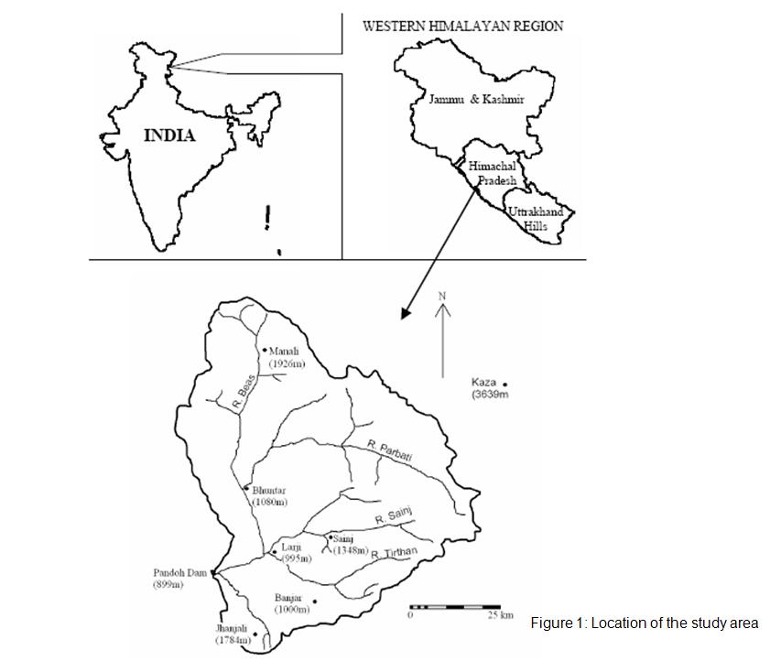

Figure 3.1: Location of the study area.

**3.2.2 Satellite data**

In this study, Terra/Aqua-MODIS satellite data have been used for SCA estimation. The Moderate Resolution Imaging Spectroradiometer (MODIS) employed by Terra and Aqua satellites provides spatially snow covered data with 500m and daily temporal resolution. It delivers public domain data in raster format. The MODIS snow cover product can be ordered free of charge through the Distributed Active Archive Center (DAAC) located at the National Snow and Ice Data Center (NSIDC). The MOD10A1 (MODIS / TERRA SNOW COVER DAILY L3 GLOBAL 500m SIN GRID V005) snow product with 500m spatial was obtained for the study basin for the years of 2000-2005. This data was provided in an Hierarchical Data Format (HDF). This data was re-projected to convert from HDF format into an ERDAS compatible img format for visualization.

The MOD10A2 product has two SDS, namely "Maximum\_Snow\_Extent" and "Eight\_Day\_Snow\_Cover". The "Maximum\_Snow\_Extent" depicts the period where snow was observed on one or more days in the period. The "Eight\_Day\_Snow\_Cover" contains the information of the numbers of days in the eight-day period when snow was observed (Riggs et al., 2006). The present study uses the "Eight\_Day\_Snow\_Cover". The MODIS data products are final output supplied to the user communities after applying all the corrections. Hence, no corrections were needed to be performed.

The MODIS Snow data products were in sinusoidal projection and WGS84 datum. This sinusoidal projection was re-projected to Geographic Lat/Long and WGS84 datum. All the MODIS data products were found to be very accurately geo-referenced.

**3.2.3 DIGITAL ELEVATION MODEL (DEM)**

The Shuttle Radar Topography Mission (SRTM) is an international project led by the U.S. National Geospatial-Intelligence Agency (NGA), U.S. National Aeronautics and Space Administration (NASA), the Italian Space Agency (ASI) and the German Aerospace Center (DLR). SRTM obtained elevation data on a near-global scale to generate the most complete high resolution digital topographic database of Earth, including three resolution products, of 1 km and 90 m resolutions for the world, and a 30 m resolution for the US (USGS, 2004). The elevation data used in this study is the 90 m resolution (3-arc SRTM), which consists of a specially modified radar system that flew onboard the Space Shuttle Endeavour during an 11-day mission in February of 2000. All SRTM data are freely available at: <http://seamless.usgs.gov/Website/> Seamless/. The SRTM-DEM was downloaded from the USGS ftp site. These data are presently supplied free of cost for scientific study. The data were supplied in GeoTIFF format. These DEMs were exported to the format as unsigned 32-bit data in ERDAS Imagine platform. Sometimes variation in pixel intensity (digital numbers) may be caused by differing sensitivities or malfunctioning of the detectors, topographic effects, or/and atmospheric effects. To correct such variations radiometric calibration were carried out. The SRTM-DEM was already projected in Geographic lat/long and WGS84 datum.

**3.3 FIELD INVESTIGATIONS**

To investigate the isotopic signatures, samples of rainfall, snow and streamflow were collected on daily and weekly basis of the study area from April 2010 to March 2013. These samples have been analysed for δ18O and δD and also for water quality analysis. At higher altitudes the melting of snow and ice starts in April in ablation period and continues up to October. During this period, samples from streamflow and rain were collected on daily basis at Manali for isotope analyses and twice in the month for electrical conductivity measurements. The streamflow is sustained by the melting of snow and glacier during the ablation period and delivers the isotopic indices of snow and glacier. From October to April, the streamflow is low as compared to summer and rainy season. For the winter season, samples of streamflow were collected on weekly basis whereas samples from rain and snow were collected as and when these events occurred in the season. For stable isotope measurements, samples were collected into pre-cleaned 20 ml Polypropylene bottles (Tarsons make). These were rinsed profusely at site with sample water and filled with water samples, tightly capped (to prevent evaporation and exchange with the atmospheric moisture) and brought to the laboratory for isotopic and water quality analyses.

The samples have been collected from six sites as shown in Figure 3. . The photographs taken during field visits are shown in Plate 3.1 to 3.7.

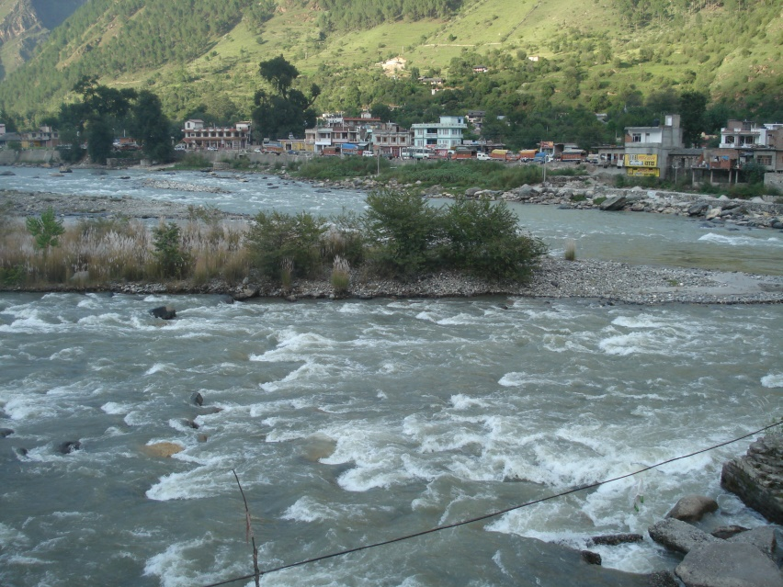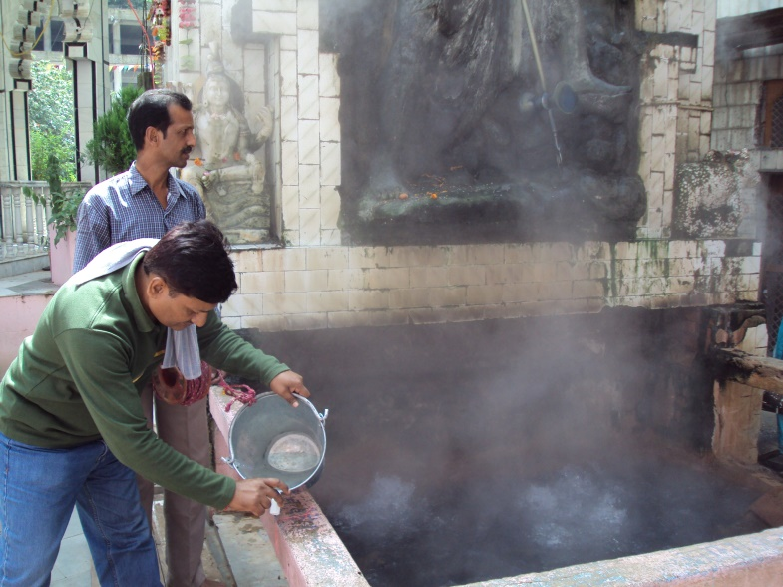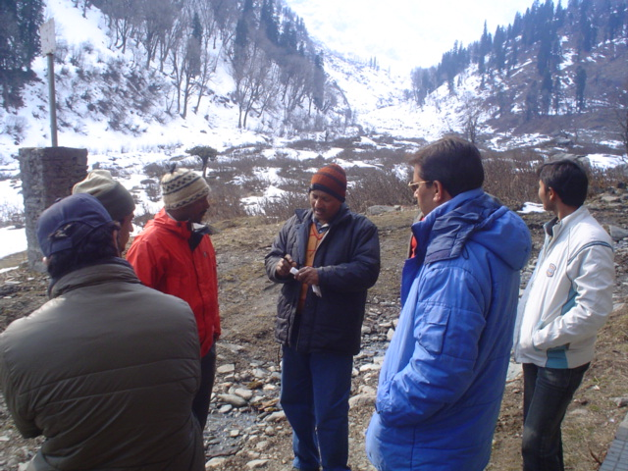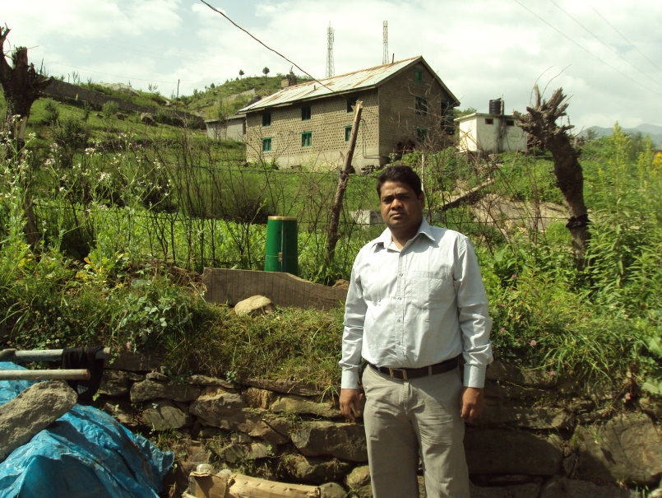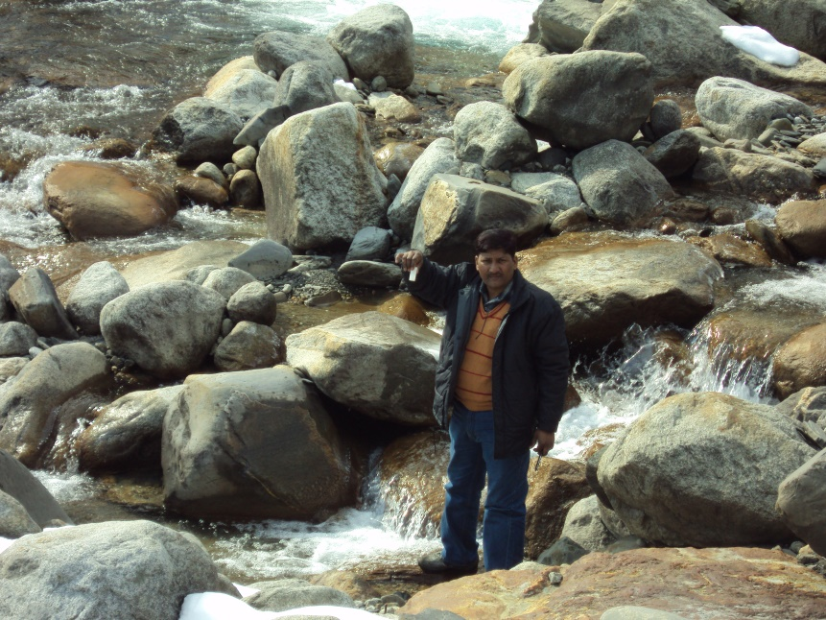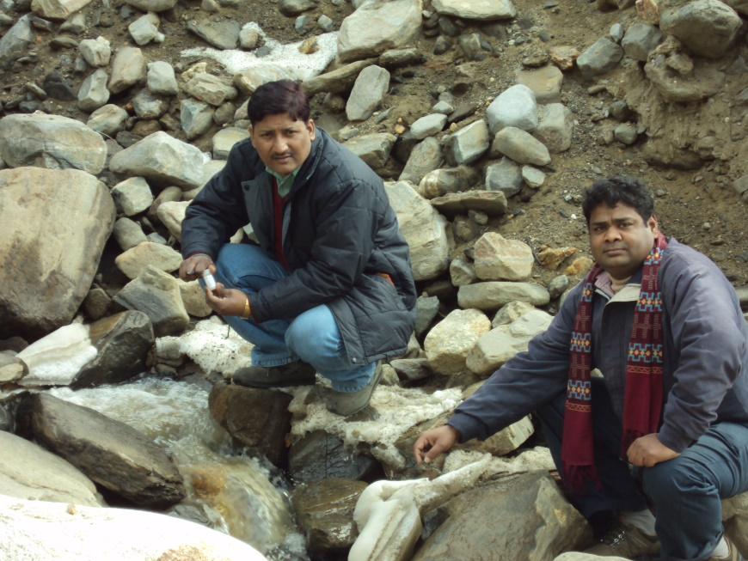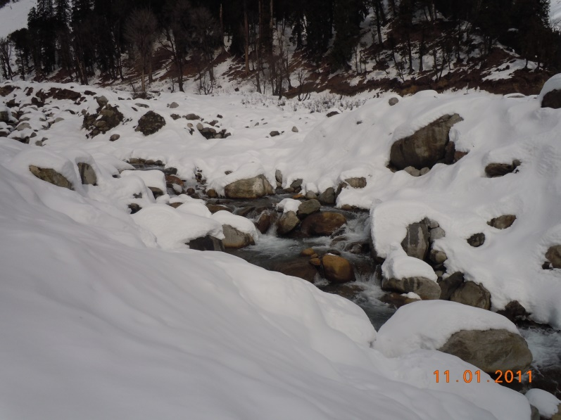**CHAPTER 4.0: TREND ANALYSIS**

Plate 4

Plate 3

Plate 2

Plate 1

Plate 7

Plate 6

Plate 5

**4.1 INTRODUCTION**

Air temperature is generally recognised as good indicator of state of climate globally because of its ability to represent the energy exchange process over the earth’s surface with reasonable accuracy (Vinnikov et. al, 1990; Thapliyal and Kurlshrestha 1991). Temperature drives the hydrological cycle which directly or indirectly influences the hydrological processes. Warmer climate leads to intensification of hydrological cycle which results in higher rates of evaporation and increase of liquid precipitation. Some studies on temperature variation on global scale (Jones et.al 1986a,b; Folland and Parker 1990; IPCC 2001) have established the fact that the earths atmosphere has witnessed a significant warming in last century. The studies in mountainous areas like the Swiss and Polish Alps, the Rockies (Brown et al. 1992; Diaz et. al. 1997; Beniston et al. 1997; Wibig et al. 2002; Beniston 2003; Diaz et al. 2003; Rebetez 2004 and the Andes (Villaba et al. 2003; Vuille et al. 2003) have demonstrated significant rise in air temperatures with alarming effects on their environment.

Several studies in India have been carried out to determine the changes in temperature and rainfall and its association with climate change. Long –term trends in the maximum, minimum and mean temperatures over the north-western Himalaya during he 20th century (Bhutiyani et al. 2007) suggest a significant rise in air temperature in the north-western Himalaya, with winter warming occurring at a faster rate. (Dimri and Ganju 2007) simulated the wintertime temperature and precipitation over the western Himalaya and found that temperature is underestimated and precipitation is overestimated in Himalaya. The changing trends of temperature and precipitation over the western Himalaya were examined and it was found that there was trend of increasing temperature and decreasing precipitation at some specific locations. (Dash et al. 2007) found an increase of 0.9 0C in annual maximum temperature over the western Himalaya. (Sharma et al. 2000) found an increasing trend in rainfall at some stations and a decreasing trend at other stations in the Koshi basin in eastern Nepal and Southern Tibet. Similar trends in rainfall were found by Kumar et al. (2005) for the state of Himachal Pradesh. A slight downward trend in monsoon rainfall and a slight upward trend in winter rainfall during 1964-1992 was analysed for Beas catchment (Singh et al. 2002)

The changes in temperature, precipitation and other climatic variables are likely to influence the amount and distribution of runoff in all river systems globally. No detailed study of trends for hydro climatic data, in particular temperature and precipitation for the Beas basin has been reported. Keeping in the view, in the present study the Beas basin has been selected to comprehend the climate change in the Beas basin up to Pandoh dam by analyzing the instrumental data of air temperature and precipitation on seasonal and annual time scale.

**4.2 DATA USED**

The hydro meteorological data on temperature, rainfall and discharge used in the study have been collected from the office of Bhakra Beas Management Board (BBMB) at Pandoh, Himachal Pradesh as described in chapter 3. The daily maximum and minimum temperature data series (1986-2009) for four distinct stations namely Bhuntar, Larji, Manali and Pandoh located at different altitudes was collected. Available daily rainfall data series (1979-2009) of five stations: Banjar, Bhuntar, Larji, Pandoh and Sainj and the stream flow data series for five stations: Bakhli, Sainj, Thalout, Tirthan and Pandoh were collected. The spatial distribution of hydrometric stations in the study is shown in Figure and their general details is listed in Table 4.1

Table 4.1. Details of the meteorological stations located in the study area.

|  |  |  |  |  |
| --- | --- | --- | --- | --- |
| S. No | Station | Latitude | Longitude | Elevation |
| 1. | Bhuntar | 31° 53' 2" | 77° 8' 51" | 1102 |
| 2. | Larji | 31° 43' 21" | 77° 12' 58" | 950 |
| 3. | Banjar | 31° 38' 8" | 77° 21' 7" | 1353 |
| 4. | Sainj | 31° 46' 0" | 77° 18' 44" | 1043 |
| 5. | Pandoh | 31° 40' 8" | 77° 3' 59" | 899 |
| 6. | Manali | 32° 14' 26" | 77° 11' 37" | 1842 |

**4.3 DATA PREPARATION**

The collected time series for the temperature, rainfall and stream flow was complied and prepared for the analysis. The available daily maximum and minimum temperature data series were used to compute the monthly time series of different variables; maximum (Tmax), minimum (Tmin) average (Tmean), highest maximum (Hmax), lowest minimum (Lmin) and range ((Trange) for all the stations. The daily rainfall data series (1979-2009) of five stations namely Banjar, Bhuntar, Larji, Pandoh and Sainj were used to form monthly totals. Likewise, the monthly totals time series was computed for the five stream flow stations. For investigation of changes in hydro climatic variables at different time scales, a year was divided into four principal seasons:

Pre-monsoon season prevailing from March to May

Monsoon season prevailing from June to September

Post monsoon season prevailing from October to November

Winter season prevailing from December to February

The monthly datasets of temperature, rainfall and stream flow were further used to compute the annual and seasonal time series, which were in turn used for the investigation of trend on annual, seasonal and monthly time scale.

**4.4 METHODOLOGY**

The term trend refers to “general tendency or inclination”. In a time series of any variable, trend depicts the long smooth movement lasting over the span of observations, ignoring the short term fluctuations. It helps to determine whether the values of a series increase or decrease over the time. In statistics, trend analysis referred as an important tool and technique for extracting an underlying pattern of behaviour or trend in a time series which would otherwise be partly or nearly completely hidden by noise. A study of trends may thus focus on the overall pattern of change over time, temporal and spatial comparisons and for making future projections.

Trends in data can be identified by using either parametric or non-parametric methods, and both the methods are extensively used. The parametric methods are considered to be more powerful than the non-parametric methods only when the data series is normally distributed, independent and homogeneous variance (Hamed and Rao 1998). Conversely, non-parametric methods are more advantageous as they only require the data to be independent and are also less sensitive to outliers and missing values.

For detection of trends for climatic studies, the non-parametric methods are widely used for analyzing the trends in several hydro-climatic times series namely rainfall, temperature, pan evaporation, wind speed etc. (Chattopadhyay et. al. 2011; Dinpashoh et. al.; Fu et al. 2004; Hirsch et al. 1982; Jhajharia and Singh 2011; Jhajharia et al. 2009, 2011; Tebakari et al. 2005; Yu et al. 1993).

In the present study to analyze the trends of the hydro-climatic series of each individual station the popular statistical methods; simple regression method (parametric), Mann-Kendall test and Sens’s estimator of slope method (non-parametric) have been applied. The systematic approach has been adopted to determine the trend in three phases. Firstly, a simple linear regression method to test the long term linear trend, secondly, non-parametric Mann Kendall test for the presence of a monotonic increasing or decreasing trend in the time series and Thirdly, the non-parametric Sen’s estimator of slope test to determine the magnitude of the trend in the time series data of meteorological parameters namely temperature, rainfall and stream flow at the basin scale.

**Determination of Anomalies**

For better understanding of the observed trends, first of all seasonal and annual anomalies of temperature and rainfall for each station were computed with reference to the mean of the respective variable for the available records. Further, these anomalies were plotted against time and the trend was examined by fitting the linear regression line. The linear trend value represented by the slope of the simple least square regression provided the rate of rise or fall in the variable

**Regression model**

One of the most useful parametric models to detect the trend is the “Simple Linear Regression” model. The method of linear regression requires the assumptions of normality of residuals, constant variance, and true linearity of relationship (Helsel and Hirsch 1992). The model for Y (e.g. precipitation) can be described by an equation of the form:

Y =at + b (4.1)

Where,

t = time (year)

a = slope coefficient; and

b = least-squares estimate of the intercept

The slope coefficient indicates the annual average rate of change in the hydrologic characteristic. If the slope is significantly different from zero statistically, it is entirely reasonable to interpret that there is a real change occurring over time. The sign of the slope defines the direction of the trend of the variable: increasing if the sign is positive, and decreasing if the sign is negative.

**Magnitude of trend**

The magnitude of trend in a time series was determined using a non-parametric method known as Sen’s estimator (Sen 1968). This method assumes a linear trend in the time series and has been widely used for determining the magnitude of trend in hydro-meteorological time series (Lettenmaier *et al.* 1994; Yue & Hashino 2003; Partal & Kahya 2006). In this method, the slopes (*Ti*) of all data pairs are first calculated by

 for i = 1,2,…,N (4.2)

where *xj* and *xk* are data values at time *j* and *k* (*j* > *k*) respectively. The median of these N values of *Ti* is Sen’s estimator of slope which is calculated as

 (4.3)

A positive value of *β* indicates an upwards (increasing) trend and a negative value indicates a downwards (decreasing) trend in the time series.

**Significance of trend**

To ascertain the presence of a statistically significant trend in hydrologic climatic variables such as temperature, precipitation and streamflow with reference to climate change, the non-parametric Mann–Kendall (MK) test has been employed by a number of researchers (Yu *et al.* 1993, 2003; Douglas *et al.* 2000; Burn *et al.* 2004; Singh *et al.* 2008a, b). The MK method searches for a trend in a time series without specifying whether the trend is linear or non-linear. The MK test was also applied in the present study. The MK test checks the null hypothesis of no trend versus the alternative hypothesis of the existence of an increasing or decreasing trend. Following Bayazit & Onoz (2007), no pre-whitening of the data series was carried out as the sample size is large (n ≥ 50) and slope of the trend was high ( > 0.01).

The statistic *S* is defined as (Salas 1993):

 (4.4)

where *N* is the number of data points. Assuming (*xj – xi*) = *θ*, the value of sgn(*θ*) is computed as follows:

 (4.5)

This statistic represents the number of positive differences minus the number of negative differences for all the differences considered. For large samples (*N* > 10), the test is conducted using a normal distribution (Helsel & Hirsch 1992) with the mean and the variance as follows:

E[S] = 0 (4.6)

 (4.7)

where *n* is the number of tied (zero difference between compared values) groups and *tk*is the number of data points in the *k*th tied group. The standard normal deviate (Z-statistics) is then computed as (Hirsch *et al.* 1993):

 (4.8)

If the computed value of │Z│> zα/2, the null hypothesis *H*0 is rejected at the α level of significance in a two-sided test. In this analysis, the null hypothesis was tested at 95% confidence level.

**4.5 RESULTS AND DISCUSSION**

**Trends in Temperature**

The anomalies of maximum (Tmax), minimum (Tmin), mean (Tmean), highest maximum (Hmax), lowest minimum (Lmin) and range ((Trange) were computed and linear regression analysis was carried out and relationship were developed for linear trends for each station at both seasonal and annual scale graphically shown in Figures. The results of the non parametric Mann-Kendall analysis for the increasing or decreasing trend and their magnitude estimated using Sens slope estimator are presented in Table 4.2 to 4.7.

Table 4.2: Mean Temperature Seasonal and annual linear trends in temperature for stations in Beas basin

|  |  |  |  |  |  |
| --- | --- | --- | --- | --- | --- |
| Season | **Staion** | **Z statistic** | **S** | **Sen Estimator** | **Linear regresion** |
| Annual | Bhuntar | 1.95 | 75 | 0.045 | 0.0373 |
| Larji | 0.9 | 35 | 0.097 | 0.0855 |
| Manali | -1.82 | -70 | -0.088 | -0.0901 |
| Pandoh | 0.01 | 19 | 0.01 | 0.0172 |
| Pre monsoon | Bhuntar | 3.32 | 134 | **0.1** | 0.0986 |
| Larji | 1.48 | 57 | 0.09 | 0.0828 |
| Manali | 0 | -1 | 0 | -0.0035 |
| Pandoh | 2.19 | 89 | **0.043** | 0.0133 |
| Monsoon | Bhuntar | 1.12 | 46 | 0.018 | 0.0169 |
| Larji | 2.01 | 77 | **0.056** | 0.0261 |
| Manali | -1.58 | -61 | -0.081 | -0.071 |
| Pandoh | -0.2 | -9 | -0.006 | 0.0186 |
| Post Monsoon | Bhuntar | 1.27 | 52 | 0.018 | 0.014 |
| Larji | 1.08 | 42 | 0.154 | 0.1398 |
| Manali | -1.58 | -61 | -0.169 | -0.1597 |
| Pandoh | -1.54 | -63 | -0.058 | 0.0002 |
| Winter | Bhuntar | 1.84 | 75 | 0.044 | 0.0499 |
| Larji | 1.8 | 69 | 0.168 | 0.1304 |
| Manali | -1.37 | -53 | -0.137 | -0.1373 |
| Pandoh | -0.22 | -10 | -0.009 | 0.0302 |

Table 4.3: Mean Max Temperature Seasonal and annual linear trends in temperature for stations in Beas basin

|  |  |  |  |  |  |
| --- | --- | --- | --- | --- | --- |
| Season | **Staion** | **Z statistic** | **S** | **Sen Estimator** | **Linear regresion** |
| Annual | Bhuntar | 1.8 | 69 | 0.065 | 0.0612 |
| Larji | 0.05 | 3 | 0.076 | 0.0765 |
| Manali | -1.8 | -69 | -0.233 | -0.2264 |
| Pandoh | 0.95 | 37 | 0.053 | 0.0511 |
| Pre monsoon | Bhuntar | 2.96 | 120 | **0.15** | 0.1387 |
| Larji | 0.94 | 39 | 0.096 | 0.0741 |
| Manali | -1.17 | -48 | -0.11 | -0.1444 |
| Pandoh | 2.75 | 112 | **0.11** | 0.101 |
| Monsoon | Bhuntar | 0.62 | 26 | 0.012 | 0.0154 |
| Larji | 0.52 | 22 | 0.017 | -0.0026 |
| Manali | -1.64 | -63 | -0.2 | -0.2029 |
| Pandoh | 0.4 | 17 | 0.025 | 0.0239 |
| Post Monsoon | Bhuntar | 0.27 | 12 | 0.003 | 0.0068 |
| Larji | 1.34 | 55 | 0.093 | 0.1017 |
| Manali | -1.53 | -59 | -0.372 | -0.3833 |
| Pandoh | -0.35 | -15 | -0.015 | 0.0139 |
| Winter | Bhuntar | 2.58 | 105 | **0.1** | 0.0959 |
| Larji | 2.01 | 82 | **0.112** | 0.1623 |
| Manali | -0.79 | -31 | -0.22 | -0.2291 |
| Pandoh | 1.81 | 74 | 0.067 | 0.0739 |

Table 4.4: Mean Minimum Temperature Seasonal and annual linear trends in temperature for stations in Beas basin

|  |  |  |  |  |  |
| --- | --- | --- | --- | --- | --- |
| Season | **Staion** | **Z statistic** | **S** | **Sen Estimator** | **Linear regression** |
| Annual | Bhuntar | 2.76 | 111 | **0.03** | 0.0285 |
| Larji | 1.9 | 73 | 0.138 | 0.1312 |
| Manali | 1.66 | 68 | 0.05 | 0.0504 |
| Pandoh | -0.58 | -23 | -0.043 | -0.0565 |
| Premonsoon | Bhuntar | 3.44 | 139 | **0.062** | 0.0613 |
| Larji | 1.74 | 67 | 0.1 | 0.1278 |
| Manali | 1.37 | 53 | 0.134 | 0.1491 |
| Pandoh | -0.17 | -8 | -0.002 | -0.0031 |
| Monsoon | Bhuntar | 1.52 | 62 | 0.021 | 0.0197 |
| Larji | 1.85 | 71 | 0.1 | 0.107 |
| Manali | 1 | 39 | 0.067 | 0.0687 |
| Pandoh | -0.97 | -40 | -0.025 | -0.0429 |
| Post Monsoon | Bhuntar | 1.27 | 52 | 0.02 | 0.023 |
| Larji | 1.58 | 61 | 0.196 | 0.2177 |
| Manali | 1.99 | 81 | **0.05** | 0.0517 |
| Pandoh | -1 | -39 | -0.1 | -0.1175 |
| Winter | Bhuntar | -0.15 | -7 | 0 | 0.0061 |
| Larji | 2.75 | 105 | **0.175** | 0.149 |
| Manali | -1.39 | -57 | -0.058 | -0.045 |
| Pandoh | -1.32 | -51 | -0.07 | -0.091 |

Table 4.5: H max Temperature Seasonal and annual linear trends in temperature for stations in Beas basin

|  |  |  |  |  |  |
| --- | --- | --- | --- | --- | --- |
| Season | **Staion** | **Z statistic** | **S** | **Sen Estimator** | **Linear regression** |
| Annual | Bhuntar | 0.15 | 7 | 0.01 | 0.0049 |
| Larji | -1.21 | -49 | -0.091 | -0.1243 |
| Manali | -1.06 | -41 | -0.17 | -0.1696 |
| Pandoh | 0.91 | 37 | 0 | 0.0354 |
| Premonsoon | Bhuntar | 0.4 | 17 | 0.023 | 0.0013 |
| Larji | -1.22 | -47 | -0.2 | -0.2274 |
| Manali | -1.14 | -44 | -0.267 | -0.2604 |
| Pandoh | -0.1 | -5 | 0 | -0.0013 |
| Monsoon | Bhuntar | 0.62 | 26 | 0.032 | 0.0166 |
| Larji | -1.46 | -59 | -0.125 | -0.1365 |
| Manali | -2.47 | -99 | **-0.143** | -0.1457 |
| Pandoh | 0.15 | 7 | 0 | 0.0033 |
| Post Monsoon | Bhuntar | 1.59 | 65 | 0.05 | 0.0623 |
| Larji | 1.71 | 68 | 0.071 | 0.0139 |
| Manali | -1.75 | -67 | -0.235 | -0.2539 |
| Pandoh | 1.03 | 42 | 0.054 | 0.0477 |
| Winter | Bhuntar | 0.17 | 8 | 0.005 | 0.0561 |
| Larji | -0.11 | -5 | 0 | -0.0061 |
| Manali | -1.51 | -58 | -0.383 | -0.3752 |
| Pandoh | 0.95 | 39 | 0.071 | 0.0786 |

Table 4.6: L min Temperature Seasonal and annual linear trends in temperature for stations in Beas basin

|  |  |  |  |  |  |
| --- | --- | --- | --- | --- | --- |
| Season | **Staion** | **Z statistic** | **S** | **Sen Estimator** | **Linear regression** |
| Annual | Bhuntar | -0.07 | -4 | 0 | 0.0182 |
| Larji | 2.01 | 77 | **0.205** | 0.152 |
| Manali | 0.71 | 29 | 0 | 0.0535 |
| Pandoh | -0.74 | -29 | -0.128 | -0.1434 |
| Premonsoon | Bhuntar | 1.19 | 49 | 0.045 | 0.0453 |
| Larji | 0.97 | 39 | 0 | 0.0796 |
| Manali | -0.18 | -8 | 0 | 0.0039 |
| Pandoh | -0.38 | -16 | 0 | -0.0148 |
| Monsoon | Bhuntar | 0.65 | 27 | 0.023 | 0.03 |
| Larji | 2.43 | 93 | **0.083** | 0.1917 |
| Manali | 2.31 | 91 | **0.083** | 0.0978 |
| Pandoh | -1.75 | -70 | -0.063 | -0.0842 |
| Post Monsoon | Bhuntar | -0.2 | -9 | -0.003 | -0.0051 |
| Larji | 1.72 | 66 | 0.2 | 0.2135 |
| Manali | 1.3 | 52 | 0.057 | 0.0778 |
| Pandoh | -1.11 | -43 | -0.154 | -0.1647 |
| Winter | Bhuntar | 0.25 | 11 | 0.011 | 0.0211 |
| Larji | 2.51 | 96 | **0.286** | 0.2211 |
| Manali | 0.56 | 23 | 0 | 0.0622 |
| Pandoh | -1.06 | -41 | -0.114 | -0.1244 |

Table 4.7: Range Temperature Seasonal and annual linear trends in temperature for stations in Beas basin

|  |  |  |  |  |  |
| --- | --- | --- | --- | --- | --- |
| Season | **Staion** | **Z statistic** | **S** | **Sen Estimator** | **Linear regresion** |
| Annual | Bhuntar | 1.84 | 75 | 0.038 | 0.0327 |
| Larji | -1 | -39 | -0.025 | -0.0547 |
| Manali | -1.9 | -73 | -0.22 | -0.2768 |
| Pandoh | 1.06 | 41 | 0.086 | 0.1082 |
| Pre monsoon | Bhuntar | 2.19 | 89 | **0.083** | 0.0774 |
| Larji | -0.9 | -35 | -0.026 | -0.0537 |
| Manali | -1.53 | -59 | -0.25 | -0.2935 |
| Pandoh | 1.43 | 55 | 0.1 | 0.1063 |
| Monsoon | Bhuntar | -0.32 | -14 | -0.002 | -0.0043 |
| Larji | -1.43 | -55 | -0.1 | -0.1097 |
| Manali | -1.8 | -69 | -0.252 | -0.2716 |
| Pandoh | 1.24 | 51 | 0.05 | 0.0667 |
| Post Monsoon | Bhuntar | -0.37 | -16 | -0.012 | -0.0162 |
| Larji | -1.89 | -77 | -0.124 | -0.116 |
| Manali | -1.95 | -75 | -0.4 | -0.4351 |
| Pandoh | 0.37 | 15 | 0.12 | 0.1314 |
| Winter | Bhuntar | 2.24 | 91 | **0.089** | 0.0898 |
| Larji | 0.2 | 9 | 0.015 | 0.0132 |
| Manali | -1.8 | -69 | -0.15 | -0.1841 |
| Pandoh | 1.45 | 56 | 0.15 | 0.1649 |

Trend analysis of annual mean temperature indicates rising trend at Bhuntar, Larji and Pandoh and deceasing trend at Manali station. None of these trends is found statistical significant. During pre-monsoon season, all the stations indicated rising trend with rising trend at Bhuntar and Pandoh statistically significant at 95% confidence level. During monsoon, post monsoon and winter seasons two stations (Bhuntar and Larji) experienced rising trend and remaining two stations (Manali and Pandoh) experienced decreasing trend. The rising trend at Larji during monsoon season was only statistically significant at 95% confidence.

Analysis of mean maximum temperature show increasing non-significant at Bhuntar, Larji and Pandoh and decreasing (non-significant) at Manali.. The maximum increase is found for Larji and minimum decrease for Pandoh. Seasonal analysis indicated increasing trend for Bhuntar and Larji during all seasons, decreasing trend for Manali. For all seasons an increasing trend for Pre-monsoon monsoon, winter season for Pandoh and decreasing trend during post monsoon for Pandoh. The increasing trend during pre-monsoon and winter at Bhuntar, during winter season at Larji and during pre-monsoon season at Pandoh were found statistically significant.

Analysis of mean minimum temperature shows increasing trend was observed during pre-monsoon season at three stations namely Bhuntar, Larji, Manali and also during winter season at Larji station. The Pandoh station showed decreasing trend in mean minimum temperature for all four seasons with maximum decrease (-0.1 0C/yr) in post monsoon season. During winter season, decreasing trend was observed at Manali whereas Bhuntar station showed no trend. Looking at the Annual mean minimum temperature, it is found that Bhuntar, Larji and Manali indicated positive trend and Pandoh indicated negative trend, with increasing trend at Bhuntar found to be statistically significant.

Analysis of highest maximum temperature at annual scale indicates increasing trend at Bhuntar station, decreasing trend at Larji and Manali stations and no trend at Pandoh station. No trend is found statistically significant. Seasonal data analysis showed increasing trend for all seasons for Bhuntar; decreasing trend for all seasons for Manali and decreasing trend in Pre and monsoon seasons and increasing trend in post monsoon season at Larji; increasing trend during post and winter season at Pandoh. Decreasing trend in monsoon season at Manali is found statistically significant.

Increasing trend (significant) for Larji and decreasing trend (non-significant) at Pandoh station was observed for annual lowest minimum temperature. During the pre-monsoon season, lowest minimum temperature was found to be stable at all stations except at Bhuntar where it is found increasing. During monsoon season, all stations except Pandoh experienced increasing trend in lowest minimum temperature. In winter seasons lowest minimum temperature is found increasing for Bhuntar, Larji and decreasing at Pandoh station.

Analysis of annual data of range in temperature indicated increasing trend at Bhuntar and Pandoh and decreasing trend at Larji and Manali. Non of these trends is found statistically significant. Seasonal analysis indicates increasing trend at Pandoh and decreasing trend at Manali in all seasons. For Bhuntar, it is found increasing during pre-monsoon and winter (significant) and for Larji station, it is found increasing during winter season.

Out of the four stations the magnitude of change varies from greatest at Larji (0.076 oC/year) to lowest at Manali (-0.2330 0C/year) at annual scale. Also, Larji shows the highest slope values for mean (0.097 0C/year), max (0.0765 0C/year), minimum (0.138 0C/year) temperature at annual scale. The slope magnitude was higher in premonsoon season in comparison to other seasons except Larji.

**4.6 TRENDS IN RAINFALL**

**Rainfall**

**General characteristics of rainfall**

Mean seasonal, mean annual and coefficient of variation of the annual rainfall are given in Table 4.8. The mean annual rainfall varies from 915.8 mm at Bhuntar to 1335.9 mm at Pandoh (for the period 1979-2009). The coefficient of variation (CV) of the annual rainfall varies from 20.3% at Banjar to 33.3% at Sainj. It is evident from the Table 7 that all the stations receive maximum rainfall during the monsoon season and least rainfall is received during the Post monsoon season. The contribution of monsoon rainfall varies from 39 % (Bhuntar) to 74% (Pandoh), while contribution of Pre monsoon season varies from 14% (Pandoh) to 30 % (Bhuntar).

Table 4.8: Seasonal distribution of rainfall at different stations in Beas basin

|  |  |  |  |  |  |  |  |  |  |  |
| --- | --- | --- | --- | --- | --- | --- | --- | --- | --- | --- |
| Station | Annual | | Pre monsoon | | Monsoon | | Post Monsoon | | Winter | |
| Mean | CV | Mean | % of annual | Mean | % of annual | Mean | % of annual | Mean | % of annual |
| Bhuntar | 915.8 | 21.2 | 278 | 30 | 359 | 39 | 52 | 6 | 226 | 25 |
| Larji | 1009.4 | 24.8 | 242 | 24 | 525 | 52 | 50 | 5 | 193 | 19 |
| Banjar | 997.9 | 20.3 | 253 | 25 | 526 | 53 | 40 | 4 | 175 | 18 |
| Sainj | 1059.4 | 33.3 | 268 | 25 | 555 | 52 | 45 | 4 | 191 | 18 |
| Pandoh | 1335.9 | 21.6 | 183 | 14 | 990 | 74 | 34 | 3 | 124 | 9 |

***Anomalies***

The anomalies of rainfall and their trends were determined for all the stations considered in the study. Anomalies in annual rainfall and their trends for the stations within the study area are shown in figure 4.1.



Figure 4.1: Anomalies in annual rainfall (% of mean) and trends at selected stations in Beas basin

***Rainfall trends***

The magnitude of the trend in the time series as determined using the Sen’s estimator is given in Table 4.9. The annual rainfall indicates increasing trend at one station namely Banjar and decreasing trend at all other four stations with maximum decrease (-8.07mm/year) at Sainj. The increasing trend at Banjar is of the order of 8.3 mm/year.

Seasonal analysis of rainfall trends shows that all stations during pre-monsoon, post-monsoon and winter season experienced decreasing trend whereas all stations experienced increasing trend in monsoon season. In monsoon season, the maximum increase is of the order of 11.91 mm/year for Banjar and minimum increase is for Pandoh (2.86 mm/year). In pre-monsoon season, the maximum decrease is for Sainj (-9.21 mm/year) and minimum decrease is for Banjar (-2.72 mm/year). In seasons other than monsoon and pre-monsoon, the magnitude of change was quite small.

The results of Mann-Kendall test applied to annual and seasonal rainfall at different stations indicates that none of the station show either increasing or decreasing significant trend in annual rainfall. Monsoon rainfall indicated positive significant trend at Banjar and Bhuntar. Pandoh station in the winter season and three stations (Bhuntar, Larji and Sainj) in pre-monsoon season showed negative significant trend in rainfall. In post-monsoon season, all decreasing trends are found non-significant.

Table 4.9: Rainfall Seasonal and annual linear trends in temperature for stations in Beas basin

|  |  |  |  |  |  |
| --- | --- | --- | --- | --- | --- |
| **Season** | **Station** | **Z statistic** | **S** | **Sen Estimator** | **Linear regresion** |
| Annual | Bhuntar | -0.54 | -33 | -2.667 | -2.0339 |
| Larji | -0.07 | -5 | -0.166 | 0.3791 |
| Banjar | 1.63 | 97 | 8.3 | 8.5655 |
| Pandoh | -1.22 | -73 | -7.46 | -9.0945 |
| Sainj | -0.99 | -59 | -8.067 | -5.3716 |
| Pre monsoon | Bhuntar | -2.14 | -121 | **-7.383** | -5.9845 |
| Larji | -2.19 | -130 | **-5.56** | -4.1214 |
| Banjar | -0.88 | -53 | -2.72 | -1.7135 |
| Pandoh | -1.28 | -73 | -4.55 | -5.2586 |
| Sainj | -1.96 | -111 | **-9.211** | -7.135 |
| Monsoon | Bhuntar | 2.65 | 157 | **5.936** | 5.5586 |
| Larji | 1.36 | 81 | 5.141 | 5.2977 |
| Banjar | 3.09 | 183 | **11.907** | 11.605 |
| Pandoh | 0.59 | 36 | 2.865 | 0.7993 |
| Sainj | 1.12 | 67 | 6.147 | 4.957 |
| Post Monsoon | Bhuntar | -0.58 | -35 | -0.531 | -0.427 |
| Larji | -0.6 | -36 | -0.333 | 0.055 |
| Banjar | -0.95 | -57 | -0.522 | -0.1906 |
| Pandoh | -0.99 | -59 | -0.727 | -0.8821 |
| Sainj | -1.29 | -77 | -0.736 | -1.021 |
| Winter | Bhuntar | -0.44 | -27 | -0.74 | -1.3051 |
| Larji | -0.48 | -29 | -0.686 | -0.8147 |
| Banjar | -0.59 | -36 | -1.038 | -1.4156 |
| Pandoh | -2.55 | -151 | **-3.38** | -3.5823 |
| Sainj | -1.39 | -83 | -3.083 | -2.4339 |

**Trends in stream flow**

Stream flow

The anomalies of discharge data were computed and linear regression analysis was carried out and relationship was developed for linear trends for each station at both seasonal and annual scale graphically shown in Figures. The results of Mann-Kendall test applied to annual and seasonal discharge series at different stations (Table 4.10 ) Analysis of discharge at different sites in the Beas river basin indicated decreasing trend of annual discharge at Bakhli, Pandoh and Thalout station and increasing annual discharge at Sainj and Tirthan site. All these trends are found non-significant at 95% confidence level. Analysis of seasonal data indicated decreasing trend (non-significant) of pre-monsoon discharge for all stations; decreasing trend (non-significant) of monsoon discharge at Bakhli, Pandoh and Thalout sites and increasing trend (non-significant) of monsoon discharge at other two sites namely Sainj and Tirthan. Discharge in post-monsoon season showed increasing trend at Bakhli and Sainj and decreasing trend at Pandoh and Thalout stations. Winter season discharge indicated decreasing trend at all stations except Bakhli.

Table 4.10: Discharge seasonal and annual linear trends in temperature for stations in Beas basin

|  |  |  |  |  |  |
| --- | --- | --- | --- | --- | --- |
| **Season** | **Station** | **Z statistic** | **S** | **Sen Estimator** | **Linear regresion** |
| Annual | Bhakli | -0.1 | -7 | -0.003 | -0.003 |
| Pandoh | -1.13 | -58 | -0.996 | -181.04 |
| Sainj | 0.92 | 58 | 0.119 | 0.0536 |
| Thalout | -1.24 | -64 | -0.924 | -1.076 |
| Tirthan | 0.48 | 35 | 0.08 | 0.2235 |
| Premonsoon | Bhakli | -0.63 | -40 | -0.051 | -0.051 |
| Pandoh | -1.4 | -72 | -1.702 | -166.31 |
| Sainj | -1.12 | -70 | -0.131 | -0.1009 |
| Thalout | -1.44 | -74 | -1.65 | -1.5659 |
| Tirthan | -0.96 | -60 | -0.196 | 0.0053 |
| Monsoon | Bhakli | -0.6 | -38 | -0.052 | -0.0206 |
| Pandoh | -0.49 | -26 | -0.846 | -323.03 |
| Sainj | 1.49 | 93 | 0.362 | 0.3104 |
| Thalout | -0.57 | -30 | -0.72 | -1.4486 |
| Tirthan | 0.75 | 47 | 0.263 | 0.3951 |
| Post Monsoon | Bhakli | 1.64 | 102 | 0.074 | 0.0615 |
| Pandoh | -0.34 | -18 | -0.145 | -103.97 |
| Sainj | 0.51 | 31 | 0.017 | -0.021 |
| Thalout | -0.57 | -30 | -0.256 | -0.2416 |
| Tirthan | 0.37 | 23 | 0 | 0.2539 |
| Winter | Bhakli | 0.05 | 4 | 0.016 | 0.0167 |
| Pandoh | -3.1 | -158 | **-0.539** | -55.215 |
| Sainj | -0.65 | -39 | -0.079 | -0.0885 |
| Thalout | -3.65 | -186 | **-0.558** | -0.5693 |
| Tirthan | -0.07 | -5 | -0.037 | 0.1709 |

**CHAPTER 5: SNOWMELT RUNOFF MODELLING**

In this chapter first principle of snowmelt runoff mdoelling is presented and then application of the model in the present study including results obtained have been discussed and presented.

**5. 1 SNOWMELT RUNOFF MODELLING**

The conversion of snow and ice into water is called snowmelt, which needs input of energy (heat). Hence the process of snowmelt is linked to the flow and storage of energy into and through the snowpack (USACE, 1998). Snowmelt models have two basic approaches towards calculating the amount of snowmelt occurring from a snowpack: energy budget method and temperature index method. The energy budget approach attempts to make the process as physically based as possible. The goal is to simulate all energy fluxes occurring within the snowpack to give an accurate account of total snowmelt in response to each of these energy fluxes over time and space. This approach is extremely data intensive, requiring vast amounts of input data either to force an initial run of a model, or to calibrate it based on historical data before running a forecast. Too often, this approach suffers from inadequate data supply or simply that the level of data is unwarranted for the purpose at hand. In light of the intensive data requirements necessary for the energy budget approach, an alternative method known as the temperature index or degree day approach allows for snowmelt calculation with much less data input. The basis of the temperature index approach is that there is a high correlation between snowmelt and air temperature due to the high correlation of air temperature with the energy balance components which make up the energy budget equation (Semádeni- Davies, 1997; Ohmura, 2001; Hock, 2003).

There are several temperature index based snowmelt models like SNOWMOD, the SSARR Model, the HEC-1 and HEC-1F Models, the NWSRFS Model, the PRMS Model, the SRM, the GAWSER Model. The Snow Melt Runoff (SRM) model is widely used for snowmelt modeling in Himalayan basin. The SRM uses snow-covered area as input instead of snowfall data, but it does not simulate the base flow component of runoff. In other words, SRM does not consider the contribution to the groundwater reservoir from snowmelt or rainfall, nor its delayed contribution to the stream flow in the form of base flow, which can be an important component of runoff in the Himalayan Rivers, and plays an important role in making these rivers perennial. Almost all the stream flow during winter, when no rainfall or snowmelt occurs, is generated from the base flow (Singh and Jain, 2003). The SNOWMOD model (Jain, 2001, Singh and Jain, 2003) is unique in this aspect as it simulates all components of runoff, i.e. snowmelt runoff, rainfall-induced runoff and base flow, using limited data.

The snowmelt model (SNOWMOD) is a temperature index model, which is designed to simulate daily stream flow for mountainous basins having contribution from both snowmelt and rainfall. The generation of stream flow from such basins involves the determination of the input derived from snowmelt and rain, and its transformation into runoff. It is a semi-distributed model and for simulating the stream flow, the basin is divided into a number of elevation zones and various hydrological processes relevant to snowmelt and rainfall runoff are evaluated for each zone. The model achieves three operations at each time step. At first, the available meteorological data are extrapolated at different altitude zones. Then the rate of snowmelt is calculated at each time step. Finally, the snowmelt runoff from SCA and rainfall runoff from SFA (snow-free area) are integrated, and these components are routed separately with proper accounting of base flow to the outlet of the basin. The model optimizes the parameters used in routing of the snowmelt runoff and rainfall runoff. Figure 2 schematically shows the different steps involved in the model. Details of computation of melt runoff and generation of stream flow from the basin are discussed below.

**5.2 INPUT DATA**

In order to execute SNOWMOD model, the following input data are required:

* Physical features of the basin, which include snow covered area, elevation bands and their areas, altitude of meteorological stations, and other watershed characteristics affecting runoff.
* Time variable data include precipitation, air temperatures, snow-covered area, stream flow data, and other parameters determining the distribution of temperature and precipitation.
* Information on the initial soil moisture status of the basin.
* Miscellaneous job control and time control data, which specify such items as total computation period, routing intervals etc.

**5.3 MODEL VARIABLES AND PARAMETERS**

**5.3.1 Division of catchment into elevation bands**

There are two approaches for defining a computer model of a watershed; a lumped model, which does not take into account spatial variability of processes, and a distributed model, which consider these. A lumped model is a simple approach and can be applied for basins that have a wide variety of physical features. However, the major limitation with these models is that it does not run beyond a single event (USACE, 1998). Distributed model on the other hand can be run for continuous simulation. In such models, the watershed is divided into subunits with variables being computed separately for each. This method of subdividing the basin is logical one, since in mountainous areas hydrological and meteorological conditions are typically related to elevation.

SNOWMOD is a semi distributed hydrological model, which allows the basin to be divided into number of bands. The number depends upon the topographic relief of the basin. There is no specified criteria for slicing the basin in different altitudinal, but an altitude difference of about 500 to 600 m is considered appropriate for dividing the basin into different elevation bands. Precipitation input for each band is the sum of snowmelt and rainfall. Runoff for each band is computed from watershed runoff characteristics developed for that particular band. Stream flow for the whole basin is obtained by summing the runoff synthesized for all elevation bands. The program stores a value for each component of flow and each routing increment for every elevation band. It maintains an inventory of snow cover area, soil moisture, snow accumulation, and all other values required for making the computation for the next period.

**5.3.2 Precipitation data and distribution**

The most challenging object of hydrological simulation of a mountain basin is the measurement of meteorological variables. The major problems posed in high mountain areas are the accessibility to the mountains on a continuous basis, the accuracy of measured meteorological variables, and the areal representativeness of measurements (Panagoulia, 1992). It has been observed that the most important factor in accurate estimation of snowmelt runoff is the assumptions of the spatial distribution and form of precipitation. In a distributed model, it is very essential to distinguish between rain and snow in each elevation band because these two form of precipitation behaves very differently in terms of contribution to the stream flow. Rainfall contributes faster to the stream flow whereas snowfall is stored in the basin until it melts. The form of precipitation is influenced by two factors; meteorological and topographical. Meteorological factors includes air temperature, lapse rate, wind etc and topographical factors include elevation, slope, aspect, vegetation cover etc. Snow falling through warmer atmosphere or melting level air temperature melts and falls as rain. Similarly, snow falls at elevation above melting level and rain falls at elevation below melting level.

A critical temperature, Tc, is specified in the model to determine whether the measured precipitation is rain or snow. In the present study, Tc is considered to be 2ºC as suggested by Singh and Jain, 2003. The algorithm used in the model to determine the form of precipitation is as follows:

If Tm ≥ Tc, all precipitation is considered as rain

If Tm ≤ 0°C, all precipitation is considered as snow

where Tm is mean air temperature. In the cases Tm ≥ 0°C and Tm ≤ Tc, the precipitation is considered as a mixture of rain and snow and their proportion is determined as follows:

 (5.1)

 (5.2)

where P is the total observed precipitation.

**5.3.3 Temperature data – Space and time distribution and Lapse Rate**

Air temperature has a logical connection with many of the energy exchanges involved in snowmelt. Also it is the meteorological variable which is readily available to hydrologists in historical and near real time. Hence air temperature is the most widely used index in snowmelt (Sorman, 2005). Daily mean temperature is the most commonly used parameter in snowmelt computation. For the present study daily mean air temperature is calculated by using the equation given below;

**** (5.3)

For the Beas basin, the daily maximum and minimum air temperature data were available for four meteorological stations namely Pandoh, Bhunter, Largi and Manali. Daily mean air temperature was calculated using equation (5.3). As mentioned earlier, the basin is divided into nine elevation bands. For each band, a base station is assigned as given in table 5.1 and 5.2. For corresponding band, the temperature data was interpolated using the air temperature data of different stations and lapse rate data.

Table 5.1: Beas basin area covered in different elevation band

|  |  |  |  |
| --- | --- | --- | --- |
| Zones | Elevation range (m) | Area (km2) | Percentage |
| 1 | 600-1200 | 77.34 | 1.46 |
| 2 | 1200-1800 | 467.56 | 8.84 |
| 3 | 1800-2400 | 823.90 | 15.57 |
| 4 | 2400-3000 | 954.12 | 18.03 |
| 5 | 3000-3600 | 713.2 | 13.47 |
| 6 | 3600-4200 | 659.63 | 12.46 |
| 7 | 4200-4800 | 811.53 | 15.33 |
| 8 | 4800-5400 | 691.51 | 13.06 |
| 9 | >5400 | 94.10 | 1.78 |

Table 5.2: Raingauge and temperature stations used for different bands

|  |  |  |  |
| --- | --- | --- | --- |
| Band | Elevation range(m) | Raingauge  station | Temperature station |
| 1 | 600-1200 | Pandoh | Pandoh |
| 2 | 1200-1800 | Largi | Bhunter |
| 3 | 1800-2400 | Manali | Largi |
| 4 | 2400-3000 | Manali | Manali |
| 5 | 3000-3600 | Manali | Manali |
| 6 | 3600-4200 | Sainj | Manali |
| 7 | 4200-4800 | Sainj | Manali |
| 8 | 4800-5400 | Sainj | Manali |
| 9 | >5400 | Sainj | Manali |

The rate with which the temperature changes with increase in elevation is called as lapse rate. Lapse rate is not a constant value but changes with season and region. Lapse rates are known to be quite variable, ranging from high values of about the dry adiabatic lapse rate to low values representing inversion conditions. For example, during continuous rainstorm conditions the lapse rate will approximate the saturated adiabatic rate, whereas under clear sky & dry weather conditions, the lapse rate during the warm part of the day will tend to the dry adiabatic rate. During the night, under clear sky conditions, radiation cooling will cause the temperature to fall to the dew point temperature, and this is particularly true for a moist air mass. As a result, night-time lapse rates under clear skies will tend to be quite low, and at times even zero lapse rates will occur (Jain, 2001).

The daily temperature in the various elevation bands have been calculated by using the temperature lapse rate approach, by extending data from the base station by the following equation,

/ 100 (5.4)

Where,Ti,j = daily mean temperature on ith day in jth zone (oC)

Ti,base = daily mean temperature (oC) on ith day at the base station

hj = zonal hypsometric mean elevation (m)

hbase  = elevation of base station (m)

* + = Temperature lapse rate in oC per 100 m

**5.3.4 Degree days**

Degree-days are the departures of temperature above or below a particular threshold value. Generally a threshold temperature of 0ºC is used, with snowmelt considered to have occurred if the daily mean temperature is above 0ºC. This follows from the idea that most snowmelt results directly from the transfer of heat from the air in excess of 0°C. The difference between the daily mean temperature and this threshold value is calculated as the degree-day. Snowmelt-runoff models, which incorporate a degree-day or temperature index routine, are the most commonly used in operational hydrology and have been successfully verified world-wide over a range of catchment sizes, physical characteristics and climates (WMO, 1986; Bergstrom, 1992; Rango, 1992, Davies, 1997). An early application of a degree-day approach was made by Finsterwalder and Schunk (1887) in the Alps and since then this approach has been used widely all over the world for the estimation of snowmelt (Martinec et al., 1994; Quick and Pipes, 1995). The basic form of the degree-day approach is:

 (5.5)

Where,

M = daily snowmelt (mm/day)

D = degree-day factor (mm ° C-1 day-1)

Tair = index air temperature (°C)

Tmelt = threshold melt temperature (usually, 0°C)

Although air temperature and other hydrological variables vary continuously throughout the day, the daily mean air temperature is the most commonly used index temperature. When daily maximum (Tmax) and minimum (Tmin) air temperature is available, daily mean air temperature is calculated as

**** (5.6)

**5.3.5 Degree Day Factor**

The degree-day method is popular because temperature is a reasonably good measure of energy flux, and, at the same time, it is a reasonably easy variable to measure, extrapolate, and forecast (Martinec and Rango, 1986). The degree-day factor, D, is an important parameter for snowmelt computation and converts the degree-days to snow melt expressed in depth of water. D is influenced by the physical properties of snowpack and because these properties change with time, therefore, this factor also changes with time. The seasonal variation in melt factor is well illustrated by the results obtained from the study reported by Anderson (1973); the lower value being in the beginning of melt season and higher towards the end melt season. A wide range of values have been reported in the literature with a general increase as the snowpack ripens. For example, Garstaka (1964) reported extreme values of Df as low as 0.7 mm per °C per d and as high as 9.2 mm per °C per d. Yoshida (1962) reported the values of D to be between 4.0 to 8.0 mm per °C per day, depending on the location, time of year and meteorological conditions. Singh and Kumar (1996) determined the D factor by monitoring a known snow surface area of the snow block within the snowpack at an altitude of about 4000m in the western Himalayan region in the summer. The mean daily value of the D was computed to be 5.94 mm °C-1 d-1, while for a dusted block it increased to 6.62 mm °C-1 d-1. In glacierized basins, the degree-day factor usually exceeds 6 mm °C-1 d-1 towards the end of summer when ice becomes exposed (Kotlyakov and Krenke, 1982). As discussed above that D changes with season, therefore, when using degree-day approach, changes in D with season should be taken into account. In the present study in the starting of melt season for every month low value of degree-day factor has been taken and it goes on increasing till the end of melt season i.e. the month of September. The range of the values of various parameter used in this study is given Table 5.3.

Table 5.3: Parameter values used in calibration of model

|  |  |  |  |
| --- | --- | --- | --- |
| S. No. | Parameter | Symbol | Value |
| 1. | Degree-day factor | D | 3.0 – 7.0 mm.oC-1.day-1 |
| 2. | Runoff coefficient for rain | Cr | 0.40 - 0.70 |
| 3. | Runoff coefficient for snow | CS | 0.50 – 0.80 |
| 4. | Temperature lapse rate | δ | Seasonally varying |
| 5. | Critical temperature | Tc | 2o C |
| 6. | Number of linear reservoirs  for snow free area | Nr | 2 |
| 7. | Number of linear reservoirs  for snow covered area | NS | 1 |
| 8. | Number of linear reservoirs  for subsurface flow | Nb | 1 |

**5.3.6 Rain on snow**

Rain-on-snow event is hydrologically an important phenomenon as most of the floods in British Columbia, Washington, Oregon and California were reported to have occurred due to this event (Colbeck, 1975; Kattelmann 1987; Brunengo, 1990; Berg et al., 1991; Archer et al., 1994). Further, this event is one of the prime causes of avalanches as rain falling over snow weakens the bond between the snowpacks thereby reducing the mechanical strength of the snowpack (Conway et. al, 1988; Heywood, 1988; Conway and Raymond, 1993).

When rain falls on snowpack it is cooled to the temperature of snow. The heat transferred to the snow by rainwater is the difference between its energy content before falling on the snow and its energy content on reaching thermal equilibrium within the snowpack. For snowpacks isothermal at 0°C, the release of heat results in snowmelt, while for the colder snowpack this heat tends to raise the snowpack temperature to 0ºC. In case the snowpack is isothermal at 0°C, the melt occurring due to rain is computed by (Jain, 2001)

 (5.7)

where

Mr = melt caused by the energy supplied by rain (mm/day)

Tr = temperature of the rain (°C)

Pr = depth of rain (mm day-1)

Only high rainfall events occurring at higher temperatures would cause the melting due to rain, otherwise this component would not be significant (Singh et al., 1997).

**5.4 COMPUTATION OF DIFFERENT RUNOFF COMPONENTS**

The stream flow from a snow fed river has three components namely,

* runoff from the snow-covered area,
* runoff from snow free-area and
* base flow

The runoff contributed from all the three components are computed separately for each elevation band and the output from all the bands are integrated to provide the total runoff from the basin.

**5.4.1 Surface runoff from snow covered area**

Runoff contributed from snow-covered area consists of

* Snowmelt triggered by the increase in air temperature above melting temperature
* Under rainy conditions, melt caused by the heat transferred to the snow surface by the rain
* Runoff from the rain itself falling over snow covered area

1. Snowmelt caused by the increase in air temperature has been estimated by degree-day approach. In this approach degree-day factor is used to convert degree-day into snowmelt expressed in depth of water.

**** (5.8)

Where,

Ms,i,j = snowmelt on ith day for jth band (mm)

Cs,i,,j  = coefficient of runoff for snow on ith day for jth band

Di,j = degree-day factor on ith day for jth band (mm.oC-1d-1)

Ti,j = temperature on ith day for jth band (oC)

Sc,i,,j = Ratio of snow covered area to the total area of jth band on ith day

1. Runoff depth from the snowmelt contributed by the heat transferred from rain falling over a snow pack is given by the equation described in section 6.5.7

**** (5.9)

where, Mr,i,j = snowmelt due to rain on snow on ith day for jth band (mm)

Pi,j = rainfall on snow on ith day for jth band (mm)

1. Runoff depth from rain itself falling over the snow-covered area, Rs, is given by

 (5.10)

For the computation of runoff from rain, the coefficient Cs is used (not the rainfall runoff coefficient, Cr), because the runoff from the rain falling on the SCA behaves like the runoff from the melting of snow.

The daily total discharge from the SCA is computed by adding the contribution from each elevation zone. Thus, discharge from the SCA, QSCA, for all the zones are given by:

 (5.11)

Where, n = total number of zones or bands.

ASCA = snow-covered area (km2) in the jth zone on the ith day

α = factor (1000/86400 or 0.0116) used to convert the runoff depth (mm day-1) into discharge (m3 s-1).

This discharge is routed to the outlet of the basin following the procedure described in the later section.

**5.4.2 Surface runoff from snow-free area**

The only source of surface runoff from snow-free area (SFA) is rainfall. Like snowmelt runoff computations, runoff from the SFA is computed for each zone using the following expression:

****  (5.12)

where, Cr,i,j  = coefficient of runoff for rain on ith day for jth band

Pi,j = rainfall on snow on ith day for jth band (mm)

Sf,i,j = Ratio of snow free area to the total area of jth band on ith day.

Because SCA and SFA are complimentary to each other, Sf,i,j can be directly calculated as 1 – Sc,i,j. The total runoff from SFA, QSFA for all the zones is thus given by:

 (5.13)

Where, ASFA,j,,j = snow-free area in the jth zone on the ith day

The discharge from the SFA is also routed to the outlet of the basin before adding it to the other components of discharge.

**5.4.3 Estimation of subsurface runoff**

The subsurface flow or baseflow represents the runoff from the unsaturated zone of the basin to the streamflow. After accounting for the direct surface runoff from snowmelt and rainfall, the remaining water contributes to the groundwater storage through infiltration and appears at the outlet of the basin with much delay as subsurface flow or baseflow. Depletion of this groundwater storage also results from evapo-transpiration and percolation of water to the deep groundwater zone. It is assumed that half of the water percolates down to shallow groundwater and contributes to baseflow, while the rest is accounted for by the loss from the basin in the from of evapo-transpiration and percolation to the deep groundwater aquifer, which may appear further downstream or become part of deep inactive groundwater storage. The depth of runoff contributing to baseflow from each zone is given by:

 (5.14)

where Mt,i,j = Ms,i,j + Mr,i,j + Rs,i,j and β is 0.50. The baseflow, Qb, is computed by multiplying the depth of runoff by the conversion factor α and area, and is given as:

 (5.15)

where A is the total area (km2) and represents the sum of ASCA and ASFA. This component is also routed separately.

**5.4.4 Total runoff**

The daily total streamflow from the basin is calculated by adding the three different routed components of discharge for each day.

**** (5.16)

As discussed above, the direct runoff results from overland or near surface flow, while baseflow is regarded as being a result of groundwater contribution into the stream. Infact, the contribution to baseflow starts only after the topsoil is saturated. In order to consider the soil moisture deficit, soil moisture index (SMI) has been considered in the present study.

**5.5 EFFICIENCY CRITERIA OF THE MODEL**

Numerous statistical criteria are available for numerical evaluation of model accuracy in each single year, in a particular season of the year, or a sequence of years or seasons. In a study of snowmelt models, the World Meteorological Organization (WMO, 1986) suggests several efficiency criteria that are particularly useful for snowmelt modeling. The most important criteria for model evaluation identified in the WMO study are the visual inspection of linear scale plots of simulated and observed hydrographs. Several numerical criteria are also identified as useful for model evaluation.

The model performance on a daily basis is commonly evaluated using the non-dimensional Nash-Sutcliffe ‘R2’ value (Nash and Sutcliffe, 1970) as given by the equation,

 (5.17)

Where, R2 = Nash-Sutcliffe coefficient of goodness of fit

= daily observed discharge from the basin

= daily estimated discharge from the basin

= mean of observed discharge

n = number of days of discharge simulation

The value of Nash-Sutcliffe coefficient is analogous to the coefficient of determination and is a direct measure of the proportion of the variance of the recorded flows explained by the model.

The model performance on a seasonal basis can also be determined by computing the percentage volume difference between the measured and computed seasonal runoff as,

 (5.18)

Where, Dv is the percentage volume difference between the measured and computed seasonal runoff.

Stream flow from the study basin, basically has three components: runoff from snow covered area, runoff from snow free area and contribution from groundwater storage in terms of baseflow. The computation of runoff for each component was made for each elevation zone separately and then output from all the bands was integrated to provide the total runoff from the study basin.

The runoff from snow covered area consists of: (i) snowmelt caused due to temperature, (ii) under rainy conditions, snow melt due to heat transferred to the snow from rain, and (iii) runoff from rain itself falling over snow covered area. The source of surface runoff from the snow free area is rainfall. Like snowmelt runoff computations, runoff from snow free area was also computed for each band.

**5.6 CREATION OF DATA BASE FOR MODELLING**

**5.6.1 DIGITAL ELEVATION DATA**

In the present study, the basin is divided into 9 elevation bands with an altitude difference of 600 m for convenience (Figure 5.1). Digital Elevation Model of the study area is used for the preparation of the area-elevation curve, shown in figure 5.1. The area covered in each elevation zone of the basin is given in table 5.1.

**5.6.2 PRECIPATION AND TEMPERATURE DATA**

For the present study, the daily precipitation data were available for four stations within the study area namely, Pandoh, Largi, Manali and Sainj (Table 5.2). The rain gauge has been assigned to the different bands based on its proximity to the respective band according to altitude of the station.

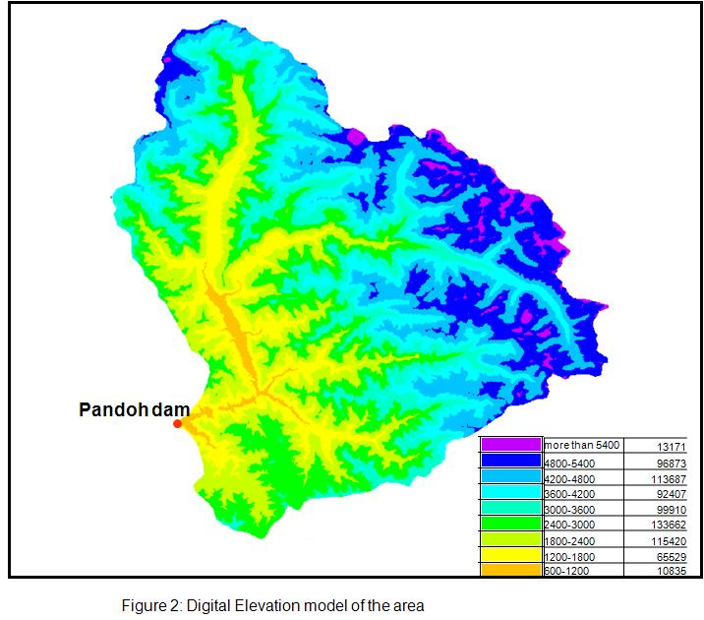

Figure 5 1: Digital Elevation model of the area



Figure 5.2: area-elevation curve of the study area

**5.6.3 SNOW COVERED AREA (SCA)**

**5.6.3.1 SCA using satellite data**

The MODIS Snow data products were in sinusoidal projection and WGS84 datum. This sinusoidal projection was re-projected to Geographic Lat/Long and WGS84 datum. All the MODIS data products were found to be very accurately geo-referenced (Jain *et al*. 2008). However, it was observed that MODIS data products and SRTM-DEM are not accurately geo-referenced with respect to each other. Hence, image-to-image re-projection was carried out for better accuracy. All the MODIS images and SRTM-DEM were geo-referenced. As many as 32 GCPs were selected in the image. GCPs are the specific pixels in the image data for which both the file coordinates (in the image) known as the source coordinates and map coordinates (in the map) known as the reference coordinates. The GCPs were spread throughout the image so that the rectification is more reliable. The Root Mean Square Error (RMSE) value was kept within a pixel (mostly 0.2). The next step was to convert the source coordinates to rectified coordinates. For this operation second-order, polynomial equation was used. The re-sampling was done using Nearest Neighbor method, which uses the value of the nearest pixel to assign to the output pixel value.

Snow exhibits high reflectance in visible band and strong absorption in SWIR (Short Wave Infrared) band. A spectral band ratio can enhance features, if there are differences in spectral slopes (e.g., Gupta *et al*, 2005). The Normalized Difference Snow Index (NDSI) uses these spectral characteristics of snow and is based on the concept of Normalized Difference Vegetation Index (NDVI) used in vegetation mapping from remote sensing data (Dozier, 1989: Hall *et al*., 1995, Gupta *et al*., 2005). The NDSI is defined as the difference of reflectance observed in a visible band and the short-wave infrared band divided by the sum of the two reflectance (Gupta *et al*., 2005). The MODIS snow cover algorithm is based on the high reflectance of snow in the visible band (band 4, 0.545– 0.565 μm) and low reflectance in the near infrared band (band 6, 1.628–1.652 μm). These two bands are used to calculate the normalized difference snow index (NDSI) (Hall *et al*., 1995).The equation is given below:

**** (5.19)

Aqua/Terra-MODIS satellite data products are available from February 2000 till present date. The MODIS snow cover product is a classified image. For development of snow covered products, NDSI approach have been used to compute snow cover area. The images were further classified by clubbing snow and lake ice into snow category and rest of the classes into non-snow category. Thus all the images were classified into snow and non-snow category. SCA from February 2001 to December 2005 have been prepared and SCA map for one year 2001 is shown in figure 5.3.

Using the classified snow maps, the total percentage of snow cover in the study area was estimated for different dates. Further, for snowmelt runoff modeling, the SCA are required for different elevation zones. For this purpose, classified DEM and SCA maps have been processed for all the dates. As discussed earlier the basin is divided into nine elevation zones. The SCA in each elevation zones were plotted against the elapsed time to construct the SDC for the various elevation zones in the basin for all the years. The SDC for the months of March to October for five years (2000-2001, 2001-2002, 2002-2003, 2003-2004 and 2004-2005) are shown in figure 5.4.

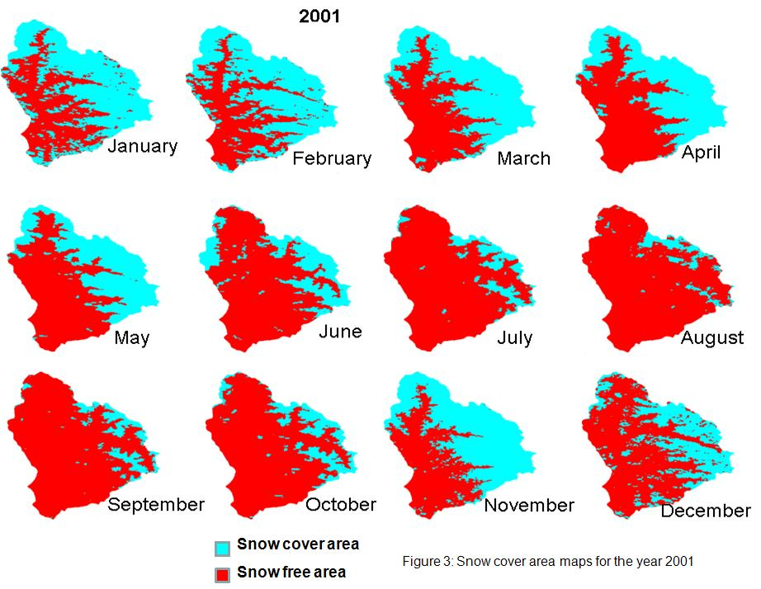

Figure 5.3: Snow cover area maps for the year 2001.

**5.6.3.2 SCA using temperature data**

As discussed above, snow covered area (SCA) have been estimated using MODIS satellite data. This data is available from 2000 onwards, therefore, to have SCA for previous years, a method for preparation of depletion of SCA using mean air temperature has been applied. Because depletion of snow is a cumulative effect of climatic conditions in and around snow cover area, the cumulative mean air temperature (CMAT) at a nearby station should represent depletion of SCA.

In Himalayan basin, SCA starts melting in beginning of March. SCA in the basin is reduced by retreating of the snow line from the lower elevations of the basin towards the higher areas. The retreat rate is reduced as the thicker and denser snow packs are reached at the higher altitudes towards the end of the melting period. With the advancement of summer season, the 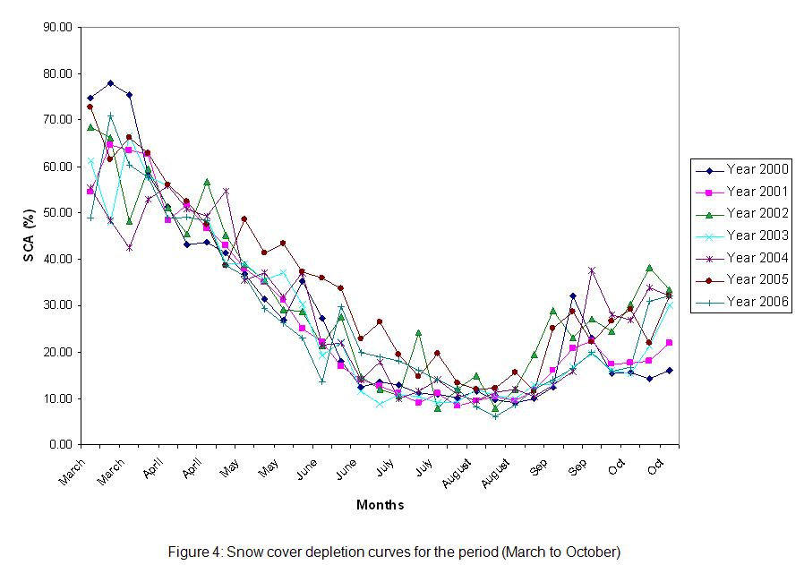

Figure 5.4: Snow cover depletion curves for the period (March to October).

snow cover starts melting in the upper part of the basin. As discussed by Singh & Kumar (1997), increase of snow depth with elevation would result in thinner and low-density snow packs at the lower elevations and thicker and denser ones at the higher altitudes. The SCA reduces with time and at each point of time melt can be related to air temperature. Therefore, cumulative temperature over the melt period should represent the depletion of SCA (Singh *et al*., 2003, Tikeli, 2005).

Rapid melting of snow, and thus the quick disappearance of SCA in lower elevations, was reported by Kattelman (1997). Gupta *et al*. (1982) derived a logarithmic relationship between SCA and the volume of seasonal snowmelt runoff for Himalayan basins. Kaya (1999) and Tekeli (2005) established a relationship between depletion of SCA in Karasu basin with CMAT on a daily basis for the years 1997 and 1998. This exponential relationship can be explained on the basis of distribution of snow in the basin (Singh *et al*., 2003 and Tekeli, 2005). An exponential relationship implies that initial increments in temperature lead to higher changes in the snow covered area than later increments in temperature of the same magnitude (Singh *et al*., 2003). These studies support the exponential relationship between SCA and CMAT used in the study.

Therefore, in this study also an exponential relationship between SCA and CMAT in the following form has been adopted.

Y=a\*exp (-bX) (5.20)

Where Y denotes the SCA and X stands for the CAMT, whereas a and b are the coefficients to be determined.

Melting starts around beginning of March, therefore, reference date for computing CMAT was considered March 1. The above relationship has been developed for each year and found that it is not exactly same for each year, because snow cover varies each year. Therefore data of four ablation seasons for the years 2001-2004 have been used to establish the relationship between SCA and CMAT.

In the present study area, the SCA for zone 1, 2 and 3 are having almost no snow cover while zones 8 and 9 are having almost 100% snow cover area. Therefore these zones have not been considered in this study. The remaining zones 4,5, 6 and 7 are having snow cover area which changes with time during ablation period therefore relationship for these four zones have been developed. The station Manali having an altitude of 2100 m has been considered in zone 4. Mean daily air temperature was obtained using maximum and minimum temperature. There is no station available above the altitude of 2500m. Therefore for zones 5, 6 and 7 temperature of Manali station have been used and computed with the help of lapse rate (0.6°C) (Singh, 1991).

The exponential fit to variation of SCA with respect to CMAT has been done for four zones. The computed coefficients in equation (5.20) are given in Table 5.4.

Table 5.4: Coefficients and R2 values for the ablation period.

|  |  |  |  |
| --- | --- | --- | --- |
| Elevation zones | a | b | R2 |
| Zone 4 | 0.72 | -0.0054 | 0.90 |
| Zone 5 | 1.0 | -0.0059 | 0.97 |
| Zone 6 | 1.0 | -0.0035 | 0.95 |
| Zone 7 | 0.92 | -0.0064 | 0.91 |

The high R2 values in Table 5.4 support the preliminary assumption of an exponential relationship between SCA and CMAT.

The studies performed here have been used for the following purposes:

* Interpolation and simulating of SCA on the basis of temperature data;
* Generation of SCA maps for climate change studies.

**5.6.3.3 Interpolation and simulation of SCA**

Once the relationship between SCA and CMAT is derived, the SCA values for the missing dates can be found by using the obtained relationship. In this way, SCA between the observation times can be interpolated and the depletion of the SCA from the basin can be simulated. Because SCA and CMAT are exponentially correlated, once the trend of depletion of SCA is established in the basin, it has been used for the other years using only CMAT data. This approach has been applied for 10 years (1990-1999) for simulating daily SCA in the study basin. The SDC for zones 4, 5, 6 and 7 are shown for the years 1996 to 1999 in figure 5.5. The simulated values can be used as input into a snowmelt runoff model (Martinec *et al*., 1998) to obtain the simulated discharges. As stated above, the relationship has been developed using data of four years, therefore this relationship has been checked for one year data before applying for other years. The SCA estimated using this relationship has been checked for one year 2001 and found that it matches well with the observed SCA as shown in figure 5.6.

**5.6.3.4 Generation of SCA maps for climate change studies**

In order to simulate the runoff in a new climate, it is necessary to determine a new set of SDC that would result from higher temperature. There will be a shift of the conventional SDC for a new warmed climate because in this situation, a greater part of the winter precipitation will be rain instead of snow. The relationship developed as above can be used to prepare modified SDC. In the above relationship, change in temperature due to climate change will be considered to estimate the corresponding snow cover area. For example, if temperature is increased by 1°C, then corresponding SDC will advance by about 15-20 days. In this study, SDC for hypothetical climate change scenarios such as increase of temperature by 1 and 2°C have been generated. The new SDC generated for zone 4, 5, 6 and 7 are shown in figures 5.7 for increase of 1°C temperature while for 2°C rise SDC are shown in figure 5.8.

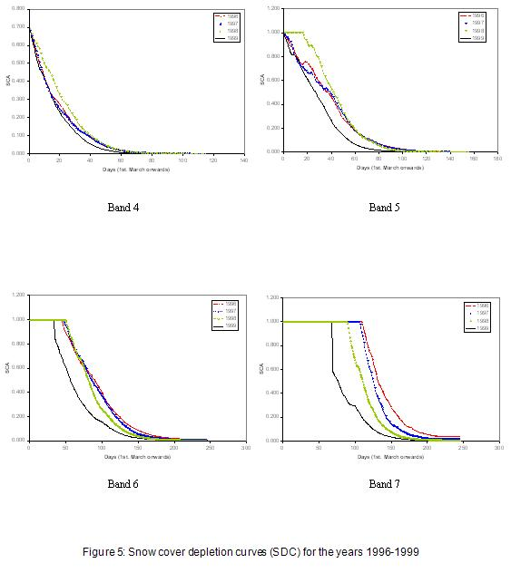

Figure 5.5: Snow cover depletion curves (SDC) for the years 1996-1999.

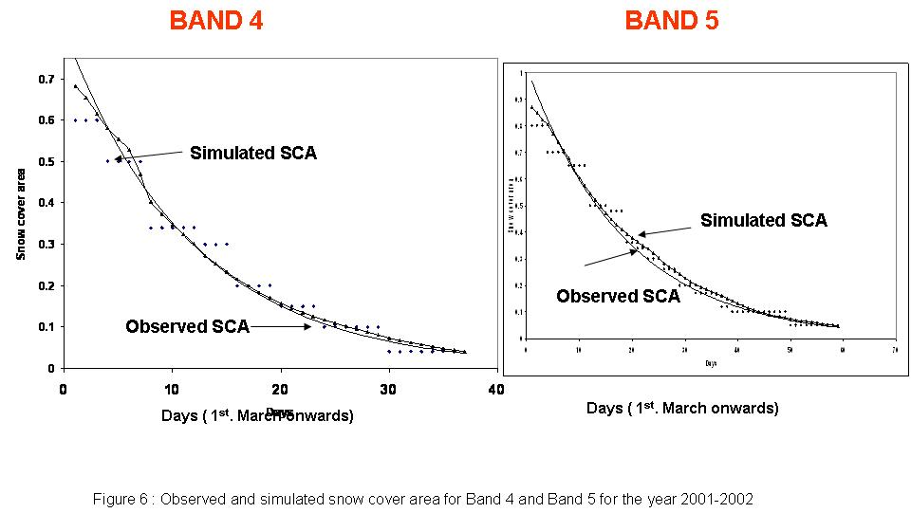

Figure 5.6: Observed and simulated snow cover area for Band 4 and Band 5 for the year 2001-2002

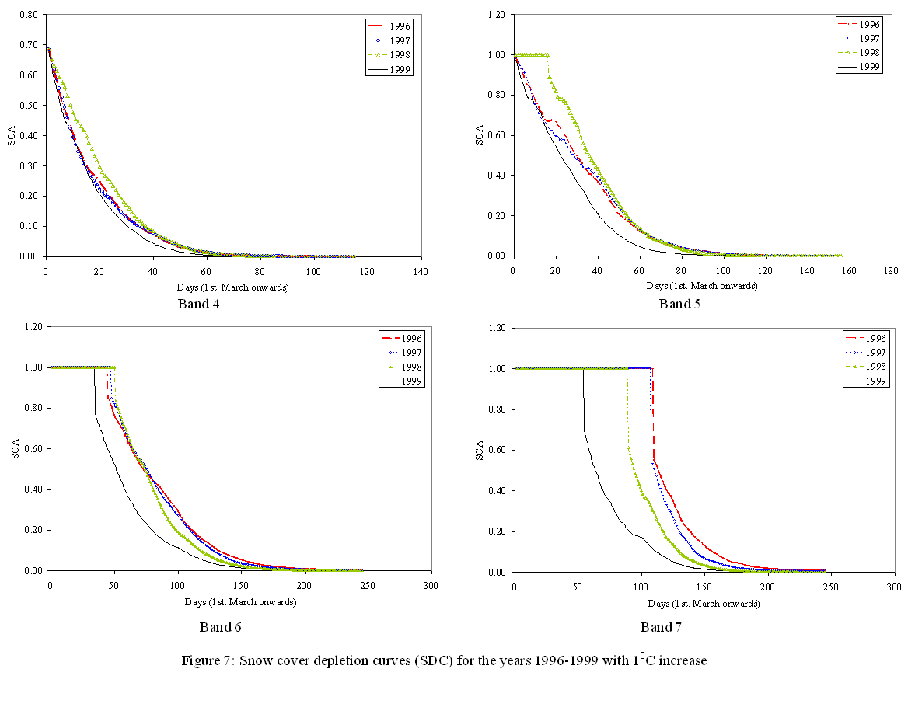

Figure 5.7: Snow cover depletion curves (SDC) for increase of 10C

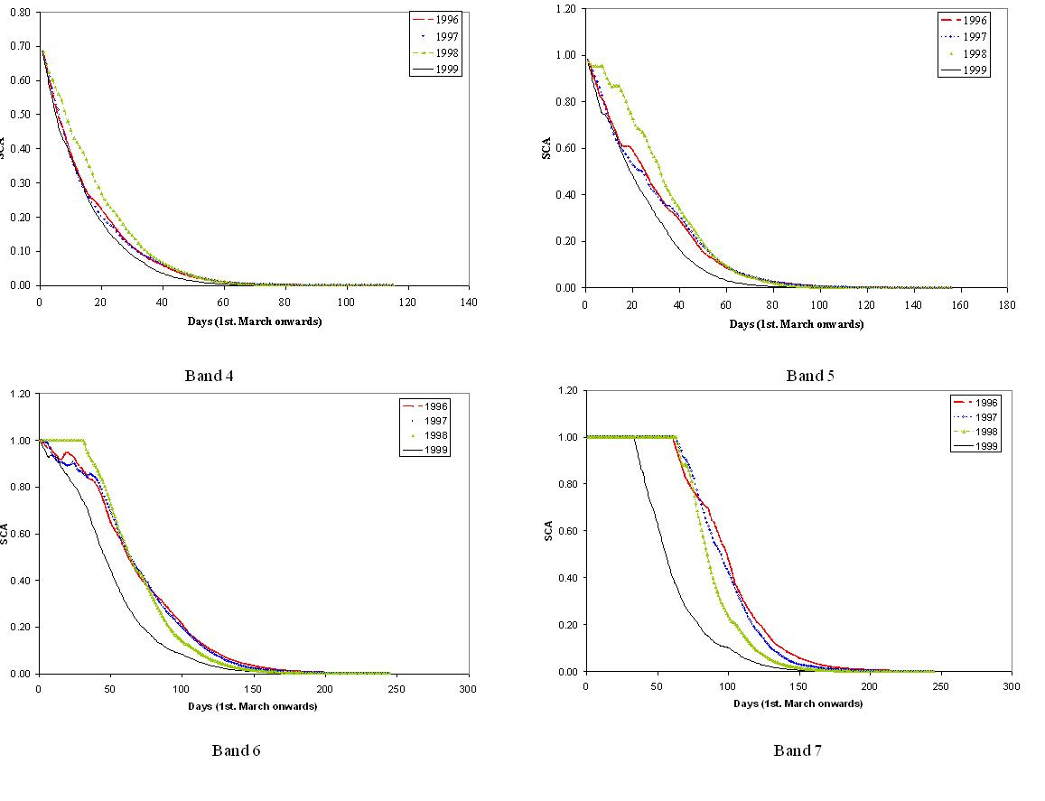

Figure 5.8: Snow cover depletion curves (SDC) for increase of 2°C

**5.7 CALIBRATION OF MODEL**

Stream flow from the study basin, basically has three components: runoff from snow covered area, runoff from snow free area and contribution from groundwater storage in terms of baseflow. The computation of runoff for each component was made for each elevation zone separately and then output from all the bands was integrated to provide the total runoff from the study basin. The runoff from snow covered area consists of: (i) snowmelt caused due to temperature, (ii) under rainy conditions, snow melt due to heat transferred to the snow from rain, and (iii) runoff from rain itself falling over snow covered area. The source of surface runoff from the snow free area is rainfall. Like snowmelt runoff computations, runoff from snow free area was also computed for each band. The hydrological models are generally calibrated using observed and simulated results. The available data set is split into two parts; one is used for calibration purpose and the next for validation to check how affectively the model performs in simulation mode. In the present study, the Rosenbrock optimization technique was used for optimization of parameter values. The hydrological models are generally calibrated using observed and simulated results. The available data set is split into two parts; one is used for calibration purpose and the next for validation to check how affectively the model performs in simulation mode. In the present study, the Rosenbrock optimization technique was used for optimization of parameter values. The model was calibrated using a daily data set of a period of 3 years (2002-2005).

The estimated and observed hydrograph shows good matching for the years 2002-2005. The efficiency (*R*2) of the model for the melt years 2002-2005 is 0.84, while difference in volume (DV) is 1.64% and RMSE is 0.28. The result indicates good performance of the model for the three-year period.

**5.8 SIMULATION OF STREAMFLOW**

The model for simulation has been used for three parts of Beas basin (i) Beas basin up to Manali (ii) Beas basin upto Bhunter and (iii) Beas basin upto Pandoh data

**5.8.1 MODELING OF STREAMFLOW OF BEAS RIVER AT MANALI**

The snowmelt runoff model SNOWMOD has been applied for simulating the daily flows for the Beas River at Manali. The flow data for the year 2004-05 and 2005-06 have been considered for calibrating the model whereas the year, 2006-07, 2008-09 and 2010-2011 have been considered for validating the model. The efficiency of the model has been computed based on the daily simulated and observed flow values for five years. The values of the model efficiencies are 82%, 80%, 78%, 81% and 81% for Beas at Manali. The performance of the model in preserving the runoff volume of entire year has been tested based on the criteria computed as percentage difference in observed and simulated runoff. The model has capability to separate out the contributions of rainfall, snow and glacier melt and base flow from the simulated flows. From hydrograph as shown in Fig 5.4, it has been observed that the model has simulated also the daily flows reasonably well showing generally a good matching with the daily observed flows. The trends and peaks of the daily flow hydrographs for the year are very well simulated by the model. Percentage difference in volume, model efficiency and contributions of rain snow and base flow computed by the model are summarized in following Table 1. As per the results for the contribution of the snowmelt runoff comes out to be 52%, 54%, 52%, 51%, and 52% in the year 2004-05, 2005-06, 2006-07, 2008-09, 2010-2011 respectively On an average, the contribution of snowmelt runoff is 52% in Beas river at Manali.

The variation in discharge occurs due to the variations in climatic conditions which affects the contribution of different components to the river discharge. Snow accumulation in Himalaya occurs generally from October to March, while snowmelt is observed from April to June, which are the premonsoon months under Indian sub continental conditions. During April to June, snowmelt is the predominant source of runoff while July to September, rainfall runoff and the snow/glacier melt runoff contribution is predominant. Hence most of the high peaks in the hydrographs are observed in these months because of contribution of the snow/glacier melt of higher altitude and rainfall. From April to June, contribution of seasonal snow located in lower altitude is more. As the season advance, lower reaches snow is almost melted out, whereas river discharge is contributed by snow/glacier located in high altitude and rainfall from June onwards. However, sometimes the flow resulting due to high intensity rainfall also reflects the peaks in the hydrograph.

**5.8.2. MODELING OF STREAMFLOW OF PARVATI RIVER AT BHUNTER**

The SNOWMOD model has been applied for simulating the daily flows for the Parvati river at Bhunter for four years. The flow data for the year 2004-05 and 2005-06 have been considered for calibrating the model whereas the year, 2006-07, 2008-09 have been considered for validating the model. The efficiency of the model has been computed based on the daily simulated and observed flow values for four years. The values of the model efficiencies are 85%, 80%, 81%, and 83% for Bhunter respectively for the years 2004-05, 2005-06, 2006-07 and 2008-09. The performance of the model in preserving the runoff volume of entire year has been tested based on the criteria computed as percentage difference in observed and simulated runoff. The model has capability to separate out the simulated and observed flow hydrographs for the all contributions of rainfall, snow and glacier melt and base flow from the simulated flows. From Fig 5.5 and 5.6, it has been observed that the model has simulated also the daily flows reasonably well showing generally a good matching with the daily observed flows. The trends and peaks of the daily flow hydrographs for the year are very well simulated by the model. Percentage difference in volume, model efficiency and contributions of rain snow and base flow computed by the model are summarized in Table 5.5.

Most of the high peaks observed in the daily flow hydrographs are generally during the months of July and August attributed to the rainfall and glacier melt. Thus these months are considered as the peak melting season in the western Himalayan region. However, sometimes the flow resulting due to high intensity rainfall also reflects the peaks in the daily flow hydrographs. The simulation of baseflow indicates that the baseflow contribution to the streamflow increases as the season advances, being at maximum during the peak season and then starts decreasing.

Snowmelt contribution are 49 %, 46 %, 48 %, and 48 % for the years 2004-05, 2005-06, 2006-07 and 2008-09 using modelling approach. Isotopic study results were obtained for snowmelt contribution in each month using two component based model of the Parvati river at Bhunter. Two component based model was applied for the month when flow is mainly contributed with the Snow and Base flow. The results obtained using isotopic techniques shows that snow/glacier melt runoff dominate in the months of April, May and June, while during winter season base flow mainly contribute to the streamflow. Contribution of the snowmelt in Parvati river for the month of April, May, June and December of year 2010 and January and February of 2011 are the 75%, 94%, 82%, 15%, 12% and 22% on an average 50% using isotope approach.

**Table 5.5**. Difference in volume, model efficiency and contributions of rain, snow and base flow computed by the model for Beas at Manali.

|  |  |  |  |  |  |
| --- | --- | --- | --- | --- | --- |
| **Year** | **Difference in Volume (%)** | **Model Efficiency (%)** | **Rain (%)** | **Snow (%)** | **Base Flow (%)** |
| 2004-05 | 5.62 | 82 | 5.8 | 52 | 42.2 |
| 2005-06 | 6.52 | 80 | 6 | 54 | 40 |
| 2006-07 | 5.41 | 78 | 6.4 | 52 | 41.6 |
| 2008-09 | 5.16 | 81 | 7 | 51 | 42 |
| 2010-2011 | 6.51 | 81 | 6.1 | 52 | 41.9 |

**5.8.3 MODELING OF STREAMFLOW OF BEAS RIVER AT PANDOH**

The model was calibrated using a daily data set of a period of 3 years (2002-2005) for Beas basin.

From the figure 5.9 it is clear that the discharge rises from April onwards and reaches its peak by August and September and than starts reducing from the month of September onwards. In all the years, high flow occurred in the month of July and August. A close observation of rainfall and streamflow data indicates that most of the peaks in the streamflow were because of rainfall.

From all the figures, it is clear that the volumes and peaks of streamflow were reproduced well by the model for all the years. The study shows that SNOWMOD a temperature index based snowmelt runoff model worked well in the study basin where limited data are available. The seasonal lapse rate was used for the first time in the model and significant improvement was observed in the efficiency of the model to simulate streamflow. The SCA estimated for the missing dates using regression method were used in the model for simulation and the efficiency of the model improved further.

**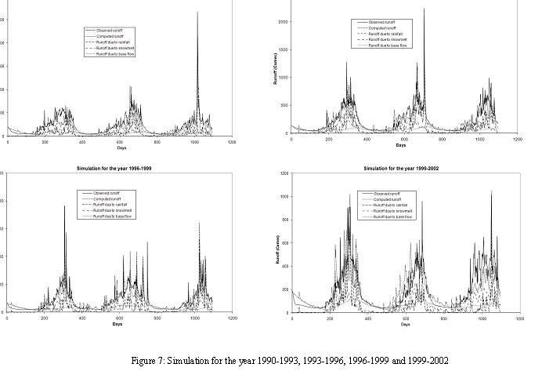5.9 ESTIMATION OF SNOWMELT RUNOFF AND RAINFALL RUNOFF**

As discussed above the model simulate snowmelt runoff and rainfall runoff separately therefore contribution of each component to the seasonal and annual total streamflow has been calculated. The estimated contribution of snowmelt and rainfall to the ablation and annual flows is shown in Table 5.6. The baseflow was separated into snowmelt and rainfall components using the contribution of these components to the baseflow both in different. This study suggests that about 39% of the runoff during ablation period is generated from snowmelt runoff and the remaining 61% is from rain. The average contributions from snowmelt and rainfall to the annual runoff are estimated to be about 38% and 62%, respectively. This means that snowmelt runoff is mainly occurring in ablation period only. In another study for this basin, Kumar et al. (2002) estimated the contribution of snowmelt and rainfall to the annual flows to be 35.1% and 64.9%, respectively, using the water balance approach. The present study provides more accurate estimates.

Figure 5.9 Stream flow hydrograph

The calibrated parameter values were computed considering the overall performance of the model and reproduction of the flow hydrograph. The model performance on a daily basis is commonly evaluated using the non-dimensional Nash-Sutcliffe ‘R2’value (Nash and Sutcliffe, 1970). After successful calibration, the model was used for simulation for a period of twelve years 1990-1993, 1993-1996, 1996-1999 and 1999-2002 for Beas basin. The parameters estimates obtained in the calibration stage were used to simulate the runoff hydrograph for the period as mentioned above.

As discussed above the model simulate snowmelt runoff and rainfall runoff separately therefore contribution of each component to the seasonal and annual total streamflows has been calculated. The estimated contribution of snowmelt and rainfall to the ablation and annual flows is shown in Table 5.2 for Beas basin. The ablation period is taken from March to August. The baseflow was separated into snowmelt and rainfall components using the contribution of these components to the baseflow. This study suggests that about 39% of the runoff during ablation period is generated from snowmelt runoff and the remaining 61% is from rain. The average contributions from snowmelt and rainfall to the annual runoff are estimated to be about 38% and 62%, respectively. This means that snowmelt runoff is mainly occurring in ablation period only.

**Table 5.6** Contribution of snowmelt and rainfall to the ablation and annual flows.

|  |  |  |  |  |
| --- | --- | --- | --- | --- |
| Season/annual | Rainfall runoff (%) | | Snowmelt runoff (%) | |
| Ablation | Annual | Ablation | Annual |
| 1991 | 0.60 | 0.59 | 0.40 | 0.41 |
| 1992 | 0.68 | 0.67 | 0.32 | 0.33 |
| 1993 | 0.61 | 0.59 | 0.39 | 0.41 |
| 1994 | 0.55 | 0.53 | 0.45 | 0.47 |
| 1995 | 0.66 | 0.65 | 0.34 | 0.35 |
| 1996 | 0.62 | 0.61 | 0.38 | 0.39 |
| 1997 | 0.56 | 0.56 | 0.44 | 0.44 |
| 1998 | 0.64 | 0.64 | 0.36 | 0.36 |
| 1999 | 0.62 | 0.61 | 0.38 | 0.39 |
| 2000 | 0.64 | 0.63 | 0.36 | 0.37 |

**CHAPTER 6: MAJOR ION CHEMISTRY OF BEAS RIVER**

**6.1 Introduction**

The Himalayas are the largest storehouse of snow and ice outside the polar region and are commonly referred to as “the abode of eternal snow” (Vohra, 1993). The Himalaya is the main source of water for the rivers in the Indo-Gangetic plains, and all the major river systems of north India, the Ganga, the Brahmaputra and the Indus, originate from the Himalayan snow and ice fields. It has been observed that the discharge of Himalayan Rivers per unit area is roughly twice that of the peninsular rivers. This is mainly due to the perennial contributions from melting of snow and ice. There are 22 glacial fed river systems in India, covering a mountain catchment of over 10 x 106 km2 (Bahadur, 1988). The degree of glaciated area varies in these river systems from 3.4% for the Indus, 3.2% for the Ganga and 1.3% for the Brahmaputra.

Highland proglacial streams are very active agents of erosion and transportation. The Himalayan Rivers, the Ganga and the Brahmaputra, together account for 3% of the total global flux of dissolved load to the world’s oceans (Sarin et al.,1989). It has been estimated that the non-Himalayan Rivers of peninsular India carry less than 5% of the total mass transport as compared to Himalayan Rivers (Subramanian, 1979). Thus a high altitude Himalayan River basin provides a natural unit within which one can examine natural weathering and geochemical processes. However, even today, the study and management of the Himalayan river basins is unfortunately constrained by a lack of reliable hydrological data. Although some work has been done in the last few decades (Hasnain et al., 1989; Hasnain, 1992, 1996; Hasnain and Renoj 1996; Chauhan and Hasnain 1993; Sarin et al., 1992), it is either confined to a near source region or is based only on few samples/observations. Adequate understanding of the Himalayan proglacial streams is extremely important for the development of a realistic programme for utilizing the potential of water that exists in the form of snow and ice in this area. Several studies have been carried out in the lower part of the Ganges river system (Abbas and Subramanian, 1984; Sarin et al.,1989; Handa, 1972), but very little information is available on geochemical aspects of the headwaters. The present work is aimed towards developing baseline data for river water quality of the Beas River, a major tributary of the Indus River, and to understanding the weathering and geochemical processes active in high altitude river basins.

**6.2 The River Beas**

The River Beas is one of the important snow-fed perennial rivers of Indus River System. It forms the world famous valleys of Kullu and Kangra in Himachal Pradesh. But ironically, its one of the source, known as Beas Rishi, is an insignificant looking igloo like structure on the right of Rohtang Pass in Pir Panjal range. To the South of this source lies another source known as Beas Kund. Both these mountain streams meet at Panchan village, nine kilometers North of Manali to form the River Beas. From Manali, after covering hundreds of kilometers through the hills, the river embraces the River Satluj at Hari Ka Patan in Ferozpore District of Punjab before flowing into Pakistan. The total length of the river is 460 km. It flows for 256 km in Himachal Pradesh, along the National Highway-21 (from Palchan to Mandi) and then along National Highway-20 (from Mandi onwards).

The River Beas played a significant role in the development of a peculiar hill culture which pervades the life of hill people living in the towns and surrounding villages since ages. The river also serves as a drinking water source to many towns on and around its bank, but due to non-availability of proper sewerage/disposal system, the waste water of the towns/cities is being discharged into Beas River and its tributaries. The important settlements on the bank of Beas River along National Highway-21 are Manali, Raison, Kullu, Bhunter, Aut, Pandoh and Mandi. All these hill stations, Manali and Kullu in particular, attract lacs of tourists every year during the tourist season (April to September). As a pre-requisite for better hospitality, these hill stations have large number of hotels/restaurants/resorts etc. to meet the needs of the tourists. However, the waste water of these towns and other settlements is polluting the Beas River and deteriorating it water quality, particularly during the tourist-season in summers.

In the present study, the water quality of River Beas has been analyzed during the year 2011 (from Beas Kund to Pandoh Dam Site) in terms of important water quality parameters to better understand the major ion chemistry of this important snow-fed perennial river.

**6.3 Analytical Methodology**

**6.3.1 Sampling and Preservation**

Three sets of water samples were collected in polyethylene bottles from various locations during February, May and July 2011 by dip (or grab) sampling method. All the samples were collected at a depth of 15 cm to avoid introduction of floating particles, using standard water sampler (Hydro Bios, Germany). The sampling bottles were washed thoroughly, rinsed with distilled water several times and finally rinsed with the sample to be sampled. The samples thus collected were stored in clean narrow mouth polyethylene bottles fitted with screw caps. The details of sampling locations are given in Table 6.1.

**Table 6.1. Details of Sampling Locations**

|  |  |  |
| --- | --- | --- |
| **S.No.** | **Site** | **Description** |
| 1. | Dhundhi | Dhundhi is the last village in Solang Valley of Kullu district. The last place to stock up with a few essentials before heading to the mountains. Metal road ends here. |
| 2. | Kothi | Kothi is a village at a distance of 12 km from Manali town with a thrilling view of the deep gorge through which the Beas swiftly crawls. The beautiful and sensing Rahalla falls is located here. A crucial link on the old trade route and still the gateway to trans Himalayan Lahaul, the Rohtang Pass is at a height of 3978 m. |
| 3. | Manali | Manali in the Beas River Valley is a hill station nestled in the mountains of the Indian state of Himachal Pradesh near the northern end of the Kullu Valley. The small town is the beginning of an ancient trade route to Ladakh and from there over the Karakoram Pass on to Yarkand and Khotan in the Tarim Basin. |
| 4. | Beas at Bhuntar | Bhuntar is a town and a nagar panchayat in Kullu district in the state of Himachal Pradesh, India.Bhuntar is center for accessing Manikaran and Manali. |
| 5. | Manikaran | Manikaran is located in the Parvati Valley between the rivers Beas and Parvati, northeast of Bhuntar in the Kullu District of Himachal Pradesh. This small town attracts tourist visiting Manali and Kullu to its hot springs and pilgrim centres. An experimental geothermal energy plants has also been set up here. |
| 6. | Parvati at Bhuntar | Bhuntar is a town and a nagar panchayat in Kullu district in the state of Himachal Pradesh, India.Bhuntar is center for accessing Manikaran and Manali. |
| 7. | Pandoh | Pandoh town is situated in Mandi district of Himachal Pradesh. An embankment dam was constructed here in 1977 on the Beas River under the Beas Project. |

Some parameters like pH and electrical conductance were measured on the spot by means of portable meters (HACH, USA). For other parameters, samples were preserved by adding an appropriate reagent and brought to the laboratory in sampling kits maintained at 4oC for chemical analysis.

**6.3.2 Chemicals and Reagents**

All general chemicals used in the study were of analytical reagent grade (Merck/BDH). De-ionized water was used throughout the study. All glassware and other containers used for the analysis were thoroughly cleaned by soaking in detergent and finally rinsed with de-ionized water several times prior to use.

**6.3.3 Physico-chemical Analysis**

Physico-chemical analysis of the collected samples was conducted following standard methods (APHA, 1992; Jain and Bhatia, 1987). A brief description of analytical methods and equipment used in the present investigations is given in Table 6.2.

**Table 6.2. Analytical Methods and Equipment Used in the Analysis**

|  |  |  |  |
| --- | --- | --- | --- |
| **S.No.** | **Parameter** | **Method** | **Equipment** |
| 1. | pH | Electrometric | Portable pH Meter |
| 2. | Conductivity | Electrometric | Portable EC Meter |
| 3. | TDS | Electrometric | Conductivity/TDS Meter |
| 4. | Alkalinity | Titration by H2SO4 | - |
| 5. | Hardness | Titration by EDTA | - |
| 6. | Chloride | Titration by AgNO3 | - |
| 7. | Sulphate | Turbidimetric | Turbidity Meter |
| 8. | Nitrate | Chromotropic acid method | UV-VIS Spectrophotometer |
| 9. | Sodium | Flame emission | Flame Photometer |
| 10. | Potassium | Flame emission | Flame Photometer |
| 11. | Calcium | Atomic spectrometry | Atomic Absorption Spectrometer |
| 12. | Magnesium | Atomic spectrometry | Atomic Absorption Spectrometer |

Soon after sample collection, pH and electrical conductivity (EC) was measured in the field by using portable pH and conductivity meters. Samples were brought to the laboratory in sampling kits maintained at 4oC. Chloride was determined by the argentometric method. Bicarbonate was analysed by potentiometric titration method keeping 4.5 pH as the end point. Sulphate concentration was determined by turbidimetric method with barium chloride crystals. Nitrate was determined by chromotropic acid method, which is based upon yellow colour produced by the reaction of nitrate with chromotropic acid, absorbance was measured at 410 nm using a UV-VIS spectrophotometer. Sodium and potassium were determined by the flame-emission method using flame photometer, while calcium and magnesium were determined using Perkin-Elmer Atomic Absorption Spectrometer using air-acetylene flame.

An overall precision expressed as relative standard deviation (RSD) was obtained for all the samples. Overall data reproducibility for cations and anions was within ±5. The cationic and anionic charge balance (<5%) is an added proof of the precision of the data.

**6.4. Results and Discussion**

The chemical composition of the Beas River water and its tributaries for the three sets of samples collected during February, May and July 2011 is given in Tables 6.3 to 6.5. The charge balance (calculated by the formula: [(TZ+ - TZ-) / (TZ+ + TZ-) x 100] between cations and anions and ratio of TDS/EC are within acceptable limits, confirming the reliability of the analytical results.

**Table 6.3. Chemical Composition of Beas River and its Tributaries (February 2011)**

|  |  |  |  |  |  |  |  |  |  |  |  |  |  |
| --- | --- | --- | --- | --- | --- | --- | --- | --- | --- | --- | --- | --- | --- |
| Site | pH | EC | TDS  Mg/L | Alk  Mg/L | Hard  Mg/L | Na  Mg/L | K  Mg/L | Ca  Mg/L | Mg  Mg/L | HCO3  Mg/L | Cl  Mg/L | SO4  Mg/L | NO3  Mg/L |
| Dhundhi | 7.46 | 160 | 102 | 41 | 78 | 1.75 | 2.06 | 20 | 3.89 | 50 | 2.0 | 22 | 0.5 |
| Kothi | 7.20 | 51 | 33 | 14 | 20 | 1.10 | 1.17 | 5.61 | 1.46 | 17 | 2.0 | 3.3 | 2.9 |
| Manali | 7.03 | 121 | 77 | 30 | 46 | 2.16 | 2.22 | 12 | 3.89 | 37 | 2.0 | 16 | 1.7 |
| Beas at  Bhuntar | 7.26 | 188 | 120 | 48 | 67 | 5.35 | 3.46 | 19 | 4.86 | 59 | 2.0 | 18 | 8.7 |
| Manikaran | 7.74 | 102 | 65 | 22 | 38 | 3.40 | 1.96 | 8.82 | 3.89 | 27 | 2.0 | 19 | 0.6 |
| Parvati at  Bhuntar | 7.21 | 181 | 116 | 47 | 61 | 5.55 | 4.41 | 18 | 3.89 | 57 | 0.1 | 19 | 8.0 |
| Pandoh | 7.55 | 155 | 99 | 54 | 62 | 7.03 | 3.31 | 17 | 4.86 | 66 | 2.0 | 16 | 0.1 |

**Table 6.4. Chemical Composition of Beas River and its Tributaries (May 2011)**

|  |  |  |  |  |  |  |  |  |  |  |  |  |  |
| --- | --- | --- | --- | --- | --- | --- | --- | --- | --- | --- | --- | --- | --- |
| Site | pH | EC | TDS  Mg/L | Alk  Mg/L | Hard  Mg/L | Na  Mg/L | K  Mg/L | Ca  Mg/L | Mg  Mg/L | HCO3  Mg/L | Cl  Mg/L | SO4  Mg/L | NO3  Mg/L |
| Dhundhi | 6.62 | 118 | 76 | 32 | 50 | 1.20 | 1.88 | 15 | 2.43 | 39 | 2.1 | 12 | 0.1 |
| Kothi | 6.64 | 55 | 35 | 13 | 20 | 1.34 | 1.27 | 5.20 | 1.67 | 16 | 2.1 | 4.6 | 2.5 |
| Manali | 6.71 | 91 | 58 | 22 | 37 | 1.42 | 1.78 | 8.87 | 3.56 | 27 | 1.9 | 14 | 0.7 |
| Beas at  Bhuntar | 6.66 | 52 | 33 | 15 | 20 | 1.27 | 1.46 | 5.61 | 1.46 | 18 | 0.1 | 6.5 | 0.8 |
| Manikaran | 6.87 | 54 | 35 | 12 | 22 | 1.69 | 1.44 | 4.61 | 2.52 | 15 | 1.1 | 9.5 | 1.6 |
| Parvati at  Bhuntar | 6.61 | 59 | 38 | 18 | 24 | 2.01 | 1.42 | 6.42 | 1.94 | 22 | 0.1 | 9.0 | 0.6 |
| Pandoh | 7.18 | 73 | 47 | 24 | 24 | 3.39 | 1.73 | 5.82 | 2.40 | 29 | 0.2 | 7.5 | 0.3 |

**Table 6.5. Chemical Composition of Beas River and its Tributaries (July 2011)**

|  |  |  |  |  |  |  |  |  |  |  |  |  |  |
| --- | --- | --- | --- | --- | --- | --- | --- | --- | --- | --- | --- | --- | --- |
| Site | pH | EC | TDS  Mg/L | Alk  Mg/L | Hard  Mg/L | Na  Mg/L | K  Mg/L | Ca  Mg/L | Mg  Mg/L | HCO3  Mg/L | Cl  Mg/L | SO4  Mg/L | NO3  Mg/L |
| Dhundhi | 6.65 | 81 | 52 | 20 | 35 | 0.77 | 1.92 | 10 | 2.43 | 24 | 2.0 | 12 | 0.1 |
| Kothi | 6.62 | 58 | 37 | 12 | 26 | 1.68 | 1.46 | 5.61 | 2.89 | 15 | 2.0 | 11 | 2.5 |
| Manali | 6.72 | 78 | 50 | 18 | 32 | 0.82 | 1.67 | 7.22 | 3.40 | 22 | 2.0 | 13 | 0.4 |
| Beas at  Bhuntar | 6.74 | 39 | 25 | 8.0 | 14 | 1.04 | 1.50 | 4.01 | 0.97 | 10 | 2.0 | 6.1 | 0.1 |
| Manikaran | 6.85 | 49 | 31 | 8.0 | 19 | 0.95 | 1.22 | 4.51 | 1.94 | 10 | 2.0 | 11 | 0.7 |
| Parvati at  Bhuntar | 7.02 | 42 | 27 | 10 | 16 | 1.00 | 1.40 | 4.01 | 1.43 | 12 | 1.1 | 6.1 | 0.3 |
| Pandoh | 7.25 | 68 | 44 | 18 | 26 | 1.99 | 1.65 | 6.22 | 2.43 | 22 | 2.0 | 8.3 | 1.5 |

In the river water, the abundance order of cations and anions varied in general as follows: Ca2+ *>* Mg2+ *>* K+ *>* Na+ and HCO3*−* > SO42*− >* Cl*− >* NO3*−*, respectively. Calcium and magnesium are dominant cations while bicarbonate and sulphate are dominant anions. Weathering of rocks is the dominant mechanism controlling the hydrochemistry of drainage basin. The relative high contribution of (Ca+Mg) to the total cations (TZ+), high (Ca+Mg)*/*(Na+K) ratio and low (Na+K)*/*TZ+ ratio indicate the dominance of carbonate weathering as a major source for dissolved ions in the river water. Sulphide oxidation and carbonation are the main proton supplying geochemical reactions controlling the rock weathering in the study area. The variation of different water quality constituents at different sites of the River Beas and its tributaries is shown in Figures. 6.1 to 6.13.

**Figure. 6.1. Variation of pH at Different Sites of River Beas**

**Figure. 6.2. Variation of Conductivity at Different Sites of River Beas**

**Figure. 6.3. Variation of TDS at Different Sites of River Beas**

**Figure. 6.4. Variation of Alkalinity at Different Sites of River Beas**

**Figure. 6.5. Variation of Hardness at Different Sites of River Beas**

**Figure. 6.6. Variation of Sodium at Different Sites of River Beas**

**Figure. 6.7. Variation of Potassium at Different Sites of River Beas**

**Figure. 6.8. Variation of Calcium at Different Sites of River Beas**

**Figure. 6.9. Variation of Magnesium at Different Sites of River Beas**

**Figure. 6.10. Variation of Bicarbonate at Different Sites of River Beas**

**Figure. 6.11. Variation of Chloride at Different Sites of River Beas**

**Figure. 6.12. Variation of Sulphate at Different Sites of River Beas**

**Figure. 6.13. Variation of Nitrate at Different Sites of River Beas**

**Piper trilinear Diagram**: One of the most important traditional ways to graphically present water quality data is by use of Piper trilinear diagram (Piper, 1944). The diagram is used to express similarity and dissimilarity in the chemistry of water based on major cations and anions. Piper (1944) has developed a form of trilinear diagram, which is an effective tool in segregating analysis data with respect to sources of the dissolved constituents in water, modifications in the character of water as it passes through an area and related geochemical problems. The diagram is useful in presenting graphically a group of analysis on the same plot.

The diagram combine three distinct fields by plotting two triangular fields at the lower left and lower right respectively and an intervening diamond-shaped field. All three fields have scales reading in 100 parts. In the triangular fields at the lower left, the percentage reacting values of the three cation groups (Ca, Mg, Na+K) are plotted as a single point according to conventional trilinear coordinates. The three anion groups (HCO3, SO4, Cl) are plotted likewise in the triangular field at the lower right. Thus, two points on the diagram, one in each of the two triangular fields, indicate the relative concentrations of the several dissolved constituents of a ground water. The central diamond-shaped field is used to show the overall chemical character of the ground water by a third single point plotting, which is at the intersection of rays projected from the plotting of cations and anions. The position of this plotting indicates the relative composition of water in terms of cation-anion pairs that correspond to the four vertices of the field. The three areas of plotting show the essential chemical character of water according to the relative concentrations of its constituents.

The chemical analysis data of all the samples collected from Beas River and its tributaries have been plotted on trilinear diagram for the three sets of data (Figures. 6.14 to 6.16) and results have been summarized in Table 6.6.

**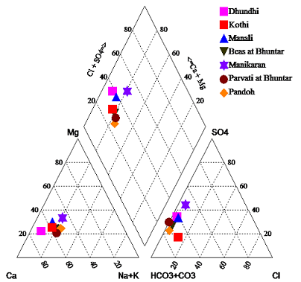**

**Figure. 6.14. Piper Trilinear Diagram Showing Chemical Character of Water**

**(February 2011)**

**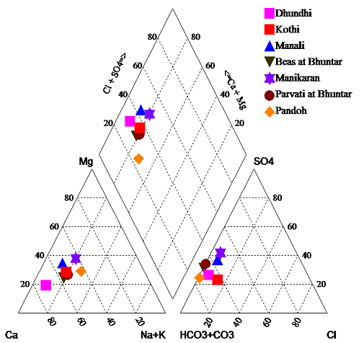**

**Figure. 6.15. Piper Trilinear Diagram Showing Chemical Character of Water**

**(May 2011)**

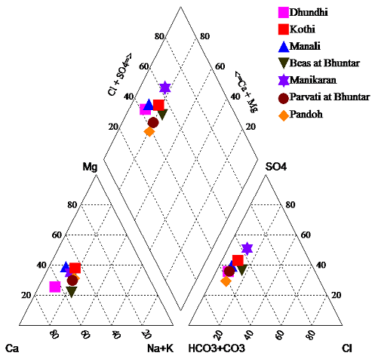

**Figure. 6.16. Piper Trilinear Diagram Showing Chemical Character of Water**

**(July 2011)**

**Table 6.6. Summarized Results of Piper Trilinear Classification**

|  |  |  |
| --- | --- | --- |
| **Month** | **Sample Site** | **Hydrochemical Facies** |
| February 2011 | Dhundhi, Kothi, Manali, Beas at Bhuntar, Parvati at Bhuntar, Pandoh | Ca-Mg-CO3-HCO3 |
| Manikaran | Ca-Mg-Cl-SO4 |
| May 2011 | Dhundhi, Kothi, Manali, Beas at Bhuntar, Manikaran, Parvati at Bhuntar, Pandoh | Ca-Mg-CO3-HCO3 |
| July 2011 | Dhundhi, Manali, Parvati at Bhuntar, Pandoh | Ca-Mg-CO3-HCO3 |
| Kothi, Beas at Bhuntar, Manikaran | Ca-Mg-Cl-SO4 |

The Piper trilinear diagram combines three areas of plotting, two triangular areas (cations and anions) and an intervening diamond-shaped area (combined field). Using this diagram water can be classified into different hydrochemical facies. It is evident from the results that majority of the samples of the study area belong to Ca-Mg-CO3-HCO3 hydrochemical facies both during February and May 2011 survey. Few samples of the study area also belong to Ca-Mg-Cl-SO4 hydrochemical facies during July 2011 survey.

**CHAPTER 7.0: SNOW AND GLACIER MELT SEPERATION USING ISOTOPE**

**7.1 INTRODUCTION**

The snow and glacier melt is a vital component of the streamflow for the Himalayan river system (Jain et al,. 2010, Rai et.al. 2009). Major Himalayan rivers receive substantial amounts of snow and glacier melt contribution during lean flow period of summer season, which ensures a year round water supply to millions of people. However, there are several studies indicating that most of these glaciers and snow packs are retreating, (Dobhal *et al.*, 2004; Hewitt, 2005; Kulkarni *et al.*, 2005; Naithani *et al.*, 2001). Ageta and Kadota (1992) have pointed out that Sixty-seven percent of glaciers are retreating at a startling rate in the Himalayas and the major causal factor has been identified as climate change. Therefore, glacial melt will affect freshwater flows with dramatic adverse effects on biodiversity, people and livelihoods, with a possible long-term implication on regional food security (WWF, 2005).

Stable isotope tracers (δ18O, δ2H) are known to be conservative, and changes in concentration with a hillslope reach occur as a result of mixing. Studies conducted worldwide during last few decades have established that stable oxygen and hydrogen isotope ratios provide useful tools for streamflow studies (Dincer et al., 1970; Martinec et al., 1974; Behrens et al., 1978; Hooper and Shoemaker, 1986; Obradovic and Sklash, 1986; Maule and Stein, 1990; Maurya et al., 2010, Ahluwalia et. al. 2013). The stable isotopes (expressed as 18O, 2H) in streamflow of Himalayan River namely, Ganga, Yamuna and Indus River have been used successfully used to study the characteristic of rivers by Ramesh and Sarin, (1992), Dalai et al., (2003) , Rai et al,. (2010); Rai et al,. (2011). Though a number of investigations have been carried out using isotopic tracers in western Himalayan region, but the use of isotopes to estimate contribution of baseflow, snow and glacier melt, and rain derived runoff has not received much attention.

River Beas originating from Beas Kund and Rohtang pass at the altitude of 3505 m and 3977 m respectively, both the stream meet to each other Palchan, 10 km. above the Manali. From a clear blue easy flowing mountain river in the non-monsoon period it turns into an awesome torrent river during the monsoon. For the hydrograph separation purpose, Manali and Bhunter sites were selected. Since discharge data at these sites were collected from BBMB (Figure. 7.1).

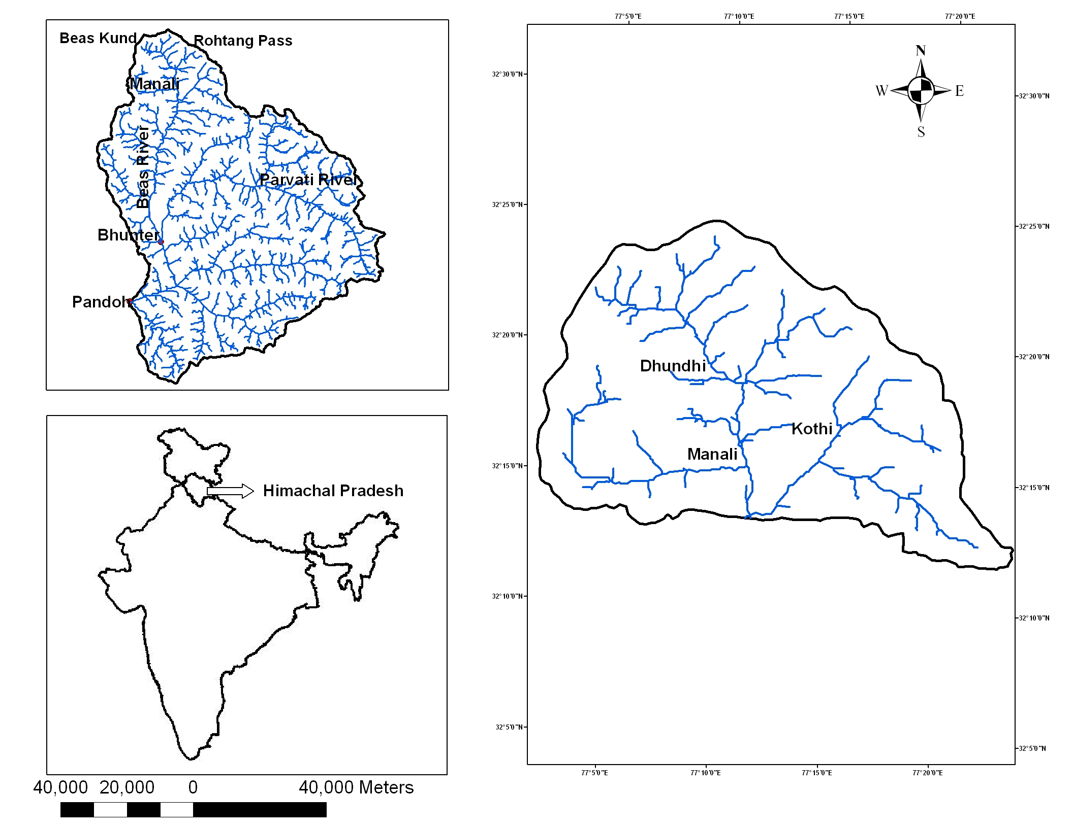

**Figureure 7.1** Study area of Beas basin upto Manali site.

Figure 7.1 Study area up to Manali

**7.2 METHODOLOGY**

Beas is snow and glacier fed river. In spite of snow and glacier melt during the ablation period, rain derived runoff contribute to river runoff significantly. Ablation period starts from April and continues up to October (Rai et al., 2009). To verify the melting pattern, snow cover area maps have been prepared using the satellite data (Figure 7.2). River runoff during the winter is mainly sustained by baseflow/subsurface flow.

The sampling strategy was developed on the basis of contribution of different component. During ablation period, samples for river and precipitation were collected on daily basis at Manali and Bhunter for isotope analysis. While groundwater samples were collected during premonsoon and post monsoon basis. To identify the isotopic signatures of river, samples of river water were collected on daily basis during ablation period during April 2010 to March 2011. The δ18O and δD of the collected samples have been analysed in National Institute of Hydrology, Roorkee and pH and EC was measured in-situ during sampling.

Beas river runoff during October to April, the river runoff is minimum in comparison to summer and rainy season. Since the river runoff during the winter is mainly sustained by baseflow/subsurface flow. Therefore, during the winter season, samples for river were collected on weekly basis whereas sample from rain and snow have been collected as and when event occurred.

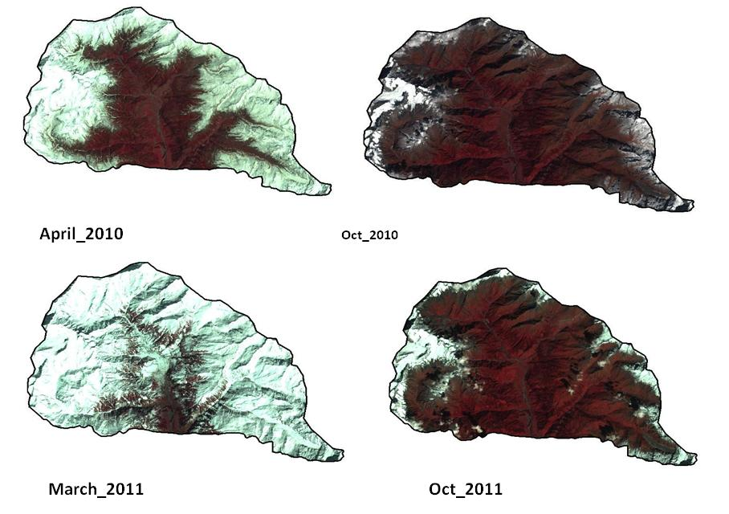

**Figure 7.2** Satellite imagery showing the ablation and accumulation period of Beas basin up to Manali.

For stable isotopes measurements, samples were collected in pre-cleaned 20 ml Polypropylene bottles (Tarsons make). These were rinsed profusely at site with sample water and filled with water samples, tightly capped (to prevent evaporation and exchange with the atmospheric moisture) and brought to the laboratory for isotopic analysis.

The oxygen and hydrogen isotope measurements were carried out using a Dual Inlet Isotope Ratio Mass Spectrometer (GV instruments, U.K) with automatic sample preparation units. For oxygen and hydrogen isotopes, 400μL water samples were taken and hokobeads were used as catalyst. Along with each batch of samples, secondary standards developed with reference to primary standards (i.e., V-SMOW, SLAP, GISP) were also measured and the final δ-values were calculated using a triple point calibration equation. The overall precision, based on 10 points repeated measurements of each sample was with the ±0.1‰ for δ18O and ±1‰ for δD.

The variation in discharge occurs due to the variations in climatic conditions which affects the contribution of different components i.e rainfall driven discharge, snow/glacier melt water, baseflow to the river discharge.

**7.2.1 Derivation of Isotopic Model for Hydrograph Separation**

Two component and three component models are developed in order to estimate the contribution of snow and glacier melt contribution, rain derived runoff and baseflow component of Beas River. The isotopic composition of river, snow and glacier melt and rainfall-runoff has been developed. For example, the δ18O of river water has been found isotopically different during the rain in comparison to pre and post events of a rainfall. In order to measure the changes in isotopic composition of river water, the sampling of the river water was carried out during the rain as well as pre and post rainfall events along with the sampling of the rainfall. The proportion of two components to the total discharge can be separated out using a two components model (Craig 1969). The water balance equation can be written as:

 (7.1)

Where, Q is the discharge component, and subscripts t, sm and r represent total river flow, snow/ice melt and runoff, respectively. Similarly, the isotopic balance equation can be written as

 (7.2)

By substituting and rearranging the equation (ii), we get

 (7.3)

Using the equation (7.3), the runoff component can be separated out. This equation is useful only when the river runoff is consisting only two components.

In the case of Beas River, snow and glacier melt, groundwater (subsurface water) and rainfall-runoff contributes to river discharge during monsoon period (July to September). Hence, for hydrograph separation, a three components mixing model is derived for the Beas River basin. The isotopic composition (δ18O) and electrical conductivity of snow/ice melt, rainfall, river and subsurface component were used along with the river discharge for the derivation of the model given below:

 (7.4)

 (7.5)

 (7.6)

Where Q, R, gw and gm are the total river discharge, surface runoff, groundwater and glacier melt contribution in m3/sec and δQ, δR,  and  are the corresponding δ18O values, respectively.

By solving these equations,

 (7.7)

 $g_{w}\left[\left(C_{g_{\text{w}}}-C_{{\text{g}}_{\text{m}}}\right)-(C_{\text{R}}-C_{{\text{g}}_{\text{m}}})\left\{\frac{\left(δ_{g_{\text{w}}}-δ_{{\text{g}}_{\text{m}}}\right)}{\left(δ_{\text{R}}-δ_{{\text{g}}_{\text{m}}}\right)}\right\}\right]=Q$ (7.8) $\left[\left(C_{mix}-C_{g_{m}}\right)-(C_{\text{R}}-C_{g_{m}})\left\{\frac{\left(δ_{mix}-δ_{g_{m}}\right)}{\left(δ_{R}-δ_{g_{m}}\right)}\right\} \right]$

**7.3 DEVELOPMENT OF ISOTOPIC INDICES FOR VARIOUS COMPONENT OF RIVER DISCHARGE**

The hydrograph of Beas River at Manali site is dominated by multiple peaks of surface runoff occurring during the rainy season . The minimum flow is recorded during the winter months of December and January when the other two components mainly rainfall and snow/glacier melt are negligible i.e., the river discharge is sustained by the groundwater. The river discharge starts increasing from April due to the melting of snow at the lower altitude melt. This increasing trend continues till June when there is very less rainfall. This clearly indicates that the increase in river discharge is due to the contribution of melting of snow and glacier. Maximum river discharge is observed during the rainy season (July, August and September) and the peak flows corresponds to high intensity rain events.

Isotopic indices of the river, snow/glacier, groundwater and rainfall have been developed in order to separate out snow and glacier melt, rainfall-runoff and baseflow (groundwater) component of river discharge. The details of isotopic signature of different component are discussed below.

**7.3.1 Isotopic Signature of Snow/Ice**

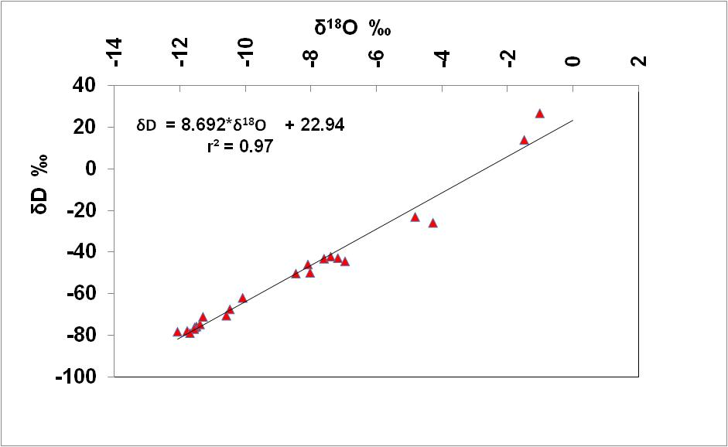Snow/ice samples were collected at Dhundhi, Kothi, Manali, Manikaran, Bhunter for isotopic measurement on events basis. The average δ18O value of the snow is taken as -10.05‰ for the entire basin. During monsoon months i.e July, August and September, δ18O values of the snow and glacier for these months are found respectively -11.20‰, -11.50‰ and -11.20‰. The isotopic signature measured for the snow at different sites are presented in Figure 7.3.

**Figure 7.3** Isotopic characteristics of snow/ice of Beas basin, Himachal Pradesh.

**7.3.2 Isotopic Characteristics of Rain**

Rain samples were collected from Kothi (2461 m), Dhundhi (2844 m), Manali (1885 m), Manikaran (1719 m) and Bhunter (1095 m) to characterize the isotopic signatures of precipitation in Beas River basin. The isotopic composition was found to be varying with rainfall events. Therefore, monthly weighted value of the rainfall is considered for hydrograph separation. The weighted annual average δ18O in precipitation varied between -10.13‰ and -15.57 ‰ at Manali, -7.50‰ and -14.40 ‰ at Bhunter. It reveals that isotopic composition of precipitation changes with altitude. The depleted values of rain with altitude are due to the altitude effect. The isotopic composition of the rain for Beas basin is presented in Figure 7.4.

****

**Figure 7.4** Isotopic signature of rainfall in Beas basin upto Bhunter.

**7.3.3 Isotopic Characteristics of Groundwater**

In order to develop the isotopic indices of groundwater, samples of springs and handpumps were collected, which are the source of groundwater in the field. The δ18O average value for the whole basin up to Bhunter is almost same i.e., -11.30‰ during non rainy months. However, δ18O average value during July, August and September are respectively -11.54‰, -11.60‰, and -11.54‰. The depletion of the groundwater signature shows the effect of precipitation during these months. During the November, river isotope signature (i.e., -11.44‰) is near to the groundwater signature. This reflects that the river flow is sustained mostly by subsurface flow while other components such as snow and glacier melt and surface runoff are negligible due to climatic conditions. In this study, δ18O value of November month is considered as baseflow isotopic signature.

**7.3.4 Isotopic Characteristics of River**

The river depleted δ18O signatures are recorded during monsoon months (July, August and September). The SW monsoon rains occurs in the study area during July to September is responsible for depleted signature of river. The depletion in δ18O values during pre-monsoon (April to June) indicate increased contribution of snow and glacier due to melting of snow and glacier at higher altitude with increased atmospheric temperature. The variation in isotopic composition of river with time clearly indicates that contribution of snow and glacier melt, groundwater and rainfall-runoff varied month to month (Fig. 7.5). As river water move downwards, the isotopic values are getting enriched site by site. For example the isotopic composition of Parvati river during December 2010 varied from -11.29‰ at Manikaran to -10.80‰ at Bhunter. This clearly indicates that contribution of subsurface flow to stream discharge increases with distance in different seasons. The weighted isotopic composition of Beas River is used to separate out the different component which mentioned in table 7.1.



**Figure 7.5** Isotopic Characteristic of Beas River .

**Table 7.1.** Isotope indices for entire Beas basin upto Bhunter.

|  |  |  |  |  |  |  |
| --- | --- | --- | --- | --- | --- | --- |
|  | **Manali** | | | **Bhunter** | | |
| **Month-2010-2011** | **River** | **Rain** | **Snow** | **River** | **Rain** | **Snow** |
| **April** | -10.28 |  | -10.05 | -10.26 |  | -10.05 |
| **May** | -10.35 |  | -10.05 | -10.10 |  | -10.05 |
| **June** | -10.34 | -10.13 | -10.05 | -10.20 |  | -10.05 |
| **July** | -11.03 | -14.16 | -11.20 | -11.85 | -9.64 | -11.20 |
| **August** | -11.96 | -15.57 | -11.50 | -12.69 | -12.89 | -11.50 |
| **September** | -11.88 | -15.43 | -11.20 | -12.68 | -14.40 | -11.20 |
| **October** | -11.06 |  | -10.05 | -11.37 | -7.50 | -10.05 |
| **November** | -11.43 |  | -10.05 | -10.94 |  | -10.05 |
| **December** | -11.04 |  | -10.05 | -10.80 |  | -10.05 |
| **January** | -11.03 |  | -10.05 | -10.60 |  | -10.05 |
| **February** | -10.99 |  | -10.05 | -10.35 |  | -10.05 |
| **March** | -10.71 |  | -10.05 | -10.24 |  | -10.05 |

**7.4 HYDROGRAPH SEPARATION OF BEAS AND PARVATI RIVER**

On the basis of availability of data, the hydrograph separation has been carried out for the period April 2010 to March 2011 for Beas river at Manali and Bhunter and for Parvati River at Bhunter. The different components of river discharge have been computed on monthly basis for the study period.

**7.4.1 Hydrograph Separation of Beas River at Manali**

The hydrograph of Beas River at Manali site is showing multiple peaks due to rain derived runoff occurring during the rainy season (Fig 7.6). The minimum flow is recorded during the winter months of November, December and January. The two components (i) rain derived runoff and (ii) snow/glacier melt becomes negligible during the winter due to negligible events rain (in part of the catchment) and fall in atmospheric temperature. Fall in air temperature in the winter months retard the melting rate of snow and glacier and during peak winter snow and glacier in upper part of the basin start accumulation. Therefore, the river discharge is sustained by the mainly baseflow, which in other words may be called subsurface flow or groundwater. The hydrograph shows increasing trend from April to June, while rainfall events are less than 20 mm except one event. It clearly indicates that melting of snow of lower part of the catchment contributing to river runoff.

The hydrograph analysis reveals that major components contributing to runoff of Beas river are snow and glacier melt, rainfall-runoff and baseflow (i.e., subsurface flow/groundwater). The isotopic indices of these components are developed through the field investigations.



**Figure7.6** Variation of stream discharge and its δ18O composition with rainfall during the year (2010-2011).

The δ18O of river water varies between minimum –11.96‰ in the month of August to maximum -10.28 ‰ in the month of April. Maximum river discharge is observed during the rainy season (July, August and September) and the peak flows corresponds to high intensity rain events. The δ18O value of rainfall is depleted (Fig 6-a, b). River isotopic composition gets depleted during the month July August and September. This depletion is due to the two reason, (i) melting of snow and glacier of higher altitude and depleted rainfall due to SW monsoon. During monsoon period, it is observed that river isotopic composition suddenly becomes more depleted. It is due to isotopically depleted rainfall events, which indicate quick rainfall-runoff contribution to the river (Fig. 7.6).

During post monsoon months, particularly in the month of November, river isotopic composition is very close to the groundwater isotopic composition (-11.07‰). Therefore, δ18O value of river for the month of November is taken as groundwater indices, which is -11.44‰ for pre-monsoon and post-monsoon season. During the monsoon the monsoon season ground water isotope signature becomes slightly depleted due depleted rainfall in the catchment. Snow isotopic signature is developed on the basis of the measurement of isotopic composition of fresh snow occurred in the catchment during the study period. It is observed that during the summer season (April to June) river showing enriched δ18O values which is due to melting of the fresh snow of lower reaches.

The river hydrograph separation has been carried out for the period April 2010-March 2011. On the basis of hydrograph pattern and variation of isotopic signature of source input, study period has been divided into the three segments i.e., premonsoon (April to June), Monsoon (July to September) and Post Monsoon (October to March). Two components mixing model has been used for the pre-monsoon and post-monsoon months and three component model has been for the Monsooon period.

The computed contribution of snow and glacier melt and other components are given in Table 7.2. The contribution of snow and glacier melt varied from negligible to 83% of the total discharge during the study period with an annual average of 51%. The subsurface contribution ranged from 17% in April to approximately 100% in November with an annual average of 37% (Table-7.2, Fig. 7.7). Rainfall-runoff varied between 6% and 26% of the total discharge during the monsoon month with an annual average 12% of the total flow.



**Figure 7.7** Rainfall-runoff, baseflow (groundwater) and Snow and glacier melt components separated out using isotopic techniques during the year 2010-2011at site Manali.

Table 7.2: Percentage contribution of various components of Beas River discharge at Manali site.

| **Month** | **Total**  **Discharge**  **(Cumecs)** | **Base**  **Flow** | **Snow/glacier Melt** | **Rainfall**  **Runoff** |
| --- | --- | --- | --- | --- |
| **April** | **24** | **4 (17%)** | **20 (83%)** | **0** |
| **May** | **43** | **10 (23%)** | **33 (77%)** | **0** |
| **June** | **49** | **11 (22%)** | **35 (72%)** | **3 (6%)** |
| **July** | **79** | **25 (32%)** | **49 (62%)** | **13 (16%)** |
| **Aug** | **98** | **27 (27%)** | **46 (46%)** | **26 (26%)** |
| **Sep** | **56** | **27 (48%)** | **18 (32%)** | **12 (20%)** |
| **Oct** | **27** | **20 (74%)** | **7 (26%)** | **0** |
| **Nov** | **13** | **13 (100%)** | **0** | **0** |
| **Dec** | **10** | **7 (70%)** | **3 (30%)** | **0** |
| **Jan** | **9** | **6 (66%)** | **3 (33%)** | **0** |
| **Feb** | **12** | **8 (66%)** | **4 (33%)** | **0** |
| **March** | **12** | **6 (50%)** | **6 (50%)** | **0** |

**7.4.2 Hydrograph Separation of Parvati River at Bhunter**

Parvati is major tributaory of the Beas river, which joins the Beas at Bhunter. The δ18O of Parvati river water varies between minimum –13.91‰ in the month of August to maximum -9.65 ‰ in the month of April. During summer season (April to June), river showing enriched δ18O values due to the melting of the snow of lower reaches. River gets depleted during the month July, August and September. The main reasons are contribution from snow and glacier from higher altitude and rainfall derived runoff. Abrupt depletion of isotopic composition of river Parvati is due to isotopically depleted rainfall events, which indicate rain derived runoff quickly join river. Therefore three components equation has been used to separate out the rain derived runoff, baseflow and snow and glacier melt contribution during the rainy season.

The δ18O value of river for the month of November is -11.44‰, which equivalent to groundwater composition. Therefore, isotopic composition of Parvati river of November month is taken as isotopic indices of base flow/subsurface flow/groundwater for premonsoon and postmonsoon months. Whereas for the monsoon season ground water isotope signature is slightly depleted (Table 7.3). Snow isotopic signature is same as developed for hydrograph separation of Beas river at Manali.

The computed contribution of snow and glacier melt and other components are given in Table 7.3. The contribution of snow and glacier melt varied from negligible to 94% of the total discharge during the study period with an annual average of 40%. The subsurface contribution ranged from 6% in May to approximately 100% in November with an annual average of 38% (Table-7.3, Fig. 7.8). Rainfall-runoff varied between 5% and 39% of the total discharge during the monsoon month with an annual average 22% of the total flow.

**Figure 7.8** Surface runoff, groundwater and Snow/glacier melt components of Parvati river separated out using isotopic technique during the year 2010-2011 at Bhunter site.

**Table 7.3** Percentage contribution of various components of Parvati River discharge at Bhunter site

| **Month** | **Total Discharge (Cumecs)**  **Discharge**  **(Cumecs)** | **Base**  **Flow** | **Snow/glacier Melt** | **Rainfall**  **Runoff** |
| --- | --- | --- | --- | --- |
| **April** | **24** | **6 (25%)** | **18 (75%)** | **0** |
| **May** | **46** | **3 (6%)** | **43 (94%)** | **0** |
| **June** | **71** | **13 (18%)** | **58 (82%)** | **0** |
| **July** | **148** | **41 (28%)** | **57 (38%)** | **50 (34%)** |
| **Aug** | **162** | **52 (32%)** | **47 (29%)** | **63 (39%)** |
| **Sep** | **78** | **40 (51%)** | **11 (14%)** | **27 (35%)** |
| **Oct** | **30** | **28 (94%)** | **1 (2%)** | **1 (5%)** |
| **Nov** | **21** | **21 (100%)** | **0** | **0** |
| **Dec** | **18** | **15 (85%)** | **3 (15%)** | **0** |
| **Jan** | **16** | **14 (88%)** | **2 (12%)** | **0** |
| **Feb** | **14** | **11 (79%)** | **3 (21%)** | **0** |
| **March** | **22** | **17 (75%)** | **5 (25%)** | **0** |

**7.4.3 Hydrograph Separation of Beas River at Bhunter**

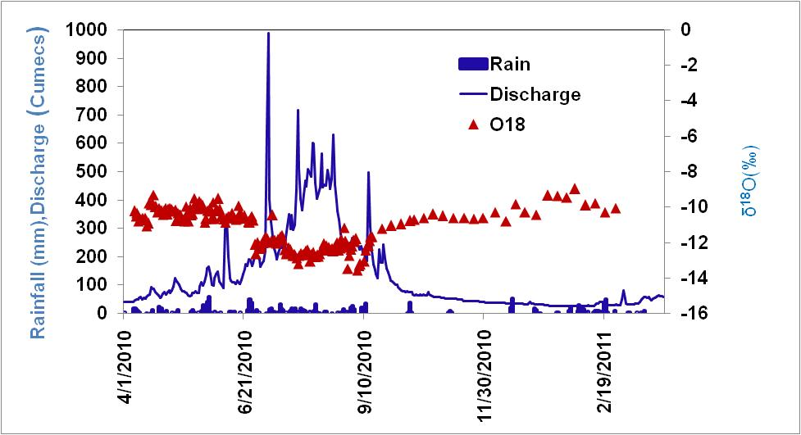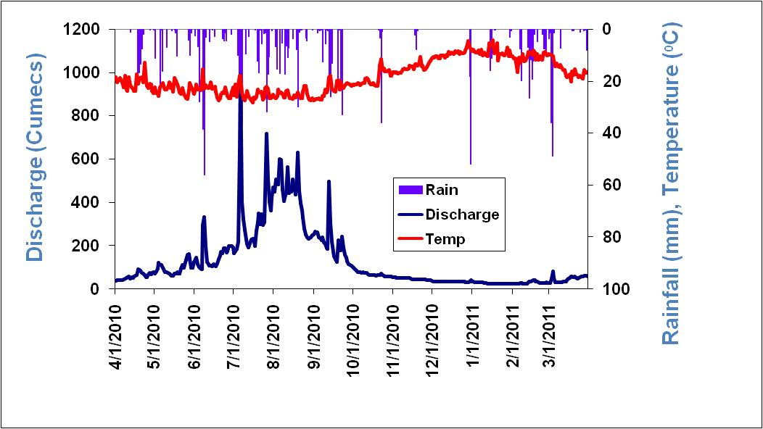The hydrograph of Beas River at Bhunter site is multiple nodal due rain derived runoff occurring during the rainy season (Fig 7.9). The minimum flow is recorded during the winter months of December and January when contribution of two components i.e., runoff and snow/glacier melt are negligible. It indicates that the river discharge is sustained by the baseflow/groundwater. The river discharge starts increasing from April due to the melting of snow of lower altitude. This increasing trend continues till June when there is very less rainfall except one event. This clearly indicates that the increase in river discharge is due to contribution of melting of snow and glacier.

**Figure 7.9** Variation of stream discharge and its δ18O composition with rainfall during the year (2010-2011) at Bhunter.

River discharge is observed maximum during the rainy season (July, August and September) and the peek flows corresponds to high intensity rain events for Beas River at Bhunter. Corresponds δ18O values of river is found depleted during these months due to rainfall (Fig. 7.9).

The δ18O of river water varies between minimum –13.59‰ in the month of August to maximum -9.33 ‰ in the month of April. The river showing enriched δ18O values during the summer season (April to June). This enrichment is due to melting of the snow of lower reaches. The δ18O value of November month (-11.44‰) is considered as representative of groundwater of pre-monsoon and post-monsoon when river is sustained by baseflow. During July, August and September, δ18O of groundwater is slightly depleted (Table 7.4). River gets depleted during the month July August and September which indicates that more contribution from snow and glacier of higher altitude with rainfall.

The snow and glacier melt contribution has been computed using two components mixing model for pre-monsoon period when rainfall is in insignificant amount. Table shows the variation of snow and glacier melt contribution in Beas river at Bhunter.

The computed contribution of snow and glacier melt and other components are given in Table 7.4. The contribution of snow and glacier melt varied from negligible to 85% of the total discharge during the study period with an annual average of 38%. The subsurface contribution ranged from 15% in May to approximately 100% in November with an annual average of 39% (Table-7.4, Fig. 7.10). Rainfall-runoff varied between 9% and 38% of the total discharge during the monsoon month with an annual average 23% of the total flow.

**Figure 7.10** Surface runoff, groundwater and Snow and glacier melt components of Beas River separated out using isotopic techniques during the year 2010-2011 at site Bhunter.

**Table 7.4** Percentage contribution of various components of Beas River discharge at Bhunter site

| **Month** | **Total Discharge (Cumecs)**  **Discharge**  **(Cumecs)** | **Base**  **Flow** | **Snow/glacier Melt** | **Rainfall**  **Runoff** |
| --- | --- | --- | --- | --- |
| **April** | **63** | **18 (28%)** | **46 (72%)** | **0** |
| **May** | **94** | **14 (15%)** | **80 (85%)** | **0** |
| **June** | **149** | **33 (22%)** | **117 (78%)** | **0** |
| **July** | **332** | **93 (28%)** | **126 (38%)** | **113 (34%)** |
| **Aug** | **420** | **133 (32%)** | **125 (30%)** | **161 (38%)** |
| **Sep** | **205** | **105 (51%)** | **31 (15%)** | **69 (34%)** |
| **Oct** | **70** | **61 (88%)** | **2 (3%)** | **6 (9%)** |
| **Nov** | **47** | **47 (100%)** | **0** | **0** |
| **Dec** | **34** | **24 (69%)** | **11 (31%)** | **0** |
| **Jan** | **27** | **17 (62%)** | **10 (38%)** | **0** |
| **Feb** | **29** | **17 (58%)** | **12 (42%)** | **0** |
| **March** | **46** | **25 (54%)** | **21 (46%)** | **0** |

**CHAPTER 8.0 CLIMATE CHANGE MODELLING**

Recently, there is growth in scientific evidence that global climate has changed over the past century due to anthropogenic factors. Human activities like burning of fossil fuels, farming and deforestation have increased concentration of greenhouse gases in the earth’s atmosphere, which absorb solar radiation reflected by the earth’s surface back into the atmosphere. This has triggered rise in the average global temperature, which is more pronounced in the past few decades. Assessing implications of projected climate change on the vulnerable resources of earth would be useful to devise strategies for sustainable management and conservation of the same. For studying impact of climate change future scenarios are needed. Climate scenarios are sets of time series or statistical measures of climatic variables, such as temperature and precipitation, which define changes in climate. Many methods have been developed for generating climate scenarios for the assessment of hydrologic impacts of climate change, which include downscaled general circulation model (GCM) simulations and hypothetical methods. GCMs are used to generate projections of future climate change on a large spatial and temporal scale.

**8.1 GENERATION OF FUTURE SCANRIOS**

The primary objective of the present study is to develop downscaling models to obtain future projections of precipitation and temperature at sites in Beas river basin on daily time scale for different climate change scenarios. The projected data would be useful to assess implications of climate change on hydrological processes in the river basin. Currently, numerical models called General Circulation Models (GCMs) are regarded as reliable tools available to simulate future climatic conditions on earth. Output from a GCM is available at centers of grid boxes (usually of size >10,000 km2) covering the earth’s surface. The performance of GCMs in simulating coarse-scale atmospheric dynamics is reasonable. However, they fail to simulate climate variables at finer (e.g., at-site) scale that is of relevance in the present study. To overcome this shortcoming, downscaling methodologies gained recognition. In this study, transfer function based statistical multisite spatial downscaling models are developed to arrive at required future projections of precipitation and temperature at sites in the Bias river basin from simulations of third generation Canadian Coupled Global Climate Model (CGCM3). An overview of various downscaling strategies in vogue in literature is provided in the following section. Another issue associated with GCMs is that they run on a sub-daily time scale and the resulting simulations, though available at finer time scale (e.g., 6-hourly), are not considered reliable. The simulations are therefore integrated in time to produce monthly and other coarser scale outputs that are considered to be more robust. In view of this, CGCM3 simulations at monthly time scale were considered to arrive at future projections of precipitation and temperature in the present study. It may be noted that in this report precipitation and rainfall are used as synonymous words.

**8.2 Overview of Downscaling Strategies**

The approaches available for downscaling output of a GCM could be classified into two categories: temporal downscaling and spatial downscaling. Temporal downscaling refers to translation of information pertaining to general circulation variables from coarser temporal scale to finer temporal scale, e.g., from monthly or seasonal scale to daily/sub-daily scale. Spatial downscaling refers to derivation of information on predictands (meteorological/hydrological variables) at finer spatial-scale (e.g., watershed, or a location) from GCM output available at relatively coarser spatial-scale. This is based on the assumption that regional climate is conditioned by climate on larger scales. A few studies (e.g.,Wilby and Wigley, 1997; Xu, 1999, Fowler et al., 2007) provide review of downscaling concepts and an overview of the various downscaling strategies in vogue in literature. The approaches which have been proposed for spatial downscaling of GCMs could be broadly classified into dynamic downscaling and statistical downscaling. In the dynamic downscaling approach a Regional Climate Model (RCM) is embedded into GCM. The RCM is a numerical model having horizontal grid spacing of about 20–50 km, which is driven by initial conditions, time-dependent lateral meteorological conditions and surface boundary conditions. The time–varying atmospheric boundary conditions are specified by the host GCM. The RCM simulates finer-scale atmospheric dynamics and can resolve orographic precipitation. The shortcomings of RCM, which restrict its use in climate impact studies, are its complicated design and high computational cost. Output of a RCM will not be readily available at locations of user choice in a river basin. Moreover, RCM is inflexible in the sense that expanding the region or moving to a slightly different region requires redoing the entire experiment. Conversely, the statistical downscaling involves deriving statistical relationships that transform large-scale atmospheric (climate) variables simulated by GCM to local scale variables.

The Statistical downscaling methodologies can be further classified into three categories: weather generators, weather typing and transfer function. Weather generators are statistical models of observed sequences of weather variables. They can be regarded as complex random number generators, the output of which resembles daily weather data at a particular location (Katz and Parlange, 1996). Weather typing approaches involve grouping of local then meteorological variables in relation to different classes of atmospheric circulation. Future regional climate scenarios are constructed either by resampling from the observed variable distribution (conditioned on the circulation pattern produced by a GCM), or by first generating synthetic sequences of weather pattern using Monte Carlo techniques and then resampling from the generated data. The transfer function based statistical downscaling relies on development of direct quantitative relationship between the local scale climate variable (predictand) and the variables containing the large scale climate information (predictors) through some form of regression. It is widely used for downscaling by modelers and hence has been chosen for the current study. Individual downscaling schemes differ according to the choic of mathematical transfer function, predictor variables or statistical fitting procedure. Examples of transfer functions that are used to develop predictor–predictand relationship include linear and nonlinear regression, artificial neural network, canonical correlation, least-square and standard support vector machines (e.g., Tripathi et al, 2006; Anandhi et al., 2008, 2009) and relevance vector machine (Ghosh and Mujumdar, 2008). Least Square Support Vector Machine (LS-SVM) downscaling model, which has been found to be effective in literature, is used for the current study. The LS-SVM provides a computational advantage over standard SVM (Suykens, 2001), and it has been found to be more effective than standard SVM and artificial neural networks in the context of downscaling rainfall over India (Srinivas and Tripathi, 2008).

**8.3 Scenarios**

As mentioned earlier also, consultancy work of downscaling was given to IISc., Bangalore. A report prepared by IISc., Bangalore is prepared separately. On the basis of outcome of this study, scenarios to study impact of climate change have been prepared.

# 8.3.1 Methodology

Statistical consistency checks were performed on the observed data of rainfall, and maximum and minimum temperatures. To devise appropriate strategy for multisite multivariate downscaling, correlation structure of historical data of predictands was examined. For this purpose, the statistics that have been computed include, site-to-site monthly cross-correlations for each of the predictands (rainfall, and maximum and minimum temperatures), and; cross-correlations between the predictands at each site.

The computed statistics indicated that each of the predictands at Bhuntar site was reasonably well correlated with those at the other sites (e.g., see Tables 8.1 and 8.2), and cross-correlation between the predictands was insignificant for the Bhuntar site than for the other sites. Consequently, three downscaling models, each for downscaling future monthly climate information simulated by GCM to one of the predictands, were developed for the Bhuntar site. Least Square Support Vector Machine (LS-SVM), which was found to be effective in literature, has been used to develop the downscaling models. The downscaled information was then translated from Bhuntar to that at other sites in the river basin by using support vector regression relationship fitted between Bhuntar site and each of the other sites in the river basin. Subsequently k-nearest neighbor disaggregation methodology (Anandhi et al., 2012) was used for temporal disaggregation of the downscaled monthly values to daily values at each of the sites.

Table 8.1: Site-to-site cross-correlation for maximum temperature at monthly time scale.

|  |  |  |  |  |
| --- | --- | --- | --- | --- |
| Site | Bhuntar | Largi | Manali | Pandoh |
| Bhuntar | 1.00 | 0.96 | 0.88 | 0.95 |
| Largi |  | 1.00 | 0.86 | 0.91 |
| Manali |  |  | 1.00 | 0.83 |
| Pandoh |  |  |  | 1.00 |

Table 8.2: Site-to-site cross-correlation for minimum temperature at monthly time scale.

|  |  |  |  |  |
| --- | --- | --- | --- | --- |
| Site | Bhuntar | Largi | Manali | Pandoh |
| Bhuntar | 1.00 | 0.96 | 0.97 | 0.94 |
| Largi |  | 1.00 | 0.95 | 0.92 |
| Manali |  |  | 1.00 | 0.92 |
| Pandoh |  |  |  | 1.00 |

### 

### 8.3.2 *k*-Nearest Neighbor temporal disaggregation methodology

The method involves finding nearest neighbor to each of the downscaled monthly values at a site. A nearest neighbour refers to an observed monthly value of predictand that is deemed closer to the downscaled monthly value of the predictand. Historical relationship between the nearest neighbor and its corresponding daily values for the site is used to disaggregate the downscaled monthly values to daily values.

Let the historical (past) and projected (future) values of predictand to be denoted by $u_{vh,τ,j}^{h}$ and $u_{vp,τ,j}^{p}$, respectively, where the subscripts vh and vp are indices for the past and future years (*vh*=1,…, *Nh*; *vp*=1,…,*Np*), and τ denotes the index for the month with the year $\left(τ=1,2,…,ω\right),$ j refers to the index for the day within the month τ . *Nh* refers to the number of years of historical record (e.g., *Nh* = 22 for rainfall data from 1979 to 2000; *Nh* = 16 for temperature data from 1985 to 2000), *Np* refers to the projected period (herein, *Np* = 100 for data from 2001-2100), and ω represents the number of months (=12) in a year. Further, let $u_{vh,τ,∙}^{h}$ denote the observed monthly mean value of the predictand computed for month τ of year υh. Similarly, let the monthly mean value projected for the predictand in the month τ of future year *vp* be $u_{vp,τ,∙}^{p}$.

$u_{vh,τ,∙}^{h}=\frac{\sum_{j=1}^{D_{τ}}{u_{vh,τ,j}^{h}}}{D_{τ}}$ τ = 1, …, ω *vh*=1,…, *Nh*  (8.1)

Where Dτ  denotes the number of days in month τ . For the model calibration period, the observed value of the predictand on day j in month τ is expressed as a ratio of the monthly mean value of the predictand as:

$w_{vh,τ,j}=\frac{u_{vh,τ,j}^{h}}{u_{vh,τ,∙}^{h}}$ j= 1,…, Dτ τ = 1,…, ω *vh*=1,…,*Nh* (8.2)

Let $W_{vh,τ}^{h}=\left\{w_{vh,τ,1,}…, w_{vh,τ,D_{τ}}\right\}$ denote the vector containing the ratios of the daily values of predictand in month τ of year *vh* . the following are the key steps of the algorithm considered to generate daily values of the predictand $u_{vp,τ,j}^{p}$ for the projected period 2001-2100 (Anandhi et al., 2012)

* 1. For every projected value of the predictand, identify the calendar month τ.
  2. For the conditioning set $Z_{τ}= \left\{u_{1,τ,∙}^{h}, …, u_{vh,τ,∙}^{h},…, u_{N_{h},τ,∙}^{h}\right\}$ for each month τ . it comprises of the observed monthly values of the predictand for the calendar month τ.
  3. To disaggregate the value of predictand in month τ, $u_{vp,τ,∙}^{p}$, select its *k*-nearest neighbors from the conditioning set zτ based on the Euclidean distance $ξ_{vp,vh,τ}$ between $u_{vp,τ,∙}^{p}$ and $u_{vh,τ,∙}^{h}$ expressed as

$ξ_{vh,vp}=\left\|u_{vp,τ,∙}^{p}-u_{vh,τ,∙}^{h} \right\|$, for *vh*= 1,…,*Nh* (8.3)

Where **|| ||** represents Euclidean norm. The number of neighbors *k* is a smoothing parameter. Lall and Sharma (1996) suggested using *k* equal to $\sqrt{N_{h}}$ as a rule of thumb, in a different context of non-parametric simulation of streamflows. Hence sensitivity of the result of disaggregation was examined for various values of *k*. The *k* nearest neighbors are observed values of the predictand that are most similar to the projected (downscaled) value of the predictand for the month τ.

4. Determine conditional probabilities *p*(*i*) for the *k*-nearest neighbors. For this purpose, assign weights to each of the *k* nearest neighbors using discrete probability mass function *p*(*i*) , that was considered by Lall and Sharma (1996) by Poisson approximation of the probability distribution function of state space neighbors. Randomly select a nearest neighbor to the projected value of the predictand by constructing cumulative density function using *p*(*i*) values.

$p\left(i\right)=\frac{1/i}{\sum_{j=1}^{k}{\left(1/j\right)}}$ i=1,…, k (8.4)

It is to be noted that p(i) is the same for all the months in the projected period. Let $u_{vh,τ,∙}^{h}$ denote the nearest neighbor.

5.The projected daily values of the predictand for the month τ in year *vp* are obtained by multiplying the projected monthly predictand value $u_{vp,τ,∙}^{p}$ with $W_{vh,τ}^{h}$ corresponding to the nearest neighbor $u_{vh,τ,∙}^{h}$

8.4 RESULTS AND DISCUSSION

Records of rainfall were available at daily time scale for five locations (Banjar, Bhuntar, Manali, Pandoh, Sainj), and only at monthly time scale for one location (Larji) in the river basin. Consequently, future projections of rainfall were obtained at monthly time scale for Larji and at daily time scale for the other five locations. Records of maximum and minimum temperatures were available at daily time scale for four locations (Bhuntar, Larji, Manali, Pandoh). Consequently future projections of temperatures were obtained at daily time scale for these locations.

For obtaining downscaled information on a predictand at Bhuntar site, a downscaling model should be ideally designed to capture quantitative relationship between the observed record of the predictand at the site and the observed records of the corresponding large scale atmospheric predictor variables. In the absence of observed records on large scale atmospheric variables (LSAV) over the study area, National Centers for Environmental Prediction (NCEP) reanalysis gridded monthly data (having a spatial resolution of 2.5 degrees) were considered as their surrogate for the sake of identifying predictor variables and developing a downscaling model. The NCEP data included pressure level variables, surface variables and surface fluxes. Information on pressure levels variables was available for at most 17 pressure levels (from among 1000, 925, 850, 700, 600, 500, 400, 300, 250, 200, 150, 100, 70, 50, 30, 20, and 10 mb).

The surface variables considered for the analysis included precipitable water, sea level pressure and variables listed as pressure level variables. The NCEP data represent the state of the Earth's atmosphere, incorporating past data from 1948 to the present and numerical weather prediction model output.

In practice, predictor variables are chosen as those that are: (i) reliably simulated by GCMs and are readily available from archives of GCM output and reanalysis datasets and (ii) strongly correlated with the predictand. In the present study, GCM for obtaining future projections of precipitation and temperature at sites in the Beas River Basin has been chosen as the third generation Canadian Coupled Global Climate Model (CGCM3/T63). Canadian Coupled GCMs have been found to simulate climate of Indian continent fairly well in previous studies (e.g., Tripathi et al., 2006; Anandhi et al., 2008, 2009, 2012). The T63 version of GCM has 31 levels in the vertical. The atmosphere model output is available on a 128×64 Gaussian surface grid (resolution is approximately 2.81° lat × 2.81° long) and the ocean model output is available on a 256×192 grid (i.e., 2×3=6 oceanic grid boxes underlying each atmospheric grid box). The ocean resolution is therefore approximately 1.4 degrees in longitude and 0.94 degrees in latitude. The model output was available for the past (1850- 2000) and future (2001-2100) years.

In the present study, predictor variables corresponding to each predictand were chosen from LSAVs available in both NCEP reanalysis data and CGCM3 simulations, such that they are reasonably well correlated with the predictand at the Bhuntar site. For the sake of this analysis, the spatial domain of each of the predictor variables was chosen as 16 NCEP-grid points that enclose the study area. CGCM3 simulations were available for IPCC emission scenarios (A1B, A2, B1 COMMIT, and 20C3M). To compute correlation of a predictand with plausible predictors in CGCM3 data, the simulations corresponding to 20C3M scenario were considered. For this scenario, atmospheric carbon-dioxide concentrations and other input data are based on historical records or estimates beginning around the time of the Industrial revolution and it extended over the period 1850-2000. A few of the typical correlation plots that have been scrutinized in this analysis are presented in Figure 8.1, for brevity.

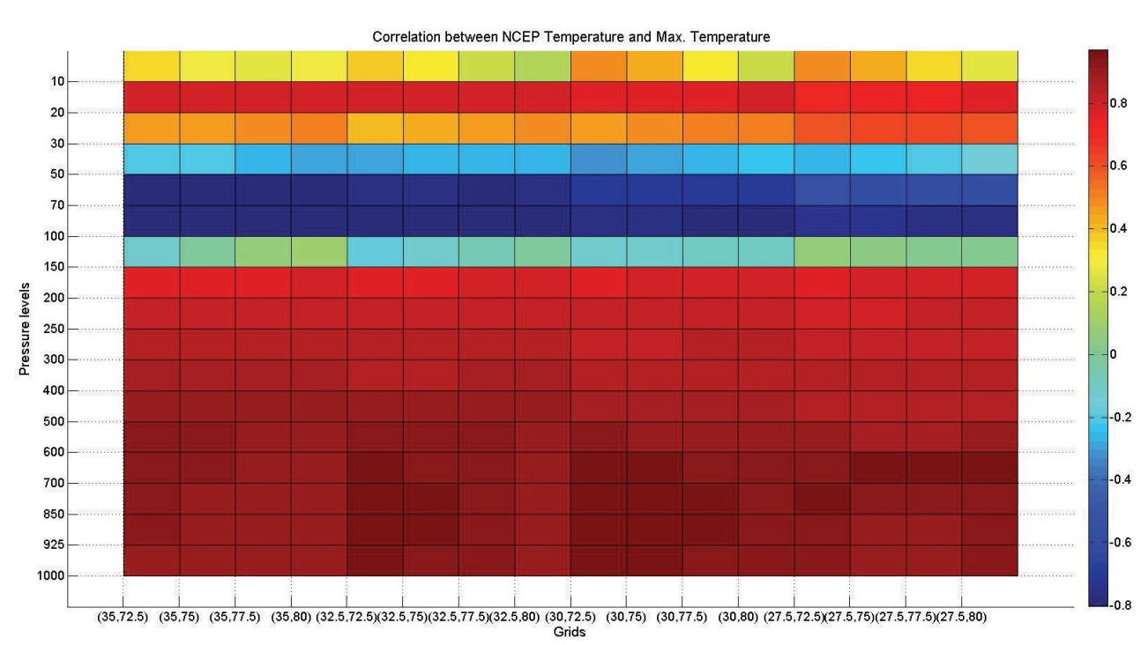

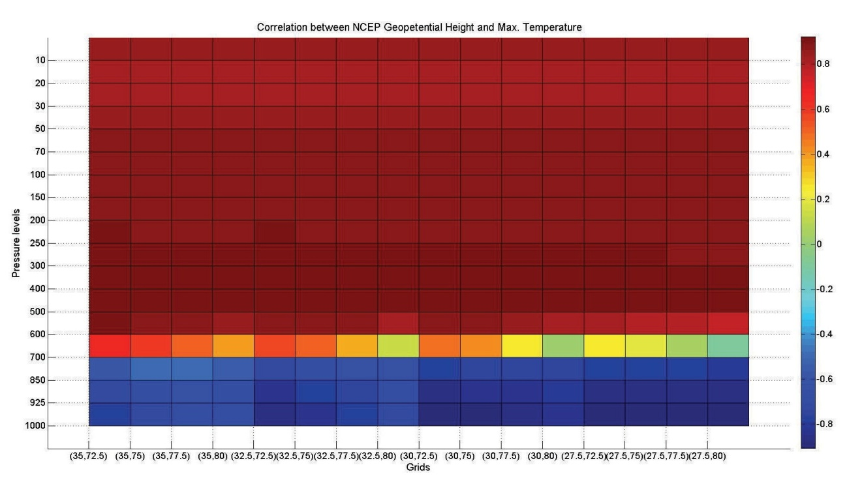

Figure 8.1: Typical correlation plots that have been scrutinized to identify predictors for downscaling maximum temperature.

The list of predictor variables that have been chosen for downscaling the predictands is provided in Table 8.3. The data of each of the predictors were standardized. For this purpose, mean and standard deviation of each predictor were computed for a pre-defined baseline period (January 1979-December 2000 for predictors of rainfall, and April 1985 to December 2000 for predictors of maximum and minimum temperatures). Standardization is widely used prior to statistical downscaling to reduce systematic bias (if any) in the mean and variance of GCM predictors relative to reanalysis data (Wilby et al., 2004). The standardized predictor data are then processed using principal component analysis (PCA) to extract principal components (PCs) that are non-redundant, orthogonal and preserve significant percentage of the variance present in the data. The use of PCs as input to a downscaling model helps in making the model more stable and at the same time reduces its computational burden.

Table 8.3: List of predictors that have been chosen for downscaling the predictands.

|  |  |
| --- | --- |
| Predictand(s) | Predictor variables |
| Precipitation | Temperature at 150 mb pressure level Geopotential height at 700 mb pressure level Specific humidity at 400 mb pressure level  u-wind at 100, 850 and 1000 mb pressure levels v-wind at 850 and 1000 mb pressure levels  Long wave radiation flux |
| Maximum and Minimum Temperatures | Temperature at 100 and 850 mb pressure levels Geopotential height at 500 and 1000mb pressure levels  Specific humidity at 700 mb pressure level  u-wind at 100 and 925 mb pressure levels  v-wind at 50 and 600 mb pressure levels  Latent heat net flux  Sensible heat net flux  Net shortwave radiation  Net longwave radiation |

Model for obtaining downscaled information on a predictand was developed to capture quantitative relationship between the observed data of the predictand and principal components (PC’s) extracted from the corresponding predictor variables in NCEP reanalysis data. Sensitivity analysis was performed to examine the effect of number of PCs on the performance of the downscaling model and optimal number of PCs was decided. Optimal values of the model parameters were determined by calibrating the model. For this purpose, parameters were tuned (by grid search procedure) so that outputs of the downscaling models (i.e., projections of monthly rainfall, and maximum and minimum temperatures) obtained for calibration period (January 1979-December 2000 for rainfall, and April 1985 to December 2000 for maximum and minimum temperatures) correlate well with the contemporaneous observed values of the predictands (rainfall, and maximum and minimum temperatures) at the Bhuntar site. In the grid search procedure, the domain (feasible range) for searching optimal values of LS-SVM model parameters was chosen as [1 200], and the model performance was found to be comparable for a few alternate combinations of model parameters.

The calibrated models were validated by comparing/correlating outputs of the downscaling models obtained for validation period (January 2001- October 2010 for rainfall, and January 2001 to March 2010 for maximum and minimum temperatures) with contemporaneous observed values of the predictands (rainfall, and maximum and minimum temperatures) at the Bhuntar site. Information pertaining to a predictand, the corresponding number of large scale atmospheric predictor variables (LSAPVs), the number of the PCs extracted from the same to develop a LS-SVM model for downscaling the predictand, and the model parameters is provided in Table 8.4. The number of LSAPVs is computed as product of the number of predictor variables given in Table 8.3 and the number of NCEP grid points (16) considered as spatial domain of the predictor variables.

Table 8.4: Information pertaining to downscaling models developed for Bhuntar site.

|  |  |  |  |
| --- | --- | --- | --- |
| Predictand(s) | Number of large scale atmospheric predictor variables | Number of PCs | Parameters of LS-  SVM model  ‘*σ* and C’ |
| Precipitation | 144 (=9×16) | 13 | 14 and 3 |
| Maximum and Minimum Temperatures | 208 (=13×16) | 3 | 1 and 200 |

To obtain future monthly projections of a predictand, principal components were extracted from monthly data of corresponding large scale atmospheric predictor variables (LSAPVs) in CGCM3 simulations, along principal directions obtained for LSAPVs in the NCEP reanalysis data. Feature vectors were formed for each of the months in the GCM record using the PCs. The feature vectors were then run through the calibrated and validated SVM downscaling model (developed for the predictand) to obtain future monthly projections of the predictand for each of the four emission scenarios (i.e. A1B, A2, B1 and COMMIT). The downscaled information was then translated from Bhuntar to that at other sites in the river basin by using support vector regression relationship fitted between Bhuntar site and each of the other sites in the river basin.

Correlations between the observed and the downscaled monthly values of maximum and minimum temperatures and rainfall (based on NCEP data) for sites considered in Bias basin are presented in Tables 8.3 to 8.7. Further these monthly values are visually compared for Bhuntar site in Figures 8.2 to 8.4. The results shown for calibration and validation for Bhuntar site indicate that the SVM downscaling model performed fairly well in downscaling monthly values of the predictands to the site. Further it can be noted that the downscaled monthly values of the predictands at other sites (determined by translating downscaled information from Bhuntar site using support vector regression relationship) are fairly well correlated with the observed monthly records of the predictands for those stations, indicating effectiveness of the model in downscaling multi-site multivariate information at monthly scale. Interestingly, the optimal values of support vector regression relationship (σ and C) were found to be 1 and 50 respectively for all the cases (sites and predictands) in the grid search procedure.

Table 8.5: Correlation between the observed and the downscaled monthly values of maximum temperature (based on NCEP data) for sites in Beas basin.

|  |  |  |  |
| --- | --- | --- | --- |
| Site Name | Calibration period (April 1985  -December 2000) | Validation period (January 2001  -March 2010) | Overall period (April 1985  -March 2010) |
| Bhuntar | 0.98 | 0.86 | 0.93 |
| Larji | - | - | 0.90 |
| Manali | - | - | 0.87 |
| Pandoh | - | - | 0.90 |

Table 8.6: Correlation between the observed and the downscaled monthly values of minimum temperature (based on NCEP data) for sites in Beas basin.

|  |  |  |  |
| --- | --- | --- | --- |
| Site Name | Calibration period (April 1985  -December 2000) | Validation period (January 2001  -March 2010) | Overall period  (April 1985  -March 2010) |
| Bhuntar | 0.99 | 0.94 | 0.97 |
| Larji | - | - | 0.94 |
| Manali | - | - | 0.95 |
| Pandoh | - | - | 0.94 |

Table 8.7: Correlation between the observed and the downscaled monthly values of rainfall (based on NCEP data) for sites in Beas basin.

|  |  |  |  |
| --- | --- | --- | --- |
| Site Name | Correlation between observed data and rainfall downscaled based on NCEP climate data | | |
| Calibration period  (Jan 1979-  Dec 2000) | Validation period (Jan 2001  -Oct 010) | Overall period (Jan 1979  –Oct 2010) |
| Bhuntar | 0.89 | 0.51 | 0.78 |
| Banjar | - | - | 0.62 |
| Larji | - | - | 0.59 |
| Manali | - | - | 0.52 |
| Pandoh | - | - | 0.46 |
| Sainj | - | - | 0.67 |

The performance of the model in downscaling monthly values of minimum temperature was found to be the best, and it is followed by that in downscaling monthly values of maximum temperature and rainfall. The model could not capture heavy rainfalls, as expected for this variable based on similar studies available in literature. In future, further avenues should be explored to devise better downscaling strategies for rainfall, especially to overcome the challenge of modeling high degree of spatio-temporal random variation in values of this variable.

To discern information contained in the downscaled future values of predictands, future projections of annual average values of a predictand for each of the sites were computed based on the downscaled monthly values of the predictand for the sites. Results indicated an increase in annual average maximum and minimum temperatures, and annual precipitation at all the sites for A1B, A2 and B1 scenarios (Figures 8.5 to 8.18). The projected increment is high for A2 scenario, and it is followed by that for A1B and B1 scenarios. For COMMIT scenario, least/negligible increment is found for annual average maximum and minimum temperatures, while rainfall showed a marginal drop in future values.

To scrutinize future changes projected in mean monthly values of a predictand for each scenario, the projected/downscaled future monthly values of the predictand were divided into five sets (2001-2020, 2021-2040, 2041-2060, 2061-2080 and 2081-2100) and average monthly values of the predictand were computed for each of the sets. Maximum mean monthly temperature is projected to increase in future at Bhuntar site during January-April for A1B, A2 and B1 scenarios. Further, decrease in the value of the statistic is projected for June-August for all the scenarios over the period 2081-2100. At Larji site maximum mean monthly temperature is projected to increase in future during January-March and October- December. At Manali, future maximum mean monthly temperature is projected to decrease during April-August and increase during January-February and October-December. At Pandoh site, value of the statistic is projected to increase in future for almost all the months for A1B, A2 and B1 scenarios, and during June-December for COMMIT scenario. Further, minimum mean monthly temperature is, in general, projected to decrease in future during June-July and increase during January-February and October-December for all the scenarios (not shown for brevity).

The k-nearest neighbor disaggregation methodology (Anandhi et al., 2012) was used for temporal disaggregation of the downscaled monthly values of predictands to daily values at each of the sites. For disaggregating a downscaled monthly value of a predictand at any station, the k nearest neighbours for the value were located from the respective month’s observed data in calibration period considered for developing downscaling model (January 1979-December 2000 for rainfall, and April 1985 to December 2000 for maximum and minimum temperatures). The ratios of daily to monthly values for the nearest neighbor were used to scale the downscaled monthly value to arrive at the disaggregated daily downscaled values. In this analysis, *k* was varied from 1 to $\sqrt{N_{h}}$, and differences in disaggregated time series obtained for different values of k were marginal in terms of their correlation with observed daily records of predictand. Consequently disaggregated values obtained for *k* =1 were deemed acceptable.

Scrutiny of results indicates an increase in annual average maximum and minimum temperatures, and annual precipitation at all sites for A1B, A2 and B1 scenarios. The projected increment is high for A2 scenario, and it is followed by that for A1B and B1 scenarios. For COMMIT scenario, least/negligible increment is found for annual average maximum and minimum temperatures, while rainfall showed a marginal drop in future values. Maximum and minimum mean monthly temperatures are, in general, projected to decrease in future during June-July and increase during January-February and October- December for all the scenarios.

Results pertaining to future projections of precipitation and temperature at sites in Beas River Basin on monthly as well as daily time scale for four emission scenarios (i.e. A1B, A2, B1 and COMMIT) for the period 2001-2100.

40

NCEP downscaled

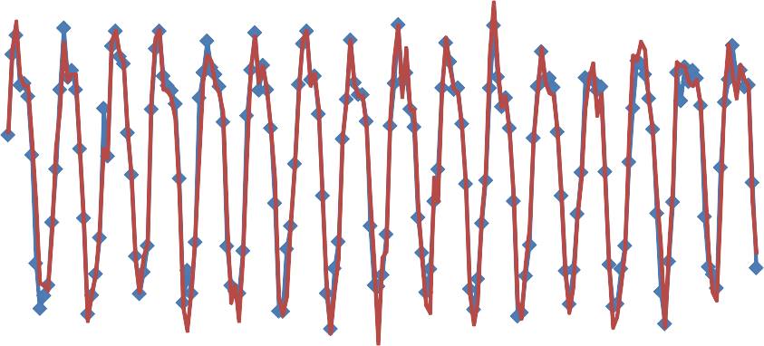

35 Observed

**Maximum Temperature (C)**

30

25

20

15

10

Jan‐1985

Jan‐1986

Jan‐1987 Jan‐1988

Jan‐1989

Jan‐1990

Jan‐1991

Jan‐1992 Jan‐1993

Jan‐1994

Jan‐1995 Jan‐1996 Jan‐1997 Jan‐1998 Jan‐1999

Jan‐2000

40 **Results of Model Validation** NCEP downscaled

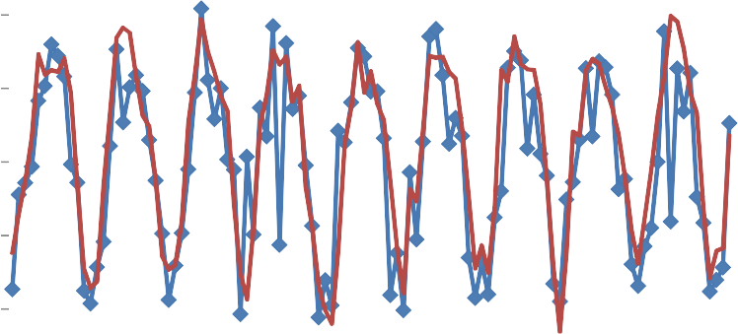

## Observed

35

**Maximum Temperature (C)**

30

25

20

15

10

Jan‐2001

Jan‐2002

Jan‐2003

Jan‐2004

Jan‐2005

Jan‐2006

Jan‐2007

Jan‐2008

Jan‐2009

Jan‐2010

Figure 8.2. Results pertaining to calibration and validation of SVM downscaling model developed to downscale NCEP data (on large scale predictor variables) to monthly maximum temperature at Bhuntar station.

25

**Results of Model Calibration**

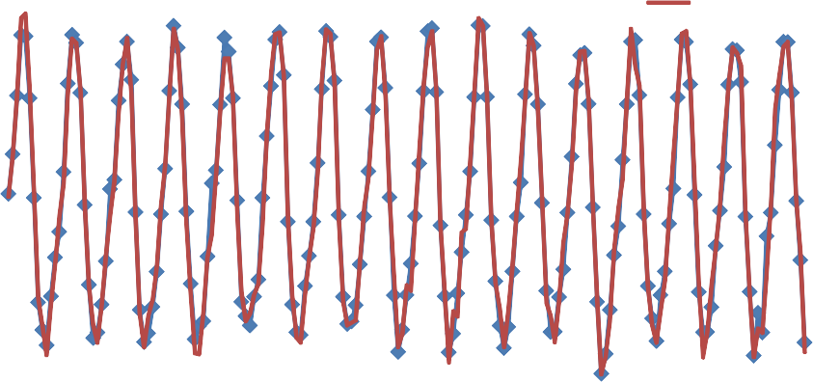

20

**Minimum Temperature (C)**

## NCEP downscaled Observed

15

10

5

0

‐5

Jan‐1985

Jan‐1986 Jan‐1987 Jan‐1988

Jan‐1989

Jan‐1990

Jan‐1991 Jan‐1992

Jan‐1993

Jan‐1994

Jan‐1995 Jan‐1996 Jan‐1997

Jan‐1998

Jan‐1999 Jan‐2000

25 **Results of Model Validation** NCEP downscaled

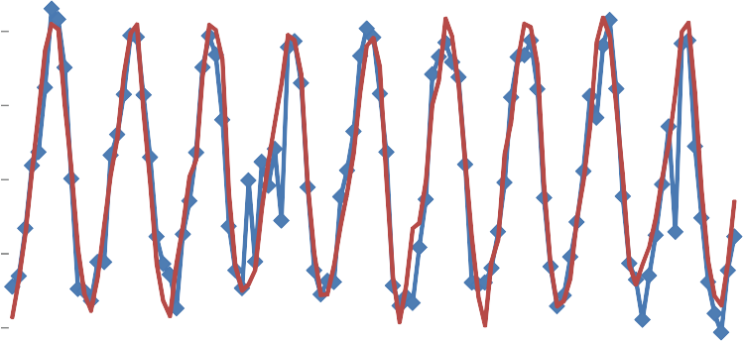

## Observed

20

**Minimum Temperature (C)**

15

10

5

0

‐5

Jan‐2001

Jan‐2002

Jan‐2003

Jan‐2004

Jan‐2005

Jan‐2006

Jan‐2007

Jan‐2008

Jan‐2009

Jan‐2010

Figure 8.3. Results pertaining to calibration and validation of SVM downscaling model developed to downscale NCEP data (on large scale predictor variables) to monthly minimum temperature at Bhuntar station.

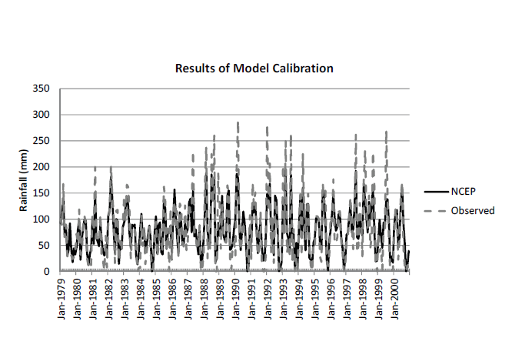

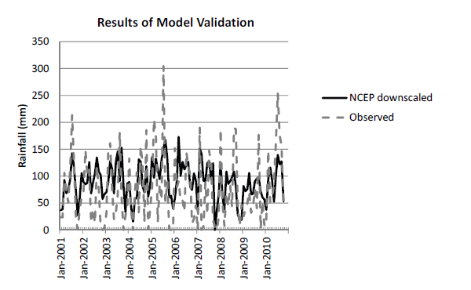





Figure 8.4. Results pertaining to calibration and validation of SVM downscaling model developed to downscale NCEP data (on large scale predictor variables) to monthly rainfall at Bhuntar station.

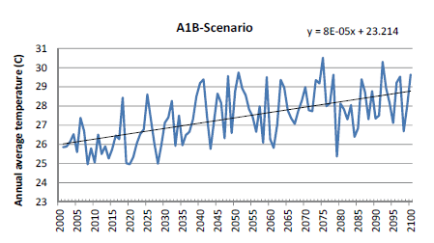

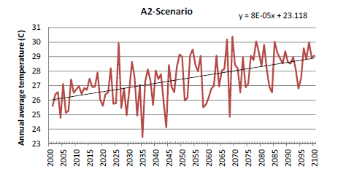

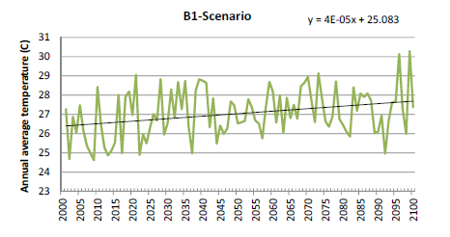

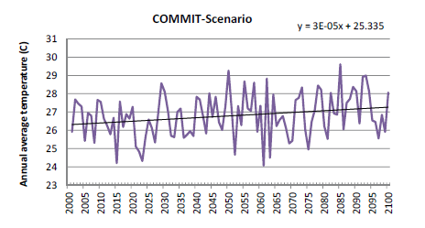

Figure 8.5: Future projections of annual average maximum temperature for Bhuntar station.

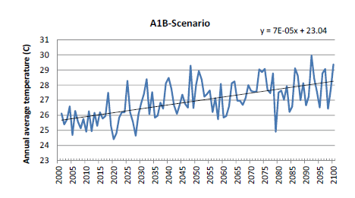

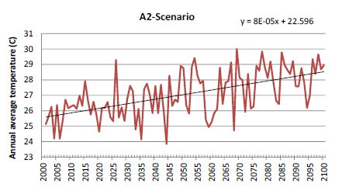

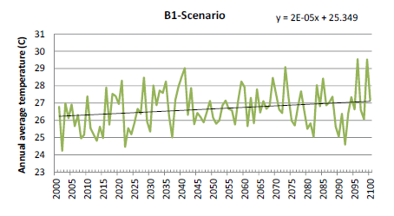

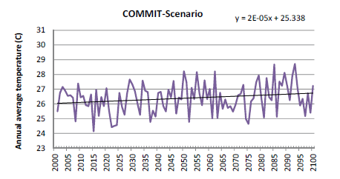

Figure 8.6: Future projections of annual average maximum temperature for Larji station.

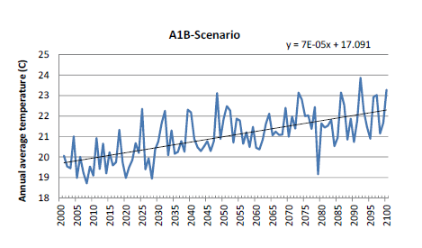

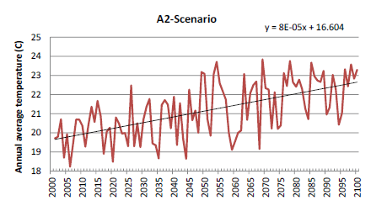

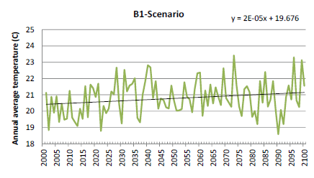

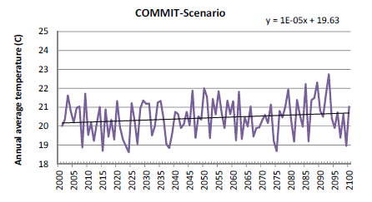

Figure 8.7: Future projections of annual average maximum temperature for Manali station.

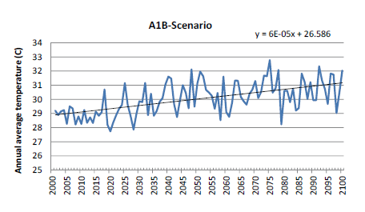

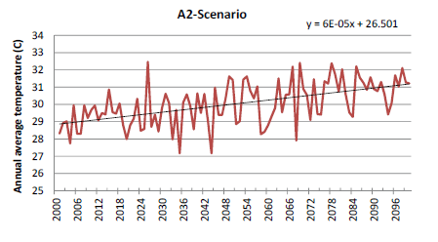

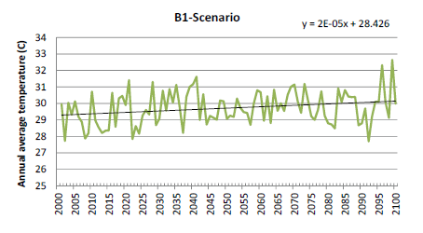

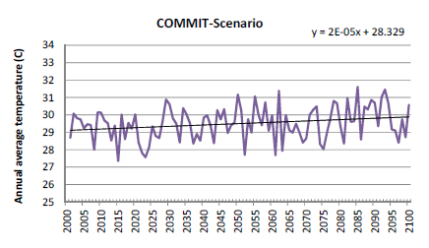

Figure 8.8: Future projections of annual average maximum temperature for Pandoh station.

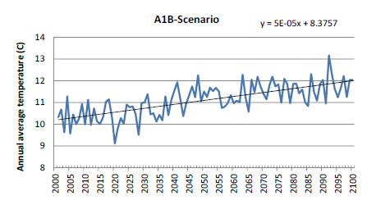

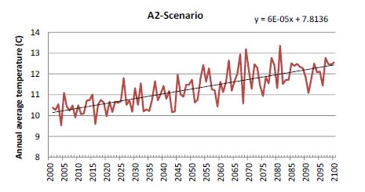

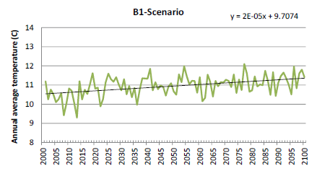

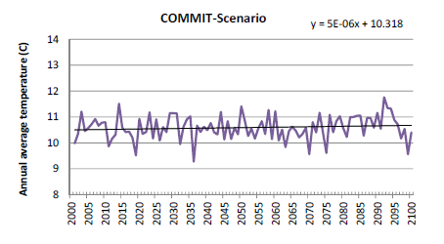

Figure 8.9: Future projections of annual average minimum temperature for Bhuntar.

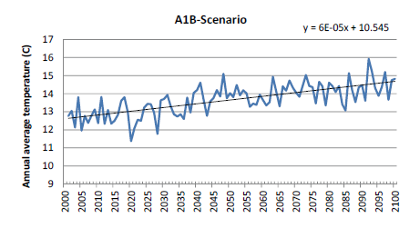

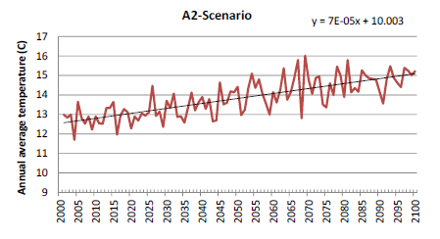

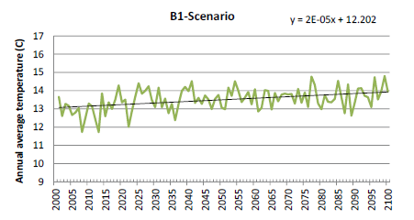

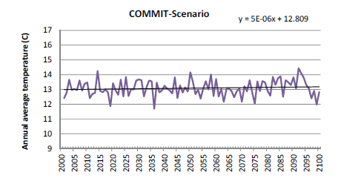

Figure 8.10: Future projections of annual average minimum temperature for Larji.

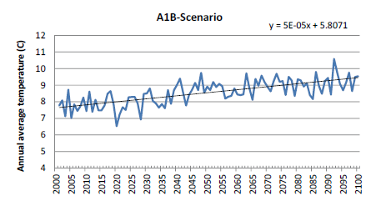

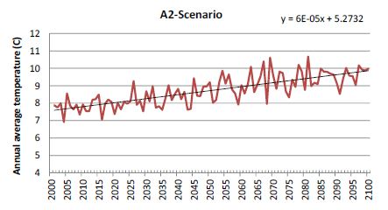

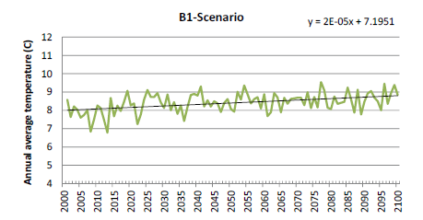

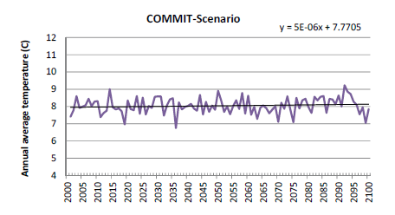

Figure 8.11: Future projections of annual average minimum temperature for Manali.

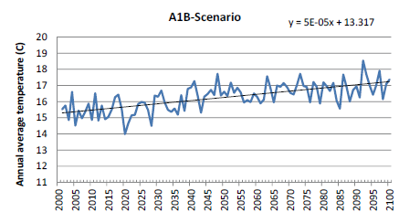

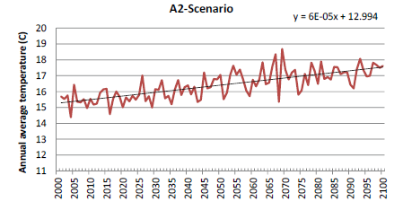

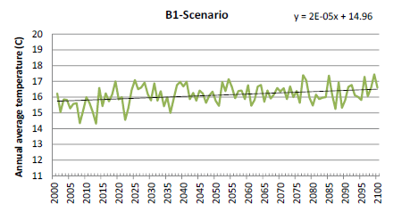

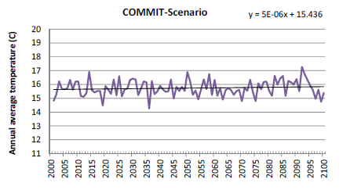

Figure 8.12: Future projections of annual average minimum temperature for Pandoh.

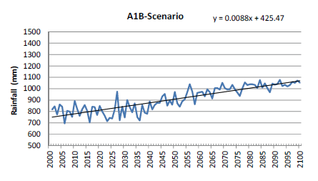

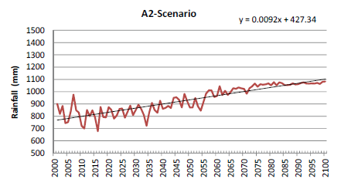

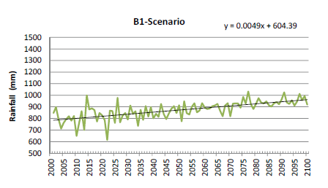

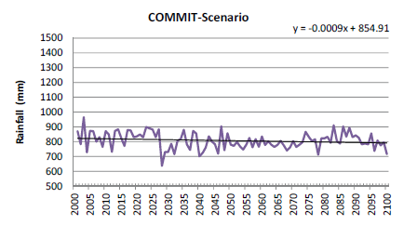

Figure 8.13: Future projections of annual rainfall for Bhuntar station.

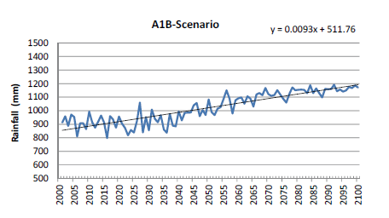

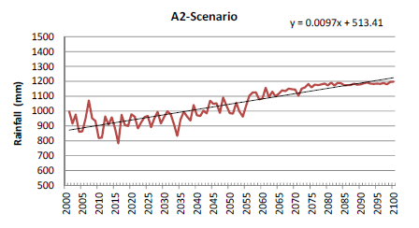

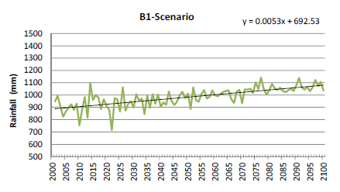

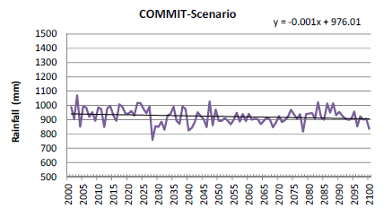

Figure 8.14: Future projections of annual rainfall for Banjar station.

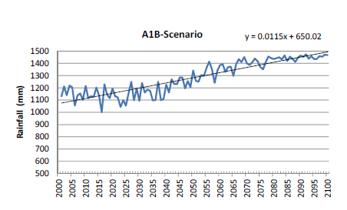

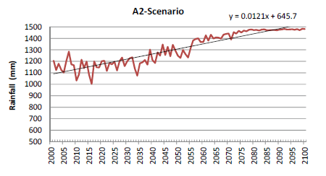



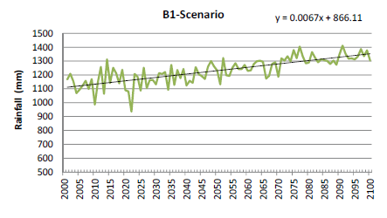

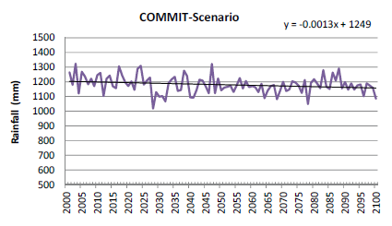

Figure 8.15: Future projections of annual rainfall for Larji station.

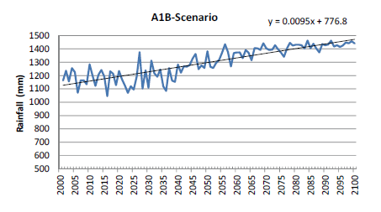

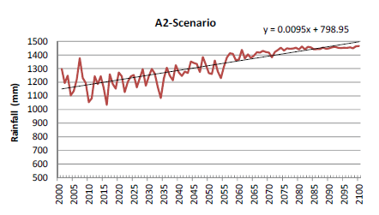

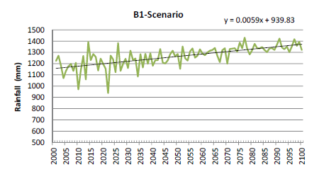

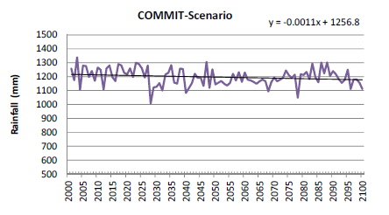

Figure 8.16: Future projections of annual rainfall for Manali station.

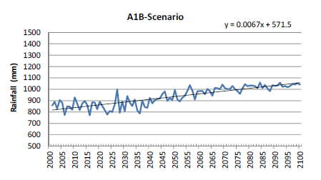

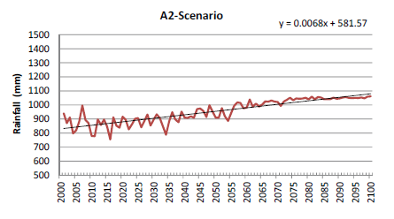

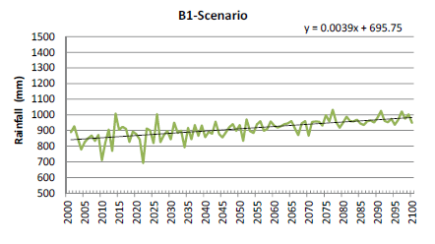

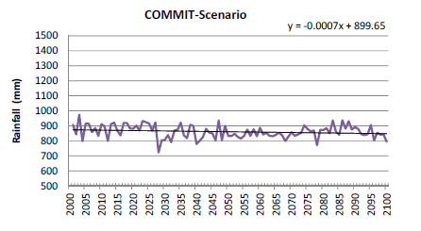

Figure 8.17: Future projections of annual rainfall for Pandoh station.

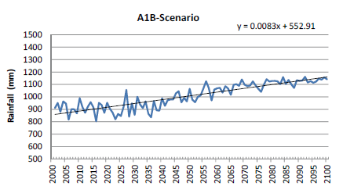

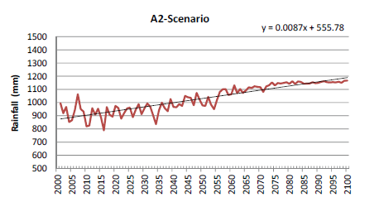

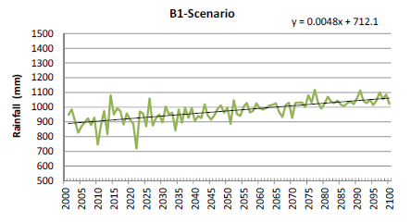

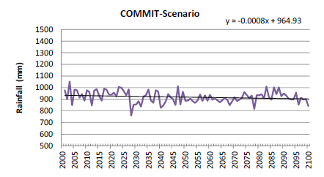

Figure 8.18: Future projections of annual rainfall for Sainj station.

**SUMMARY:**

From the above analysis daily maximum and minimum temperature are projected up to the year 2100. From these projected values, computations for the period of 2001-2020, 2021-2040, 2041-2060, 2061-2080, 2081-2100 have been carried out and given in table 8.8, 8.9, 8.10 and 8.11 for the stations Manali, Lagri, Pandoh and Bhunter.These values are also shown graphically in Figure 8.19 to 8.22 for the stations Manali, Lagri, Pandoh and Bhunter. From these figures and table, it is seen that for the months of April to June, the temperature values are decreasing.

|  |  |  |  |  |  |  |  |  |  |  |  |
| --- | --- | --- | --- | --- | --- | --- | --- | --- | --- | --- | --- |
| **A1B** | **Observed** | **2001-2020** | **2021-2040** | **2041-2060** | **2061-2080** | **2081-2100** | **2001-2020** | **2021-2040** | **2041-2060** | **2061-2080** | **2081-2100** |
|  |  |  |  |  |  |  | **Change** |  |  |  |  |
| **Jan** | 11.79 | 10.74 | 13.83 | 15.60 | 16.04 | 15.23 | -1.06 | 2.04 | 3.81 | 4.25 | 3.44 |
| **Feb** | 12.94 | 12.96 | 13.29 | 14.83 | 16.17 | 17.69 | 0.02 | 0.35 | 1.89 | 3.23 | 4.75 |
| **Mar** | 16.66 | 15.50 | 16.48 | 17.76 | 18.36 | 17.26 | -1.16 | -0.17 | 1.10 | 1.71 | 0.61 |
| **Apr** | 22.53 | 18.94 | 19.80 | 21.54 | 21.44 | 23.15 | -3.59 | -2.73 | -0.99 | -1.09 | 0.62 |
| **May** | 26.16 | 24.12 | 24.94 | 22.47 | 24.67 | 24.66 | -2.04 | -1.21 | -3.69 | -1.48 | -1.49 |
| **Jun** | 27.52 | 23.02 | 24.97 | 24.81 | 23.80 | 24.84 | -4.49 | -2.55 | -2.70 | -3.71 | -2.68 |
| **Jul** | 27.07 | 25.19 | 25.34 | 25.08 | 25.76 | 25.65 | -1.88 | -1.73 | -1.99 | -1.31 | -1.42 |
| **Aug** | 26.59 | 24.39 | 24.54 | 23.73 | 23.65 | 23.83 | -2.20 | -2.05 | -2.86 | -2.94 | -2.76 |
| **Sep** | 25.62 | 24.58 | 24.90 | 24.96 | 24.65 | 25.01 | -1.05 | -0.72 | -0.66 | -0.97 | -0.61 |
| **Oct** | 22.55 | 24.54 | 24.43 | 25.26 | 24.72 | 25.46 | 1.99 | 1.89 | 2.72 | 2.18 | 2.91 |
| **Nov** | 18.08 | 19.44 | 21.37 | 21.11 | 22.49 | 23.18 | 1.36 | 3.28 | 3.02 | 4.41 | 5.10 |
| **Dec** | 13.66 | 13.83 | 14.05 | 16.76 | 16.70 | 16.64 | 0.17 | 0.39 | 3.10 | 3.04 | 2.98 |

Table 8.8 Projected maximum temperature for different time period for Manali station

Table 8.9 Projected maximum temperature for different time period for Largi station

|  |  |  |  |  |  |  |  |  |  |  |  |
| --- | --- | --- | --- | --- | --- | --- | --- | --- | --- | --- | --- |
| **A1B** | **Observed** | **2001-2020** | **2021-2040** | **2041-2060** | **2061-2080** | **2081-2100** | **2001-2020** | **2021-2040** | **2041-2060** | **2061-2080** | **2081-2100** |
|  |  |  |  |  |  |  | **Change** |  |  |  |  |
| **Jan** | 13.92 | 16.45 | 18.98 | 20.73 | 21.04 | 19.92 | 2.53 | 5.06 | 6.81 | 7.12 | 6.00 |
| **Feb** | 16.60 | 17.95 | 18.23 | 19.75 | 21.16 | 22.93 | 1.35 | 1.63 | 3.15 | 4.56 | 6.33 |
| **Mar** | 20.25 | 20.94 | 22.00 | 23.34 | 23.96 | 22.82 | 0.69 | 1.75 | 3.09 | 3.71 | 2.58 |
| **Apr** | 26.92 | 24.50 | 25.35 | 27.31 | 27.40 | 29.02 | -2.42 | -1.57 | 0.39 | 0.48 | 2.10 |
| **May** | 31.09 | 30.86 | 32.50 | 31.32 | 31.96 | 32.79 | -0.23 | 1.41 | 0.23 | 0.87 | 1.70 |
| **Jun** | 33.64 | 32.03 | 32.05 | 32.96 | 32.97 | 32.10 | -1.61 | -1.59 | -0.68 | -0.67 | -1.53 |
| **Jul** | 31.20 | 31.29 | 32.42 | 30.84 | 31.75 | 31.51 | 0.09 | 1.21 | -0.36 | 0.55 | 0.31 |
| **Aug** | 30.49 | 30.07 | 30.35 | 29.50 | 29.15 | 29.33 | -0.42 | -0.14 | -0.99 | -1.34 | -1.16 |
| **Sep** | 29.27 | 30.34 | 30.81 | 30.69 | 30.48 | 30.83 | 1.07 | 1.54 | 1.42 | 1.21 | 1.56 |
| **Oct** | 25.97 | 30.10 | 30.11 | 31.08 | 30.81 | 31.66 | 4.13 | 4.14 | 5.11 | 4.84 | 5.69 |
| **Nov** | 21.01 | 24.90 | 26.73 | 26.62 | 27.84 | 28.70 | 3.89 | 5.72 | 5.61 | 6.83 | 7.69 |
| **Dec** | 15.07 | 18.93 | 19.42 | 22.36 | 21.90 | 21.95 | 3.86 | 4.35 | 7.29 | 6.83 | 6.88 |

Table 8.10 Projected maximum temperature for different time period for Bhunter station

|  |  |  |  |  |  |  |  |  |  |  |  |
| --- | --- | --- | --- | --- | --- | --- | --- | --- | --- | --- | --- |
| **A1B** | **Observed** | **2001-2020** | **2021-2040** | **2041-2060** | **2061-2080** | **2081-2100** | **2001-2020** | **2021-2040** | **2041-2060** | **2061-2080** | **2081-2100** |
|  |  |  |  |  |  |  | **Change** |  |  |  |  |
| **Jan** | 15.56 | 13.89 | 18.72 | 20.95 | 21.37 | 23.95 | -1.67 | 3.16 | 5.39 | 5.81 | 8.39 |
| **Feb** | 17.23 | 17.85 | 18.35 | 20.39 | 21.90 | 23.72 | 0.62 | 1.12 | 3.16 | 4.67 | 6.49 |
| **Mar** | 20.94 | 21.73 | 22.68 | 23.98 | 24.52 | 24.71 | 0.79 | 1.74 | 3.04 | 3.59 | 3.77 |
| **Apr** | 26.58 | 25.07 | 25.94 | 27.78 | 28.13 | 29.04 | -1.51 | -0.63 | 1.20 | 1.56 | 2.47 |
| **May** | 30.45 | 31.74 | 33.37 | 34.84 | 33.09 | 32.07 | 1.29 | 2.91 | 4.38 | 2.63 | 1.61 |
| **Jun** | 32.78 | 35.22 | 32.91 | 34.47 | 35.52 | 27.67 | 2.44 | 0.13 | 1.69 | 2.74 | -5.11 |
| **Jul** | 31.03 | 31.39 | 32.93 | 30.83 | 31.63 | 26.66 | 0.36 | 1.90 | -0.20 | 0.60 | -4.37 |
| **Aug** | 30.41 | 30.22 | 30.53 | 29.91 | 29.41 | 27.57 | -0.19 | 0.12 | -0.50 | -1.00 | -2.84 |
| **Sep** | 29.88 | 30.43 | 30.89 | 30.70 | 30.60 | 30.84 | 0.56 | 1.01 | 0.82 | 0.72 | 0.96 |
| **Oct** | 27.51 | 30.14 | 30.14 | 31.01 | 30.97 | 29.61 | 2.63 | 2.63 | 3.50 | 3.46 | 2.11 |
| **Nov** | 22.74 | 25.53 | 27.05 | 27.14 | 28.10 | 24.99 | 2.79 | 4.31 | 4.40 | 5.36 | 2.25 |
| **Dec** | 17.45 | 18.76 | 19.28 | 22.15 | 22.09 | 23.79 | 1.31 | 1.84 | 4.71 | 4.65 | 6.34 |

Table 8.11 Projected maximum temperature for different time period for Pandoh station

|  |  |  |  |  |  |  |  |  |  |  |  |
| --- | --- | --- | --- | --- | --- | --- | --- | --- | --- | --- | --- |
| **A1B** | **Observed** | **2001-2020** | **2021-2040** | **2041-2060** | **2061-2080** | **2081-2100** | **2001-2020** | **2021-2040** | **2041-2060** | **2061-2080** | **2081-2100** |
|  |  |  |  |  |  |  | **Change** |  |  |  |  |
| **Jan** | 19.04 | 20.11 | 23.04 | 24.80 | 24.86 | 24.04 | 1.07 | 4.00 | 5.76 | 5.82 | 5.00 |
| **Feb** | 20.65 | 22.04 | 22.27 | 23.95 | 25.21 | 26.70 | 1.38 | 1.62 | 3.30 | 4.56 | 6.05 |
| **Mar** | 24.25 | 24.86 | 25.78 | 27.08 | 27.51 | 26.64 | 0.61 | 1.53 | 2.83 | 3.25 | 2.39 |
| **Apr** | 30.07 | 28.12 | 29.10 | 30.73 | 30.76 | 31.95 | -1.95 | -0.97 | 0.66 | 0.69 | 1.88 |
| **May** | 33.86 | 33.51 | 35.49 | 35.30 | 34.68 | 35.99 | -0.34 | 1.63 | 1.44 | 0.82 | 2.13 |
| **Jun** | 34.29 | 35.96 | 34.55 | 36.04 | 36.90 | 34.79 | 1.67 | 0.26 | 1.75 | 2.61 | 0.50 |
| **Jul** | 32.07 | 33.34 | 34.93 | 32.72 | 33.39 | 33.11 | 1.27 | 2.86 | 0.65 | 1.32 | 1.04 |
| **Aug** | 31.73 | 32.32 | 32.57 | 32.18 | 31.78 | 31.83 | 0.59 | 0.84 | 0.44 | 0.04 | 0.10 |
| **Sep** | 31.80 | 32.51 | 32.84 | 32.63 | 32.68 | 32.81 | 0.71 | 1.04 | 0.83 | 0.88 | 1.01 |
| **Oct** | 30.04 | 32.11 | 32.13 | 32.88 | 33.08 | 33.44 | 2.07 | 2.09 | 2.84 | 3.04 | 3.40 |
| **Nov** | 25.70 | 28.65 | 29.75 | 29.98 | 30.53 | 31.05 | 2.95 | 4.05 | 4.28 | 4.83 | 5.35 |
| **Dec** | 20.45 | 22.80 | 23.48 | 26.13 | 25.86 | 25.51 | 2.35 | 3.03 | 5.68 | 5.41 | 5.06 |

Figure 8.19 Projected daily max. temperature for different time period for Manali station.

Figure 8.20 Projected daily max. temperature for different time period for Largi station.

Figure 8.21 Projected daily max. temperature for different time period for Bhunter station

Figure 8.22 Projected daily max. temperature for different time period for Pandoh station.

**CHAPTER 9.0 STREAM FLOW/SNOWMELT RUNOFF UNDER CHANGED CLIMATE SCENARIOS**

Streamflow trends can result from both climate and land use changes, and thus requires precipitation and temperature data for climate change. In the previous chapter climate modeling carried out at IISc. Bangalore have been described. As per this chapter, the projection of precipitation is . The projection of temperature is giving reliable estimates. Therefore in this study impact of temperature has been carried out. A literature review of few studies has been given earlier in which the impact of the changes in temperature on stream flow have been discussed.

**9.1 Impact of climate change on stream flow**

In order to provide an indication of the extent of impacts of climatic change on water resources, Stream flow represents an integrated response to hydrologic inputs on the drainage basin. The model applied in the present study simulates melt runoff as well as rainfall runoff. However there is effect mainly on snowmelt runoff due to change in climate. In this study impact of temperature change on stream flow have been presented.

The climate change impact assessment is carried out using the scenarios developed by climate models. The predictor variables derived from climate modelling are used in the hydrological model to generate stream flows. The comparison of water balance and stream flow is performed in order to quantify the changes in the hydrology f the catchment due to future climate change. Even though the hydrological model used in the study is found capable of reproducing the historical stream flow record reasonably well, its application to predict the hydrology of streams in future climate depends on its ability to model the current scenarios (Dibike et al., 2007). The validated model is used to generate the stream flows at the outlet for the current as well as future periods by using the downscaled temperature data corresponding to A2 and B2 scenarios developed by the HadCM3. No change in other (land use or soil cover) is assumed in the future scenarios. This makes it sure that the projections for future are entirely dependent on the climate change scenarios. A number of studies on climate change impact mainly temperature have been carried out and briefly presented in the following section.

Much of the literature on hydrologic simulation aims to find the sensitivity of streamflow and glacier to climate warming by using step increases in temperature. Hydrologic simulation studies in glaciated basins in Nepal point towards increased flow (Fukushima et al., 1991, Braun et al., 1993; Shilpakar et al., 2009) with a consequent potential threat of GLOFs under a temperature rise up to 3 °C. A study done on a high-altitude sub-basin of Satluj River Basin (tributory to Indus River Basin) revealed an increase in runoff up to 18% from snomelt and 38% from glacier melt for 2 °C warming (Singh and Kumar, 1997). Singh and Bengston (2004) report a three year simulation with 1-3 °C rise in temperature in the Satluj River Basin and show reduction in melt in snowfed basin but increase in galcierfed basin. On the contrary, in another tributary in the same basin, however, Rathore et al. (2009) report about 40% reduction in glacier extent, 5-19% reduction in snow extent, and 8-28% reduction in seasonal streamflow with 1 °C rise in temperature for 2004-2040. Temperature rise is expected to increase streamflow in the short term in some Chinese rivers due to increased glacier melt (Yao et al., 2007). Climate sensitivity analysis in a glacier-dominated region in the Niyang River Basin in the Tibetan Plateau indicates high sensitivity of streamflow to climate change, particularly temperature change (Zhang et al., 2011). Simulations with unchanged precipitation showed annual streamflow increase by an average of 65 mm per 0.5 °C temperature increment (Zhang et al., 2011). Rees and Collins (2006) carried out a comparative study evaluating climate change impacts on two hypothetical conceputal catchments representing glaciological features similar to Batura Glacier in Karakoram and Langtang Glacier in the Nepalese Himalaya using a 0.06 °C year-1 climate warming (for 150 years starting 1990) and time-varient glacial extent. Results for subcatchments with more than 50% glacial area showed an increase in streamflow, which peaked at 2050 and 2070 with 150% and 170% of intial flow and stabilized to lower values with the disappearance of glaciers in 2086 and 2109 respectively in the west (Batura) and east (Langtang) glaciers (Rees and Collins, 2006). In another basin scale study, the flow in upstream areas (≥2000 masl) was projected to decrease by 8.4% in Indus, 17.6% in Ganges, and 19.6% in Brahmaputra basins in 2046-2065 compared to 2001-2007, showing the relative importance of glacier melt contributions (Immerzeel et al., 2009). Immerzeel et al. (2009) used climate warming scenarios with the SRES A1B emission and a mass-balance based glacier evolution scenarios. Projected future precipitation increases in the region are expected to compensate for streamflow reduction due to declining glacial contributions (Immerzeel et al., 2009).

In a recent study of climate change impacts on the hydrology of the Langtang River catchment (360 km2), Immerzeel et al. (2011) applied five GCMs to a high-resolution combined cyrospheric-hydrologic model under SRES A1B and found that both downscaled precipitation and temperature were projected to increase (average temperature by 0.06 °C y-1; precipitation by 1.9 mm y-1). Under multimodel average climatic conditions, Immerzeel et al. (2011) project glaciers to shrink and retreat (32% by 2035 and 75% by 2088) resulting in reduced glacier melt contribution to streamflow; however, the loss in glacier melt contribution is compensated by increased baseflow and runoff leading to an increase in total runoff of 4 mm y-1.

**9.2. Impact of temperature change on stream flow**

The literature was dominated by climate change sensitivity analysis and impact studies particularly with respect to temperature change. Simulations of temperature change while keeping precipitation unchanged suggest reduced glacier extent, increased snow and glacier melt, initial increase but eventual decline in streamflow, and increased threat of GLOFs. In the present study also impact of change of temperature on stream flow has been carried out.

As per the IISc Report, the projected temperature for four scenarios has been obtained. In these study A1B scenarios has been used.

Since the Beas basin is divided into nine zones and four of them are partially snow covered, modified SCA depletion curves were prepared for four zones as described in chapter 4. With modified meteorological and snow cover depletion data, stream flow has been simulated for the scenarios A1B.

The model has been simulated and the results are presented already in the chapter 6. The daily temperature projection are available for the 21st. century. The model has been simulated for the years 1990-2002 .The model have been simulated with the change in temperature and also with modified depletion curves for the years 2040-43, 43-46, 46-49, 49-52 and also for the years 2090-93, 2093-96, 2096-99. The results of these simulations are given in table 9.1

**Table 9.1: Simulation of streamflow**

|  |  |  |  |  |
| --- | --- | --- | --- | --- |
|  | Simulated | Rainfall contribution | Snowmelt runoff contribution | Base flow contribution |
| 1990-2002 | 209.44 | 79.52 | 58.42 | 71.49 |
| 2040-43 | 179.90 | 77.17 | 30.49 | 72.25 |
| 2043-46 | 182.70 | 85.27 | 26.54 | 70.88 |
| 2046-49 | 180.89 | 75.87 | 30.67 | 74.36 |
| 2049-52 | 183.08 | 79.04 | 30.16 | 73.88 |
|  |  |  |  |  |
| 2093-96 | 217.44 | 96.44 | 51.56 | 69.44 |
| 2096-99 | 212.75 | 84.69 | 49.78 | 78.28 |

The average simulated flow for the years 1990-2002 was compared with the simulated flows of projected for the different years as given in the table. The change in annual flow as well as snowmelt runoff is given in table 9.2. From this table it can be seen that the total flow will reduce for the years 2040-43 while for the years 2093-96 and 2096-99 it will increase marginally. The snowmelt runoff will decrease in all the future scenarios.

**Table 9.2: Mean (annual) runoff for different scenarios for Beas basin.**

|  |  |  |  |  |
| --- | --- | --- | --- | --- |
|  | Average annual flow (cumec-days) | Percentage change | Average annual flow (cumec-days) | Percentage change |
| Scenarios |  |  |  |  |
| 1990-2002 | 209.44 |  | 58.42 |  |
| 2040-43 | 179.90 | 14.10 | 30.49 | 47.81 |
| 2043-46 | 182.70 | 12.77 | 26.54 | 54.57 |
| 2046-49 | 180.89 | 13.63 | 30.67 | 47.50 |
| 2049-52 | 183.08 | 12.59 | 30.16 | 48.37 |
|  |  |  |  |  |
| 2093-96 | 217.44 | -3.82 | 51.56 | 11.74 |
| 2096-99 | 212.75 | -1.58 | 49.78 | 14.79 |

From table 9.1 and 9.2 it can be seen that stream flow and snowmelt runoff both are decreasing for projected daily temperature. For the project period up to 2052, the reduction in total stream flow is of the order of 12-14% while reduction in snowmelt runoff is 47-54%. For the period of 2093 to 2096, the there is reduction in snowmelt runoff of the order of 11-15% while there is slight increase in the total stream flow i.e. of the order of 1.5 to 4%.

**CHAPTER 10.0 CONCLUSIONS**

In the present study data base for Beas basin have been created. Field investigations have also been carried out for different sites in Beas basin. The trend analsis, simulation of stream flow, isotopic analsis and impact of climate change have been studied. The results and conclusion for these objectives are given below.

The mountainous basin is highly sensitive to climate change. Any change in rainfall and temperature highly influences stream flow downstream. The detection of trends and magnitude of variations due to climatic changes in hydro climatic data, particularly temperature, precipitation and stream flow, is essential for the assessment of impacts of climate variability and change on the water resources of a region. The present study is based on the analysis of trends in temperature and rainfall data using parametric (linear regression) and non-parametric (Mann-Kendall test and Sen’s estimator of slope) methods on seasonal and annual time scales for the Beas basin in Western Himalayas.

The analysis shows that majority of stations show increasing trend in the mean annual temperature while one station (Manali) shows a decreasing trend over the last three decades. During pre-monsoon season, all the stations indicated rising trend with rising trend at Larji and Pandoh statistically significant at 95% confidence level. The annual rainfall indicates increasing trend at one station namely Banjar and decreasing trend at all other four stations with maximum decrease (-8.07mm/year) at Sainj. Seasonal analysis of rainfall trends shows that all stations during pre-monsoon, post-monsoon and winter season experienced decreasing trend whereas all stations experienced increasing trend in monsoon season. More such analysis is required to examine the trend in climatologically variables in other Himalayan basins. Also there is need to understand the behavior of this basin to climate change and its future impact to plan and manage the water resources.

The simulation of stream flow as well as snowmelt runoff has been carried out. The model was calibrated with the three year data of 2002-2005. The SNOWMOD model was run for the data of the years 1990-2002. The model simulated snowmelt runoff and rainfall runoff separately therefore contribution of each component to the seasonal and annual total streamflows has been calculated. The ablation period is taken from March to August. This study suggests that about 39% of the runoff during ablation period is generated from snowmelt runoff and the remaining 61% is from rain. The average contributions from snowmelt and rainfall to the annual runoff are estimated to be about 38% and 62%, respectively. This means that snowmelt runoff is mainly occurring in the ablation period only.

The water quality analsis of the samples collected from the field have been carried out. The major ion chemistry of the River Beas indicates that calcium and magnesium are dominant cations while bicarbonate and sulphate are dominant anions. The relative high contribution of (Ca+Mg) to the total cations (TZ+), high (Ca+Mg)*/*(Na+K) ratio and low (Na+K)*/*TZ+ ratio indicate the dominance of carbonate weathering as a major source for dissolved ions in the drainage basin. According to hydrochemical facies, the majority of the samples belong to Ca-Mg-CO3-HCO3 hydrochemical facies.

The hydrograph separation has been carried out using isotopic techniques of Beas river at Manali and Bhunter and Parvati River at Bhunter for the period April 2010 to March 2011. The results of hydrograph separation reveal the temporal and spatial variation of snow and glacier melt in Beas River. The contribution of snow and glacier melt, rainfall-runoff and baseflow (i.e., subsurface/ groundwater) computed for Beas and Parvati river are following:

1. The results of hydrograph separation at Manali show that the contribution of snow and glacier melt varied from negligible to 83% of the total discharge during the study period with an annual average of 51%. The subsurface contribution ranged from 17% in April to approximately 100% in November with an annual average of 37%. Rainfall-runoff varied between 6% and 26% of the total discharge during the monsoon month with an annual average 12% of the total flow.
2. The contribution of snow and glacier melt of Beas river at Bhunter on annual average is found 38% of the total runoff which is less that that of Manali. It indicates that as river moves downstream side, snow and glacier melt contribution is decreasing. The contribution of baseflow and rainfall-runoff is increasing.
3. The results hydrograph separation of Parvati river reveals that contribution of snow and glacier melt varied from negligible to 94% of the total discharge during the study period with an annual average of 40%. The subsurface contribution ranged from 6% in May to approximately 100% in November with an annual average of 38%. Rainfall-runoff varied between 5% and 39% of the total discharge during the monsoon month with an annual average 22% of the total flow.

The future scenarios using statistical downscaling approach have already been carried out through IISc. Bangalore. The use of these scenarios to study the impact of climate change is in final stage and the results will be provided in the final report.

In this study, effect of different changed climate scenarios on the melt runoff as well as stream flow has been studied for Beas basin. Daily snowmelt runoff was simulated for the study basin for different climatic scenarios. An increase in air temperature throughout the year will change the melt rates resulting in an earlier start of the snowmelt season and a significant redistribution of snowmelt runoff to the early snowmelt season months. The change in computed stream flow due to change in climate scenarios provided an indication of the influence of climate change.

The stream flow and snowmelt runoff both are decreasing for projected daily temperature. For the project period up to 2052, the reduction in total stream flow is of the order of 12-14% while reduction in snowmelt runoff is 47-54%. For the period of 2093 to 2096, the there is reduction in snowmelt runoff of the order of 11-15% while there is slight increase in the total stream flow i.e. of the order of 1.5 to 4%.

**REFERENCES**

Agarwal, K. C., Kumar, V. and Das, T., 1983, Snowmelt runoff for a catchment of Beas basin, Proceedings of the First National Symposium on Seasonal Snowcover, 28-30, April, SASE, Manali, Vol II, pp. 43-63.

Arora, M., Goel, N. K., and Singh, P., 2005, Evaluation of temperature trends over India, Hydrological Sciences, Vol. 50, No. 1, pp. 81-93.

Birsana, M. V., Molnara, P., Burlandoa, P., Pfaundlerb, M., 2005, Streamflow Trends in Switzerland, Journal of Hydrology, Vol. 31, pp. 312–329.

Brasseur, G.P., and Roeckner, E., 2005, Impact of improved air quality on the future evolution of climate, Geophysical Research Letters 32, L23704. doi:10.1029/2005GL023902.

Burn, D. H., and Elnur, M. A. H., 2002, Detection of hydrological trends and variability, Journal of Hydrology, Vol. 255, pp. 107-122.

Chang Yu- Xu, 1999, Climate Change and Hydrologic Models: A Review of Existing Gaps and Recent Research Developments, Water Resources Management, Vol. 13, pp. 369-382

Dey, B., Sharma, V. K., Goswami, D. C. and Subba Rao, P., 1988, Snow cover, snowmelt and runoff in the Himalayan river basins: final technical report, National Aeronotics and Space Administration, NASA-CR-182434, 37p.

Dye, D.G., 2002: Variability and trends in the annual snow-cover cycle in Northern Hemisphere land areas, 1972–2000. Hydrologic Processes, Vol. 16, pp. 3065–3077.

Hameed, T., Marino, M.A., De Vries, J.J., and Tracy, J.C., 1997, Method for trend detection in climatological variables, Journal of Hydrologic Engineering, Vol. 4, pp. 154–160.

Hess, A., Iyer, H., Malm, W., 2001, Linear trend analysis: a comparison of methods, Atmos. Environment, Vol. 35, pp. 5211–5222.

Jain, S. K., 2001, Snowmelt runoff modeling and sedimentation studies in Satluj basin using remote sensing and GIS, PhD Theisis unpublished, University of Roorkee.

Jain, S. K., Ajanta Goswami, A. K. Saraf., 2007b, Accuracy Assessment of MODIS, NOAA and IRS Data in Snow Cover Mapping Under Himalayan Condition, International Journal of Remote Sensing, (in press)

Jain, S. K., Ajanta Goswami, A. K. Saraf., 2007c, Land Surface Temperature and its Lapse Rate in Satluj basin using NOAA Data, International Journal of Remote Sensing, (in press)Jain, S. K., and Ajanta Goswami, 2007d, Drought Monitoring Using NOAA AVHRR Data in Western India, Disaster Preventation Management, (in press)

Kendall, M.G., 1955. Rank Correlation Methods, Griffin, London.

Mann, H.B., 1945, Nonparametric tests against trend, Econometrica, Vol. 13, pp. 245-259.

Martinec, J., Rango, A. and R.Roberts, 2007, WinSRM version 1.11, November, 2007

McBean, E. and H. Motiee, 2006, Assessment of impacts of climate change on water resources- a case study of the Great Lakes of North America, Hydrologic Earth System Science Discussion, Vol. 3, pp. 3183-3209, Available online at: [www.hydrol-earth-systm-sci-discusss.net/3/318/2006](http://www.hydrol-earth-systm-sci-discusss.net/3/318/2006) (accessed on December 20, 2007).

Modarresa, R. and Silva, V. P. R., 2007, Rainfall trends in arid and semi-arid regions of Iran, Journal of Arid Environments, Vol. 70, pp. 344–355.

Seth, S. M., 1983, Modelling of daily snowmelt runoff during pre-monsoon month for Beas basin upto Manali, Proceedings of the First National Symposium on Seasonal Snowcover, 28-30 April, SASE, Manali, Vol. II, pp. 104-115.

Singh, P., and Jain, S. K., 2002, Snow and glacier melt in the Satluj River at Bhakra dam in the western Himalayan region, hydrological sciences journal, Vol. 47, No. 1, pp-93-109.

Singh, P. & Jain, S. K., 2003, Modelling of stream flow and its components for a large Himalayan basin with predominant snowmelt yields. Journal of Hydrological Sciences, 48 (2), 257-276.

Zhang, Q., Jiang, T., Gemmer, M., and Becker, S., 2005, Precipitation, temperature and runoff analysis from 1950 to 2002 in the Yangtze basin, China, Hydrological Sciences, Vol. 50, No. 1, pp. 65-79.

Anandhi, A, Srinivas, V.V., Nagesh Kumar, D., Nanjundiah, R. S., 2012. Daily relative humidity projections in an Indian river basin for IPCC SRES scenarios. Theoretical and Applied Climatology, 108, 85–104, DOI 10.1007/s00704-011-0511-z

Anandhi, A, Srinivas, V.V., Nagesh Kumar, D., Nanjundiah, R. S., 2009. Role of predictors in downscaling surface temperature to river basin in India for IPCC SRES scenarios using support vector machine, International Journal of Climatology, Wiley InterScience, 29(4), 583-603, DOI: 10.1002/joc.1719

Anandhi, A, Srinivas, V.V. Nanjundiah, R.S., Nagesh Kumar, D., 2008. Downscaling precipitation to river basin in India for IPCC SRES scenarios using support vector machine. International Journal of Climatology, Wiley InterScience, 28(3), 401-420, DOI: 10.1002/joc.1529

Courant, R., Hilbert, D., 1970. Methods of mathematical physics. Vol. I and II, New York, Wiley Interscience.

Fowler, H.J., Blenkinsop, S., Tebaldi, C., 2007. Linking climate change modeling to impacts studies: Recent advances in downscaling techniques for hydrological modeling. International Journal of Climatology, 27, 1547-1578. DOI: 10.1002/joc.1556.

Ghosh, S., Mujumdar, P. P., 2008 Statistical downscaling of GCM simulations to streamflow using Relevance Vector Machine. Advances in Water Resources, 31/1, pp. 132-146, doi : 10.1016/j.advwatres. 2007.07.005

Haykin, S., 2003. Neural Networks: A comprehensive foundation. Fourth Indian Reprint, Pearson Education, Singapore, pp.842.

Hush, D. R., Horne, B. G., 1993. Progress in supervised neural networks: What’s new since Lippmann?. IEEE Signal Processing Magazine 10, 8-39.

Katz R.W., Parlange, M.B., 1996. Mixtures of stochastic processes: applications to statistical downscaling. Climate Research, 7, 185–193.

Keerthi, S.S., Lin, C.-J., 2003. Asymptotic behaviors of support vector machines with Gaussian kernel. Neural Computation 15 (7), 1667–1689.

Lall, U., Sharma, A., 1996. A nearest neighbor bootstrap for time series resampling. Water Resources Research, 32(3), 679–693

Lin, H.-T., Lin, C.-J., 2003. A study on sigmoid kernels for SVM and the training of non- PSD kernels by SMO-type methods. Technical report, Department of Computer Science and Information Engineering, National Taiwan University.

Mercer, J., 1909. Functions of positive and negative type and their connection with the theory of integral equations. Philosophical Transactions of the Royal Society, London, A, 209, 415-446.

Prasad, V. H., Roy, P. S., 2005. Estimation of snowmelt runoff in Beas basin, India. Geocarto International, 20(2), 41-47.

Srinivas V.V., Tripathi, S., 2008. Statistical downscaling of regional precipitation under climate change scenarios using support vector machines. In: Singh, V. P. (Ed.), Hydrology and Hydraulics, Water Resources Publications, Highlands Ranch, Colorado, USA, Chapter 15, 533-586.

Tripathi, S., Srinivas, V. V., Nanjundiah, R. S., 2006. Downscaling of precipitation for climate change scenarios: A support vector machine approach. Journal of Hydrology, 330(3-4), 621-640. doi:10.1016/j.jhydrol.2006.04.030.

Wilby, R. L., Charles, S. P., Zorita, E., Timbal, B., Whetton, P., Mearns, L. O., 2004. The guidelines for use of climate scenarios developed from statistical downscaling methods. Supporting material of the Intergovernmental Panel on Climate Change (IPCC), prepared on behalf of Task Group on Data and Scenario Support for Impacts and Climate Analysis (TGICA).

Wilby, R.L., Wigley, T.M.L., 1997. Downscaling general circulation model output: A review of methods and limitations. Progress in Physical Geography, 21, 530–548.

Xu, C.Y., 1999. From GCMs to river flow: a review of downscaling methods and hydrologic modelling approaches. Progress in Physical Geography, 23(2), 229–249.

Abbas, N. and Subramanian, V. (1984), Erosion and sediment transport in the Ganges river basin, J. Hydrol., 69, 173-182.

APHA (1992), Standard Methods for the Examination of Water and Waste Waters, American Public Health Association, 18th Edition, Washington, DC.

Bahadur, J. (1988), Himalayan water from snow and glaciers, Proc. First Nat. Wat. Comm., Vol. II, 59-65, Ministry of Water Resource, Govt. of India.

Chauhan, D. S. and Hasnain, S. I. (1993), Chemical characteristics, solute and suspended sediment loads in the melt waters draining from Satopanth and Bhagirath Kharak glaciers, Ganga basin, India. In: Snow and Glacier Hydrology (ed. G. J. Yong) (Proc. Kathmandu Symposium Nov. 1992), 403-410, IAHS Publ. No. 218.

Handa, B. K. (1972), Geochemistry of Ganges river water, Indian Geohydrol., 8, 71-78.

Hasnain, S. I. (1992), Glaciofluvial sediment transfer from Chota Shigri, Himachal Pradesh. In: Proc. Int. Symposium on Hydrology of Mountainous Areas (Shimla, India), 273-283. NIH, Roorkee, India.

Hasnain, S. I. (1996), Factor controlling suspended sediment transport in Himalayan glacier meltwaters, J. Hydrol., 181, 49-62.

Hasnain, S. I., Subramanian, V. and Dhanpal, K. (1989), Chemical characteristics of melt waters from a Himalayan glacier, India, J. Hydrol., 106, 98-106.

Hasnain, S. I. and Renoj, J. T. (1996), Factor controlling suspended sediment transport in Himalayan glacier meltwaters, Sediment transport and solute variation in melt waters of Dokriani (Bamak), Garhwal Himalaya, J. Geol. Soc. India, 47, 731-739.

Jain, C. K. and Bhatia, K. K. S. (1988), Physico-chemical Analysis of Water and Wastewater, User’s Manual, UM-26, National Institute of Hydrology, Roorkee.

Sarin, M. M., Krishnaswamy, S., Dilli, K., Somayajulu, B. L. K. and Moore, W. S. (1989), Major ion chemistry of Ganga-Brahmaputra river system: weathering processes and fluxes of the Bay of Bengal, Geochim. Cosmochim. Acta,53, 997-1009.

Sarin, M. M., Krishnaswamy, S. K., Trivedi, J. R. and Sharma, K. K. (1992), Major ion chemistry of the Ganga source waters: weathering in the high altitude Himalaya. In: Proc. Indian Academy of Sciences (Earth Planet Sci.), 1, 89-98.

Subramanian, V. (1979), Chemical and suspended sediment characteristics of rivers of India, J. Hydrol., 44, 37-55.

Vohra, C. P. (1993), Himalayan glaciers. In: Harnessing the Eastern Himalayan Rivers, Regional Cooperation in South Asia (Ed. B. G. Verghese and Ramaswamy R. Iyer), Kenark, New Delhi, India.